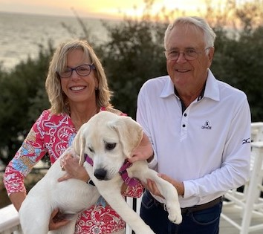
Diana Ferguson
3227 Darby Road

Relevant personal and professional experience
- Having previously served on the GCA Board, I have decided to run for a GCA Board position in the upcoming 2021 election because I believe it is a way to give back to our community. As 2020 has shown us all, change is a constant, and we must never take things for granted. Glenmore is a strong vibrant community, yet needs to have a sound strategy, effective oversight, and community involvement to ensure its value is protected in the long run.
- My passions include spending time with family and friends, travel, cooking, exercise, and tennis.
- I have a BS in Engineering, and executive management certificates from Wharton School of Business and Thunderbird International University. I also have an executive construction management certificate from Texas A&M.
- I was fortunate to hold many exciting and challenging positions in the Engineering and Construction industry. In these roles, I lived and travelled throughout the country and world.
- I served on various Boards both internal and external to the companies I worked for. Most recently, I served over eight years on the EHL Board. EHL is the parent company for Golder Associates, a global engineering and consulting firm. I retired from serving on this Board in 2018.
- While working part-time, I served for two years on the ‘Women’s Build’ Board for Habitat for Humanity in Charlottesville. My primary role was leading their major fundraising effort ‘Hike for Habitat’.
- In 2015, I was elected to serve on the GCA Board. I was appointed VP, and briefly served as President at the end of my term. While serving, I had primary responsibility for the following efforts:
  - Lead the study team to decide on the purchase of the Glenmore Country Club.
  - Lead the Governance Framework Review, which included the major revision of the GCA C&Rs.
  - Determine the next steps for the Glenmore Farm, including the decision and risk analysis to transition from a community run equestrian center to a 3rd party leasing.
  - Implement the Traffic Calming recommendation to install stop signs and speed humps on Darby West.

Vision for the Glenmore community
- I am pleased to read that the Board has continued to migrate to an oversight Board versus a managing Board.
- My primary objective as a Board member will be to ensure that the Board takes action and decisions that maintain or enhance the value of Glenmore and our properties. This not only includes activity within the boundaries of Glenmore, but involvement in County actions, such as the proposed Breezy Hill development.
- I look forward to many more years in Glenmore as it’s a great place to live. Thank you for your consideration.

