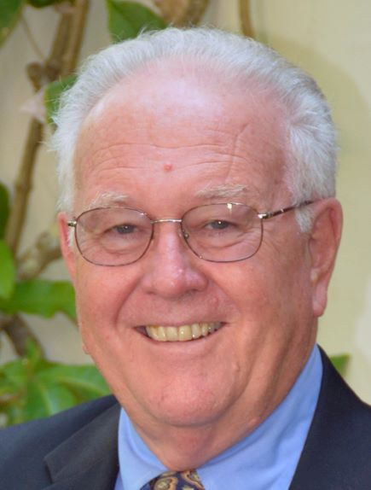
Glenmore Community Association
Board of Directors Nominee Information

Name: David Breneman
Address: 3208 Heathcote Lane
Years in Glenmore: 10

Relevant personal and professional experience
Which of your personal and professional experiences do you believe will most contribute to the work of the GCA Board of Directors?
David Breneman and his wife, Donna Plasket, purchased their home in Glenmore in 2009, and he was elected to the GCA Board for 2012 and 2013. David has served as president of Kalamazoo College, as dean of the Curry School of Education at UVA, and as president of The Society of the Four Arts in Palm Beach, FL, from which position he retired in September 2019. A Ph.D. economist and experienced administrator and board member of educational and other nonprofit organizations, his approach to leadership and service is to seek ways to help an already strong organization become even better.

Vision for the Glenmore community
What are your views and hopes for the Glenmore community and the major issues you foresee?
We have been asked to spell out our vision for Glenmore. I believe the community is generally in fine shape and does not call for transformative actions on the part of GCA. What is needed are Board and committee members, as well as community members at large, committed to solving the numerous issues that inevitably arise each year. Some of the irritants are outside our direct control, such as traffic on 250, the impact of Rivanna Village and the potential development of Breezy Hill, and in these cases GCA must work as an active advocacy group. Internal issues, such as finance and budgeting, road and common area maintenance, speeding, pedestrian safety, trails, architectural review and the equestrian center require steady attention and a Board alert to the views of residents.
Firmly committed to Glenmore, I will bring proven problem-solving experience to bear on these and other issues facing our community.

