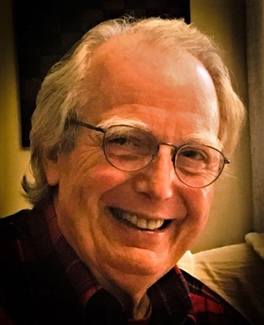
Glenmore Community Association
Board of Directors Nominee Information
Name: Thomas White
Address: 3375 Marsden Point
Years in Glenmore: 3
Relevant personal and professional experience
After graduating from law school, I practiced law briefly in Philadelphia, and then as an attorney-advisor in the office of Tax Legislative Counsel at the U.S. Treasury. Then, I joined the faculty of the UVa Law School, where I taught for fifty years, beginning in 1967 and retiring in 2017. Originally, I taught courses in Federal Income and Estate Tax. Subsequently, I included courses in Domestic Relations where much of my scholarly work has involved tax issues that impact marital settlements. In this respect, I was actively involved in dealing with related issues through the Tax Section of the American Bar Association. Then, in the late 1980’s until retirement I taught real estate transaction courses analyzing equity investment in real developments. One area of great concern to me has been affordable housing, and the tax incentives designed to support private investment in affordable housing. I have participated in the development and publication of course materials, the most recent edition of which is still being taught in other law schools. Later in my career, my course work focused on legal problems in managing the financing of retirement and in aging.
Work on the Law School faculty included a two-year term as the chair of the University Faculty Senate Executive Committee. I am a graduate of Williams College and the University of Pennsylvania Law School. I have been on the staff of Tax Legislative Counsel in the U.S. Treasury Department, and, subsequently, on the staff of the Joint Tax Committee of the U.S. Congress. In Charlottesville, I lived on University Circle, and then in Bellair. After my then wife died from cancer, I met and married Gayle, whose husband has also died from cancer. Together, we purchased our Glenmore residence. While here only three years, we have immensely valued our experience living in this community. This experience leads me to volunteer for the governing board to do what I can to support the warm and friendly community that we value.
What are your views and hopes for the Glenmore community and the major issues you foresee?
Because of the value I put on the community friendly place we have found Glenmore to be, I will work to maintain that most important aspect. Now that Glenmore has a professional management group, my concern there will be to make sure that their work is consistent with our community’s objectives and to keep our members informed about that work and about how the Glenmore Board uses the resources supported by our annual dues.
My real estate development experience leads to my concern for continuing development in Glenmore, and the relationship between newer construction and preexisting parts of Glenmore. Development projects outside Glenmore, which may impact the welfare of the Glenmore community both immediately and in the future, will also need to be monitored, much as we now do for the proposed Breezy Hill development. As far as the Rivanna development is concerned, I think that care will need to be taken to manage the relationship between that development and the amenities that Glenmore offers, particularly for that part of Glenmore adjacent to the development. Other residential development outside Glenmore seems inevitable, so this will be a continuing problem as possible traffic improvements in this respect seem rather limited,
One aspect of Glenmore that I find most attractive is its walking trails apart from the paved portions that follow some streets. This is an interest on which I would work as a member of the Board.

