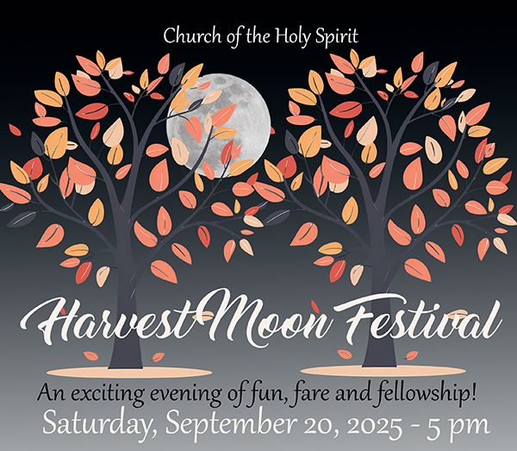
Church of the Holy Spirit
2025 Service Auction
Saturday, September 20, 2025
Donation Form
All donations must be received by August 31, 2025
Fill this out, save a copy (your name/item) and email it to jrpaxton@churchholyspirit.net

Donor Name |  | E-mail
Address (street, city, state, zip code) |  |  | Telephone
I am donating this service or item to the Auction:
Describe what you are donating—
Do you want to set a minimum bid? (We won’t sell unless we hit this minimum bid.)
Is there a limit of (# people, # time, date, season, etc)
Is there a physical limitation for the users? (physically fit, agility, age limit, etc.)
Is there an expiration date for claiming this item? (date, # days, time of year, etc.)
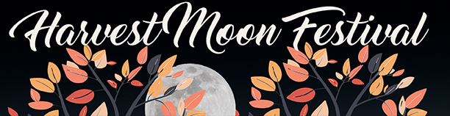
Have you thought about your service or goods donation for the Service Auction?

The proceeds from this fun evening help to fund the mission of CHS:
To become like Christ as we serve others, proclaim God’s love, and grow in the Spirit.
Wondering what to donate? Here are some ideas that keep with the theme of this year’s event.
- Homemade Apple or pumpkin pie
- Basket of wines and cheeses
- An evening of baby-sitting…maybe with a restaurant gift card
- Handmade knit/crochet item
- A weekend in your New England Leaf-Peeping timeshare
- Dinner at a local restaurant for 2 or 4 persons
- Cooking lessons for our NJ Fall produce
- Limo service to airport
- Fall inspired cocktail party food or desserts for a dinner party
- Airline miles for a trip to anywhere!
- Vacation rental for a week
- Cocktail party for ____ number of guests
- What will you donate?

