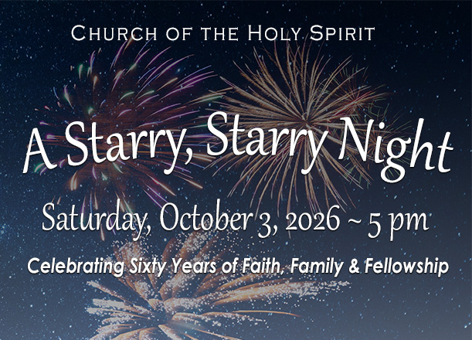
Church of the Holy Spirit
2026 Service Auction
Saturday, October 3, 2026
Donation Form
All forms & donations must be received by September 6th, 2026
Fill this out, save a copy (your name/item) and email it to eva@churchholyspirit.net

Donor Name |  | E-mail
Address (street, city, state, zip code) |  |  | Telephone
I am donating this service or item to the Auction:
Describe what you are donating —
Do you want to set a minimum bid? (We won’t sell unless we hit this minimum bid.)
Is there a limit of (# people, # time, date, season, etc)
If bidding goes wild, would you be willing to offer an additional one?
Is there an expiration date for claiming this item? (date, # days, time of year, etc.)
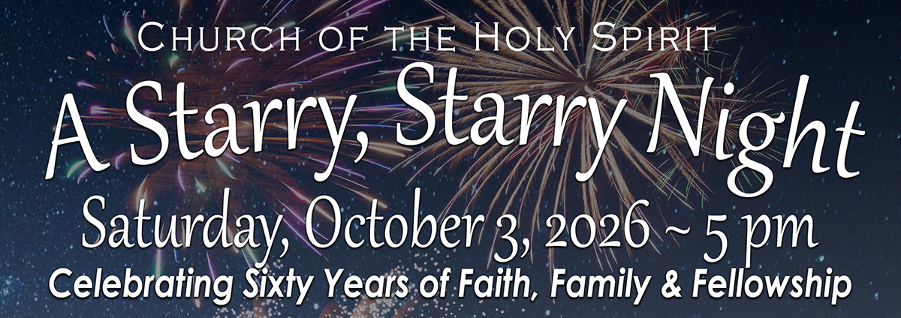
Have you thought about your service or goods donation for the Service Auction?

The proceeds from this fun evening help to fund the mission of CHS:
To become like Christ as we serve others, proclaim God’s love, and grow in the Spirit.
Wondering what to donate? Here are some ideas that have been donated in the past:
- Homemade Apple or pumpkin pie
- Basket of wines and cheeses
- An evening of baby-sitting…maybe with a restaurant gift card
- Handmade knit/crochet item
- A stay in your vacation home or timeshare
- Dinner at a local restaurant for 2 or 4 persons
- Cooking lessons for our NJ Fall produce
- Limo service to/from airport
- Festive appetizers or desserts for a dinner party
- Airline miles for a trip to anywhere!
- Vacation rental for a week
- What will you donate?

All forms & donations must be received by September 6th, 2026
Fill this out, save a copy (your name/item) and email it to eva@churchholyspirit.net

