Recycle Your Holiday Lights & Batteries here at TEMS
Collection Bins are located at the front entrance of the school
rechargeable & single use batteries
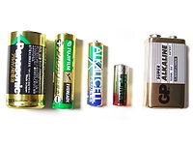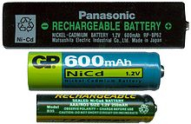
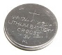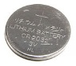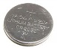

Recycling lights & batteries will keep heavy metals & plastics out of landfills and our environment. New Batteries can be made from the plastic & metals from the batteries that are recycled.

Collection is hosted by the TEMS Green Initiative

