Recycle Your Holiday Lights & Batteries here at TEMS
Monday, December 5th – Friday, January 13th
Collection Boxes will be located in the front & back entrances of the school
rechargeable & single use batteries
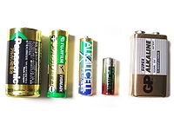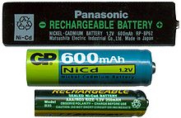
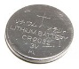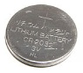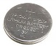

Recycling reduces the need for landfills

Thank you for helping us Protect Our Planet - We're doing it together One Step at a Time!

Collection is hosted by the 6th grade Green Initiative

