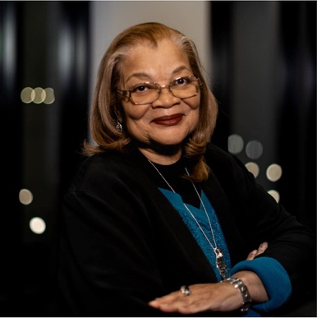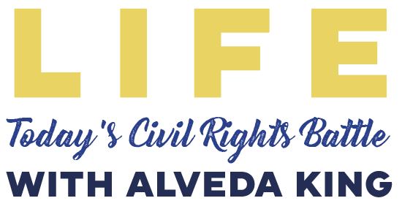

A special MLK Day program hosted by Salt & Light Global
Monday, January 15th, 2024 at South Church in Lansing

Join Alveda King (Niece of MLK Jr.) & Professor William Wagner for a special talk about protecting the first and most basic civil right: LIFE. Registration includes lunch and the chance to connect with other prolife activists. You will be inspired with practical ways that you can make a difference for life! Attendees are encouraged to bring a pack of diapers or wipes to benefit local pregnancy centers.

Sponsorship Opportunities
Contributions from businesses and individuals help make this special event and more like it possible. Your support is greatly appreciated!

Event Sponsors
Champion for Life $3,000—Your name/logo printed on the programs, special recognition from the platform during the program, clickable banner advertisement on the Event Registration Page, Full-Screen ad projected prior to and during the event,

Nourishing Life $1,000—Lunch Sponsor signs placed throughout the Life Center as Lunch is being served with your name/logo on it, special recognition from the platform during the program, clickable banner advertisement on the Event Registration Page, Full-Screen ad projected prior to and during the event

Event Advertising

Full Screen Ad $100—Full-Screen ad projected prior to and during the event

Send this form and check made payable to:
Salt & Light Global, P.O. Box 1544, Jackson, MI 49204

Name: _______________________________________________________________________

Business Name: ____________________________ Title: _______________________________

Address: _________________________________ Phone:______________________________

City/State/Zip: _____________________________ Email:_______________________________

Email your logo or image to KBussard.SLG@gmail.com no later than January 8, 2024. Full page ads should be a 16x9 aspect ratio at a minimum of 300dpi, and can be designed gratis upon request. For questions on ad size specifications or anything else, please call Katherine at (517) 667-8569.

