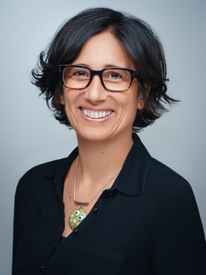
Louise Carvalho
Louise was born in Liverpool, England and grew up on Vancouver Island, Canada. She is of Anglo-Irish and Goan descent, has dual nationality, speaks several languages, and lived in six countries. Louise loves to share her passion for diversity in its many visible and invisible forms.
A lawyer by profession, Louise has practiced in Canada, in England, within the United Nations and European Union institutions in post-conflict Kosovo, and at the Organisation for the Prohibition of Chemical Weapons (Nobel Peace Prize 2013) in The Hague.
Louise joined CERN in October 2014 as a Legal Adviser and was appointed Diversity & Inclusion Programme Leader in 2018. She carries both functions at 50% each.
While enjoying the occasional fusion between the legal and D&I activities (such as embedding gender-inclusive language in CERN’s legal frameworks), Louise champions the business case for diversity and the absolute necessity for the workplace to be welcoming and inclusive of everyone's visible and invisible characteristics.
“When we create a work environment in which we can bring our full selves to work, that is when we experience our full potential.” - L Carvalho, D&I Programme Leader

