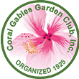

Contact: Susan Rodriguez FOR IMMEDIATE RELEASE:03/15/2021
AS I SEE IT….
A JURIED PHOTOGRAPHY COMPETITION
asiseeit@coralgablesgardenclub.org

AS I SEE IT
2021
A JURIED PHOTOGRAPHY COMPETITION
Grand Prize $1000 and $2800 in category prizes
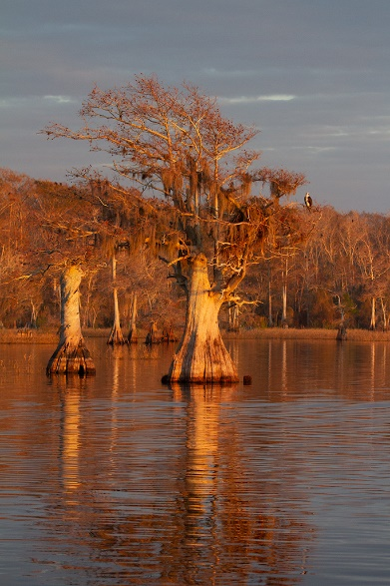
Coral Gables, FL: The Coral Gables Garden Club is sponsoring a photography competition for any photographers, 18 years of age or older. All cameras are welcome, including Smartphones.
Figure 1Courtesy of Fabiola Forns
The competition aims to find the best photos of Florida’s natural environment and wildlife, plants and insects, the City of Coral Gables, and historical places. Coast lines, vista’s, beautiful foliage and flowers, the photographs in this competition will display the talent of the photographer taking the pictures but will inspire visitors to visit and explore our state and the City Beautiful.
“We are excited to see many high-quality images submitted that reflect our state’s diversity, natural environment, Coral Gables and beyond” says Garden Club organizer Susan Rodriguez.
The Coral Gables Garden Club, Inc. is a not-for-profit organization and is proud to sponsor this competition. The club was established in 1925 and has a commitment to the environment, children’s education, the elderly and the beautification of our community.
The proceeds of this competition will help fund all the organizations programs which include mangrove restoration in our coastal areas, the urban tree canopy, reforestation, college level scholarships and many community-based projects.
The submission dates to upload your images begins April 15th, 2021 and continues through May 31st until 10:00 P.M. You may submit as many images as you like for a fee of $10 per entry.
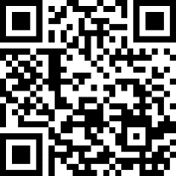
For a full list of eligibility criteria, rules and categories visit https://www.coralgablesgardenclub.org/photocontest or scan the below QR Code with your phone.
Winning photographs will be featured in major local publications, on the Coral Gables Garden Club’s website and an exhibition is under discussion Covid-19 permitting. For more information contact us at asiseeit@coralgablesgardenclub.org or (305)439-3440. Contact President Judy Mangasarian for more information at jmango15@gmail.com or 305-775-2280. Attached are pictures you may use.

Coral Gables Garden Club, Inc. P.O. Box 141463 Coral Gables, Fl 33134
www.coralgablesgardenclub.org
||||||
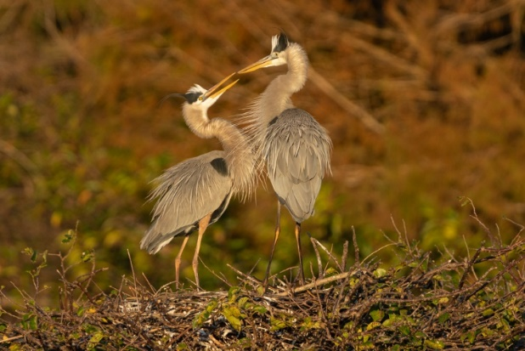
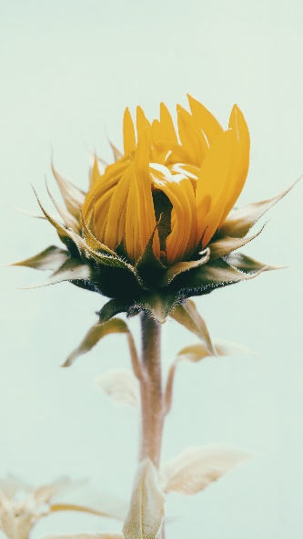
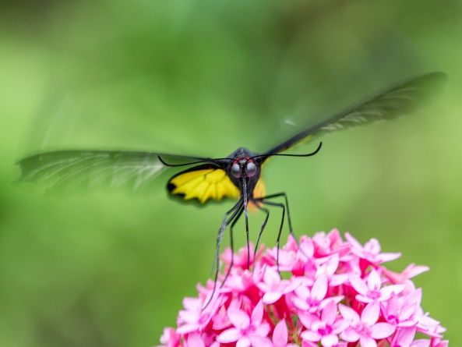
Figure 4Courtesy of Alfred Forns
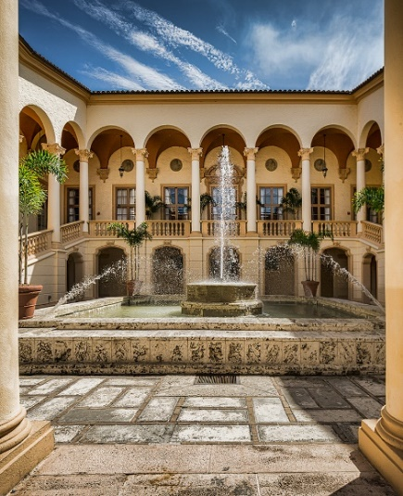
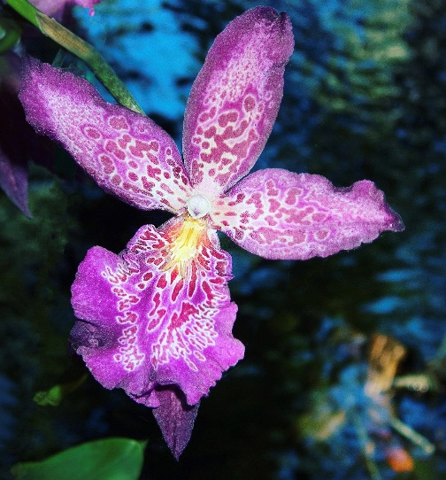

Photos by Fabiola Forns

Coral Gables Garden Club, Inc. P.O. Box 141463 Coral Gables, Fl 33134
www.coralgablesgardenclub.org

