High School Youth from Thunder Bay and Fort Francis Ontario attend Diversity, Inclusion and Anti-racism onsite program in Calgary.
Locally, provincially, and Canada wide, communities are becoming increasingly diverse.
Diversity, Inclusion and Anti-racism education are the areas of acceptance, understanding and positive action vital to create the world in which we all wish to live!
“Thunder Bay has received international attention because of the racism that is rampant throughout our organizations, including policing and health care. Documentaries, such as Ryan McMahon's Thunder Bay and the OIPRD's review of policing services have demonstrated that we experience a problem with racism in the area. Given that Thunder Bay's population is increasingly diversifying at a rapid rate, there is a significant need to continue with work on anti-racism and empowering marginalized youth voices in our community.” Anthony Jeethan, MEd, PhD – Lakehead District School Board
The Kiwanis Clubs of Westford Thunder Bay and Fort Francis became aware of a well-established diversity, inclusion and anti-racism program in Alberta, ”The Seeds Connection” operating since 1987 in Alberta. Participation in the Seeds Program is now accepted as a high school credit in Alberta.
The Seeds Connections program has three main components; an online pre-study to understand dealing effectively with racism, discrimination, stereotyping and prejudice; a weeklong, on-site in Calgary for an immersive element of applied and experiential learning blending cross cultural understanding, and ethnocentrism; and then a “be the change project component” where students plan and deliver a program to school, or community based on their learning and insights.
The High School administration in Thunder Bay and Fort Francis were convinced of the value of the program after meeting with Seeds Connections representative and local Kiwanians with a desire to make this happen.

With donations from the Westfort - Thunder Bay Kiwanis Club, the Fort Francis Kiwanis Club and the Kiwanis Foundation of Canada, 14 high school students from northwest Ontario, were able to participate in the program including the on-site residential component in Calgary, with other students from across Alberta.
.
Photo 1. Kiwanis Foundation Director Roland Sabourin attending one of the onsite sessions and presented the Kiwanis Foundation discretionary grant to Seeds Connections Board of Directors Secretary Adam Pommer.

Student Comments:
- "My experience at the SEEDS camp was eye-opening. For example, I had the opportunity to participate in a sweat lodge ceremony, which was a great and spiritual experience. Interacting with people from different backgrounds in such a meaningful setting allowed me to gain a deeper appreciation for cultural traditions and rituals. This experience not only broadened my perspective but also brought a sense of unity and understanding among the campers."
- "I found that the public speakers that came in were enriching activities that led to deeper thinking on the topics both during and after the presentations. I found that the activities that came along with these public speakers were also enriching and interesting (the sweat lodge with Walter or the journal page with Allison). I appreciated the attempts to prompt reflection through the daily journaling time”

Connection students from Superior Collegiate and Vocational Institute in Thunder Bay, presented their “Be the Change" event on May 30th

They organized a Multicultural Fashion show. They invited students to participate and showcase their culture’s unique clothing. They also planned to include food and information on the various cultures in Thunder Bay. The CVI students explained that there are many new Canadians in Thunder Bay representing many cultures and that they wanted to celebrate and bring attention to these cultures by hosting a Multicultural Fashion show.

Photos from CVI Student Multi-Cultural Event

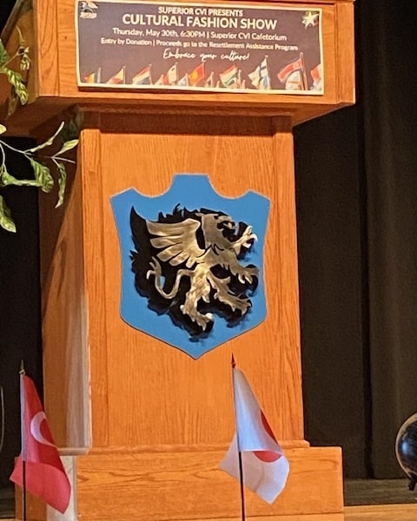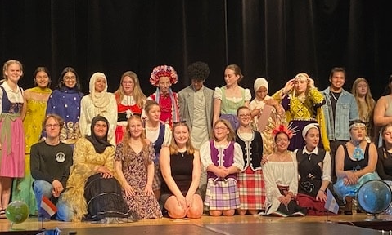

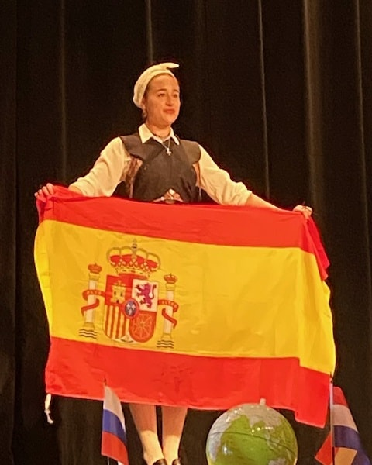

“We heard student stories about the rich traditions associated with certain clothing, and stories of resistance, empowerment, and resilience. Community members have asked that we make this a regular thing within the school board. SEEDS presented an amazing opportunity for students to connect with other leaders across the country to support the vital work of anti-racism.” Anthony Jeethan – Lakehead School District Board.

Some Kiwanis Club of Westfort members were there to see this amazing program that they helped to support.

KFC Director Roland Sabourin from Western Canada remarked that the Board Discretionary grants and the newer Community Outreach grants help Kiwanis Clubs meet the needs of their community and stay relevant to the changing needs

By supporting the Kiwanis Foundation of Canada (minimum of $15 per member donation) Clubs become eligible to receive any of the grants available from the Foundation.

