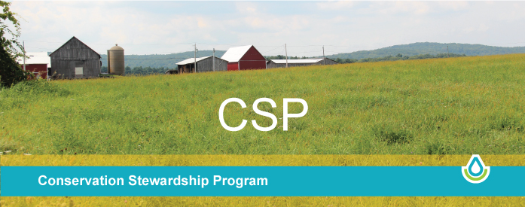

USDA announces October 21 application date for Conservation Stewardship Program
The U.S. Department of Agriculture’s Natural Resources Conservation Service (NRCS) has announced that October 21, 2022 will be the cut-off date for applications for the Conservation Stewardship Program (CSP) to be considered and ranked for 2023 funding.
CSP helps agricultural producers take the conservation activities on their farm to the next level. It provides a payment for maintaining the current conservation efforts on the land and covers part of the cost for producers implementing new conservation activities.
The program provides many benefits including increased crop yields, decreased inputs, wildlife habitat improvements and increased resilience to weather extremes. CSP is for working lands including cropland, pastureland, nonindustrial private forest land and agricultural land under the jurisdiction of a tribe.
While applications are accepted throughout the year, interested producers should submit applications to their local NRCS office by October 21, 2022, to ensure their applications are considered for 2023 funding.

Your Stewardship Goals. Our Assistance.
Have you ever looked across your property and thought about some land management goals you would like to take to the next level? Maybe we can help.
No one knows more about your land than you do, and no one knows more about conservation than we do. Together we can develop a plan tailored to your land and your goals to help you increase productivity and protect the value of your land.
Our Conservation Stewardship Program (CSP) helps you build on your existing conservation efforts while strengthening your operation. Whether you are looking to improve grazing conditions, increase crop yields, or develop wildlife habitat, we can custom design a CSP plan to help you meet those goals. We can help you schedule timely planting of cover crops, develop a grazing plan that will improve your forage base, implement no-till to reduce erosion or manage forested areas in a way that benefits wildlife habitat. If you are already taking steps to improve the condition of the land, chances are CSP can help you find new ways to meet your goals.

Sustainable Production
CSP is for working lands. It is the largest conservation program in the United States with 70 million acres of productive agricultural and forest land enrolled in CSP. Thousands of people that have made the choice to voluntarily enroll in the program because it helps them enhance natural resources and improve their business operation.
CSP participants are seeing real results. Some of these benefits include:
- Improved cattle gains per acre
- Increased crop yields
- Decreased inputs
- Wildlife population improvements
- Better resilience to weather extremes
Through CSP, we can help you build your business while implementing conservation practices that help ensure the sustainability of your entire operation. Good land stewardship not only conserves the natural resources on your farm, ranch or forest, it also provides multiple benefits to local communities, including better water and air quality and wildlife habitat, as well as food and fiber.

How does CSP Work?
If you decide to enroll in CSP, the local NRCS conservation planner will have a one-on-one consultation with you to evaluate your current management system and the natural resources on your land. Then the NRCS conservation planner will present a variety of CSP enhancement alternatives for you to consider implementing on your land, based on existing conservation practices. The variety of CSP conservation activities that are offered give you a lot of freedom to select enhancements or practices that help you meet your management goals. These improvements work naturally with your land to bring out your land’s best potential.

CSP Conservation Activities
Applicants must schedule, install and adopt at least one new conservation activity (conservation practices, enhancements, or bundles) on the operation.
Conservation practices must meet the criteria in the conservation practice standards and specifications available in the Field Office Technical Guide (FOTG).
Enhancements are a conservation activity used to treat natural resource concerns and improve producer conservation performance. Enhancement adoption results in environmental benefits that are equal to or greater than the performance level for the planning criteria identified for a given resource concern.

Eligibility/Requirements
Applicant Eligibility – Applicants may include individuals, legal entities, joint operations or Indian Tribes. All CSP applications must meet the following eligibility requirements:
- Be listed as the operator in the USDA farm records management system for the operation being offered for enrollment.
- Document that they control the land for the term of the contract and include all eligible land in their entire operation in that contract.
- Comply with highly erodible land and wetland conservation provisions and comply with Adjusted Gross Income provisions.
- Comply with tenants and sharecroppers provision.

​Land Eligibility – CSP is available to all producers, regardless of operation size or type of crops produced. Eligible lands include private and Tribal agricultural lands (crop and pasture), nonindustrial private forest land (NIPF), associated agricultural land, and farmstead. Producers must have effective control of the land for the term of the proposed contract. Contracts must include all eligible land associated with the applicants agricultural or NIPF operation.
Stewardship Threshold Eligibility – NRCS will use the Conservation Assessment Ranking Tool (CART) to determine whether or not the applicant is addressing resource concerns in order to meet the stewardship eligibility requirement.
An applicant’s conservation activities must meet or exceed the stewardship threshold for the following:
- At least two resource concerns at the time of contract offer on all land uses.
- ​At least one additional resource concern by the end of the conservation stewardship contract on at least one land use.
- Renewal applicants must meet or exceed two additional PRCs or implement new or improve existing conservation activities to achieve higher levels of conservations performance for a minimum of two priority resource concerns met or exceeded in the initial contract.
Applications for conservation practices and systems will be prioritized. High priority applications will be ranked. Applications that will result in greater environmental benefits for national, state, and/or local natural resource priorities will receive a higher score. Applications are selected for funding in ranking order.
Ranking dates and the application process are subject to change. Contact your local field office for the latest information. For more information on available programs, the application process, and natural resource priorities, visit the Massachusetts NRCS website at www.ma.nrcs.usda.gov.
NRCS has two field offices in southeastern Massachusetts:
- Wareham field office – 508-295-5151, ext. 2, serving Bristol, Norfolk and Plymouth counties

- West Yarmouth field office – 508-771-6476, serving Cape Cod and the Islands
Additional restrictions and program requirements may apply.

