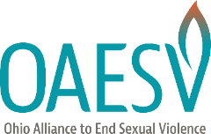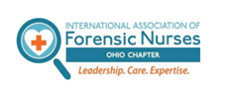
April 8, 2020
The Honorable Mike DeWine The Honorable David Yost
Governor of the State of Ohio Attorney General of the State of Ohio
77 S. High Street, 30th Floor 30 E Broad Street, 14th Floor
Columbus, OH 43215 Columbus, Ohio 43215

The Honorable Larry Obhof The Honorable Kenny Yuko
President of the Ohio Senate Minority Leader of the Ohio Senate
1 Capitol Square, 2nd Floor 1 Capitol Square, 3rd Floor
Columbus, Ohio 43215 Columbus, Ohio 43215

The Honorable Larry Householder The Honorable Emilia Strong Sykes
Speaker of the Ohio House of Representatives Minority Leader of the Ohio House
77 S High Street, 14th Floor 77 S High Street, 14th Floor
Columbus, Ohio 43215 Columbus, Ohio 43215

Re: The Ohio Alliance to End Sexual Violence and Ohio Chapter - International Association of Forensic Nurses Reiterates Opposition to “At Home Sexual Assault Kits” Amid Pandemic
Dear Governor DeWine, Attorney General Yost, President Obhof, Leader Yuko, Speaker Householder, and Leader Sykes:
In Fall 2019, coalitions and state governments nationwide condemned the production and proposed sale of “at-home sexual assault kits.” At that time, a company called MeToo Kits unsuccessfully solicited universities to distribute their product to survivors.
The company changed its name to Leda Health, and recently reinvigorated its efforts to profit from sexual violence. The company is reaching out to lobbyists and lawmakers in various states to seek protection from efforts to ban over the counter kits. Similarly, competitor Preserve Group donated kits to states for use during the COVID-19 emergency. Though these companies claim their kits will increase reporting and improve survivor outcomes, the distribution of a “Do It Yourself” kit is nothing less than manipulative and dangerous. Leda Health and its competitors seek to commercialize a medical process federal regulations mandate be free of charge for survivors in states receiving VAWA funding.

Make no mistake – donations during COVID-19 are part of a larger marketing effort that could cause substantial damage to survivors and prosecutions for decades to come.

‘We want to give our first 10,000 kits to the frontlines of COVID as a donation,’ Madison Campbell, the 24-year-old cofounder of the MeToo Kits Company, told me. “That’s how we’re going to enter the market. From a venture capital perspective, if we’re able to get these kits into the hands of folks, and it becomes something that is commonplace, we can figure out how to make money later.” … She plans to keep giving kits away unless the federal or state governments shut her down. ‘I wouldn’t be shocked if that happened,’ she adds.
We urge all relevant state actors to prohibit such kits in Ohio for the following reasons:
- The practice suggested by Leda Health is not survivor-centered. Relying upon a survivor to conduct their own medical forensic examination places an unfair responsibility on the survivor, which could lead to additional trauma.
- When a survivor seeks a medical forensic examination at an Ohio hospital, procedures that adhere to both the Ohio Department of Health’s Protocol for Sexual Assault Forensic and Medical Exams and the Office of the Ohio Attorney General’s SAFE Program are conducted by specially trained medical professionals. In a hospital, survivors are medically cleared before evidence collection takes place – a crucial step in addressing injuries incurred. Hospitals can provide necessary STI and HIV prophylaxis treatments and many refer to emergency contraception free of charge. Leda Health’s “at-home” kits are unregulated and leave survivors vulnerable to untreated injuries.
- Survivors who access care at a hospital are connected to rape crisis center advocacy, which includes emotional support and linkage to resources.
- Evidence collected and stored in an “at-home” kit is not legally sound. The results of an at-home kit would not be admissible under the rules of evidence in State or Federal Courts. No prosecutor could use “at home kit” results in any case. Law enforcement, prosecution teams, and medical professionals are continually and extensively trained in proper medical forensic examination and chain of evidence procedures.
The COVID-19 crisis heightens Leda Health and their competitors’ capacity for profit and harm. Fear of infection or confusion about continued hospital services may deter survivors from seeking a SAFE exam. An “at-home” kit is not an adequate substitute. We continue to align with the appropriate agencies and medical centers to keep advocates and survivors informed on hospitals providing appropriate care during this unprecedented time, and will continue to caution against these dangerous products through all available channels.
We believe that the practice and product promoted by Leda Health are dangerous for survivors and must be prohibited by law.
For questions, please write us at tucker-lauderman@oaesv.org.

Sincerely,
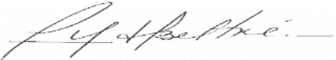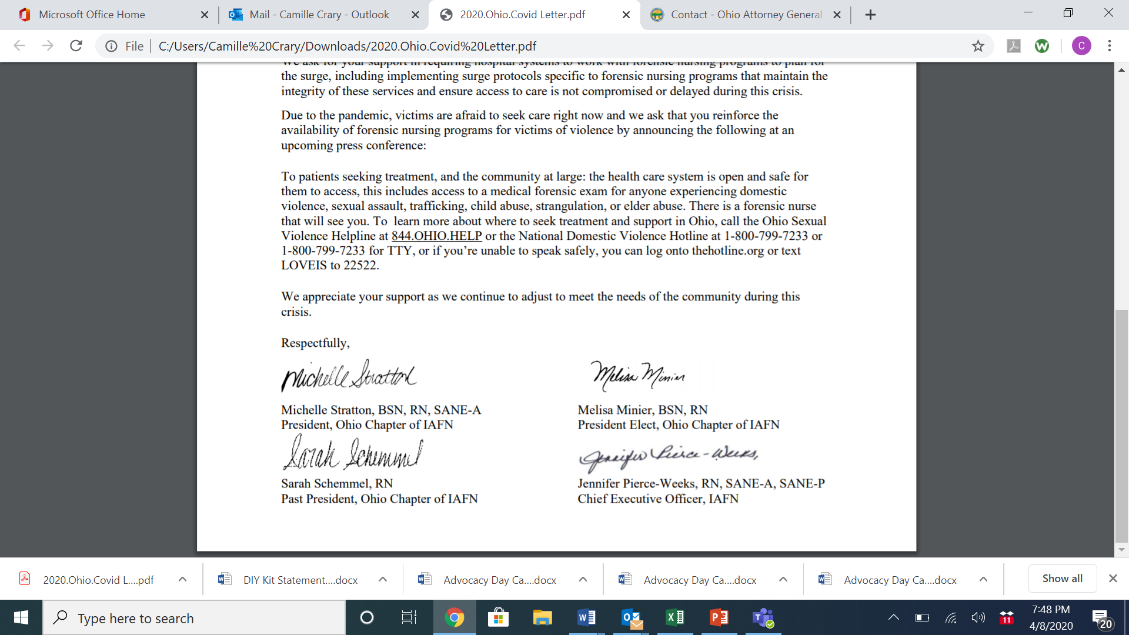
Rosa Beltré Michelle Stratton, BSN, RN, SANE-A
Executive Director President
Ohio Alliance to End Sexual Violence Ohio Chapter of IAFN
Melissa Minier, BSN, RN Sarah Schimmel, RN
President Elect Past President
Ohio Chapter of IAFN Ohio Chapter of IAFN

Madison Pauly, DIY Rape Kit Companies See the Coronavirus as their Chance for a Comeback, MotherJones (April 10, 2020), https://www.motherjones.com/politics/2020/04/diy-remote-rape-kit-coronavirus/.

