Association of NYS Youth Bureaus  INVOICE #2024YLF | 194 Washington Ave, Suite 415  Albany, NY 12210  nysyouthbureaus@gmail.com

Youth Bureau: _____________________________  Address: __________________________________  __________________________________ | BALANCE DUE  Upon Receipt  $_____

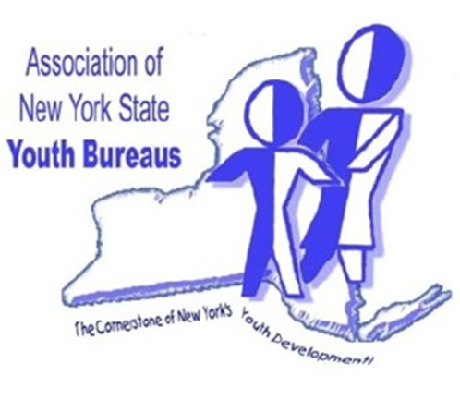
Item Description | Quantity | Price Per | Total
2024 Youth Leadership Forum  Albany, NY 2/5/2024 – 2/6/2024  (Includes 1 Adult chaperone at no charge) | # ___ Adult Registration | $ 50 | $________
2024 Youth Leadership Forum  Albany, NY 2/5/2024 – 2/6/2024  (Includes 1 Adult chaperone room at no charge) | # ___ Adult Overnight Reservation | $124 | $________
 |  | TOTAL | $________
Please make all checks payable to:
Association NYS Youth Bureaus
194 Washington Ave, Suite 415
Albany, NY 12210

Please visit us at: https://www.anysyb.com/.

