Association of NYS Youth Bureaus  INVOICE #2026YLF | 1 Park Place, Suite 300  Albany, NY 12205  nysyouthbureaus@gmail.com

Youth Bureau: _____________________________  Address: __________________________________  __________________________________ | BALANCE DUE  Upon Receipt  $_____

Item Description | Quantity | Price Per | Total
2026 Youth Leadership Forum  Albany, NY 2/2/2026 – 2/3/2026  (Includes 1 Adult chaperone at no charge) | # ___ Adult Registration | $ 75 | $________
2026 Youth Leadership Forum  Albany, NY 2/2/2026 – 2/3/2026  (Includes 1 Adult chaperone room at no charge) | # ___ Adult Overnight Reservation | $150 | $________
 |  | TOTAL | $________
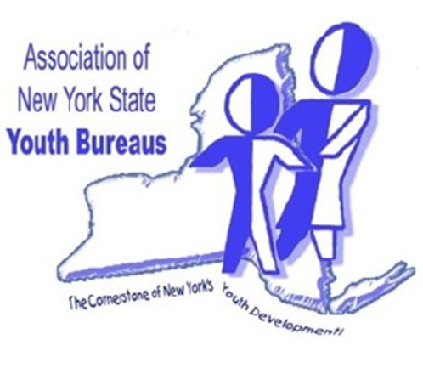
Please make all checks payable to:
Association NYS Youth Bureaus
1 Park Place, Suite 300
Albany, NY 12205

Please visit us at: https://www.anysyb.com/.

