Join the Columbian Squires
Membership is open to boys who are practicing Catholics, ages 10-18.

Meetings are held the first Sunday of each month beginning at 12:45 PM in Saint Anselm Hall. Lunch is provided.
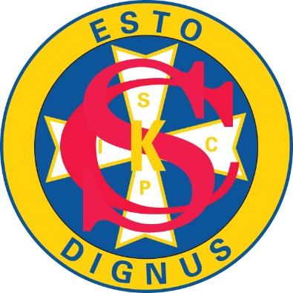
The Squires attend fun events throughout the year to religious and historical locations, as well as, going to ball games, museums, and outdoor attractions. We also participate in service projects to help Saint Benedict School and Church, as well as, Little Sisters of the Poor and Saint Francis Home.

For more information, please contact Steve Mohring at:
stevemohring@gmail.com or

(804) 615-1382

The Squires Motto: Esto Dignus: Be Worthy

