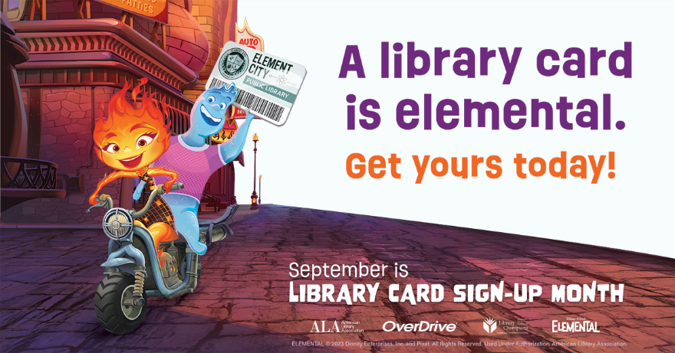

Library Card Sign-Up Month 2023 – Press Release
For immediate release
August 29, 2023
Contact:
(Monica Caruso , County Librarian, mcaruso@arlibrary.org, 828-264-8784, X 4)
Get in Your Element this Fall with a Library Card
(Boone, NC) — September is Library Card Sign-up Month, a time when the Watauga County Public Library joins the American Library Association (ALA) and libraries nationwide to remind everyone about the valuable resources available with a library card.
From borrowing books, e-books, and audiobooks to accessing NC Live , learning new skills, or attending a book club, doing a scavenger hunt or story time, a library card helps everyone do more of what they enjoy without stretching their budget.
Interested in trying a new hobby? Thinking about starting or growing a small business? New to computers and the internet? The library can help. The Watauga County Public Library has Wi-Fi and computers/printers. Make an appointment with our Adult Services staff who can help you with a computer tutorial or even just to learn how to get started with your career goals.

NC Live can be accessed with a library card anywhere you have an internet connection. With content from more than 50,000 newspapers, journals, magazines, encyclopedias, ebooks, e-audio, and streaming video titles, NC Live offers users the highest quality, most authoritative, subscription resources in the information marketplace.
Students who attend Watauga County schools can use their student ID number to check out up to ten books or audiobooks with no fines. This allows access to electronic resources also. “This is like having an extra library card and is a wonderful partnership between the schools and the Library”, says Monica Caruso, County Librarian.
There’s something for everyone at Watauga County Public Library, and signing up for a library card is the first step on the path to academic achievement and lifelong learning for students. It's elemental, really—everyone should have one!
To sign up for a library card or to learn more about the library’s resources and programs, please visit Watauga County Public Library (arlibrary.org) Sign up for an e-card here.
During September, we will give a coupon out to each person who gets a library card for a free hot chocolate while they last, courtesy of Espresso News.
Since 1987, Library Card Sign-up Month has been held each September to mark the beginning of the school year. During the month, the ALA and libraries work together in a national effort to ensure every child signs up for their own library card.

