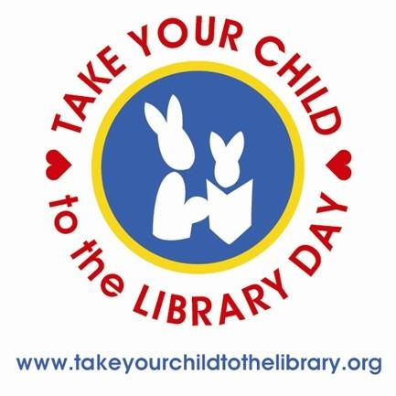 | 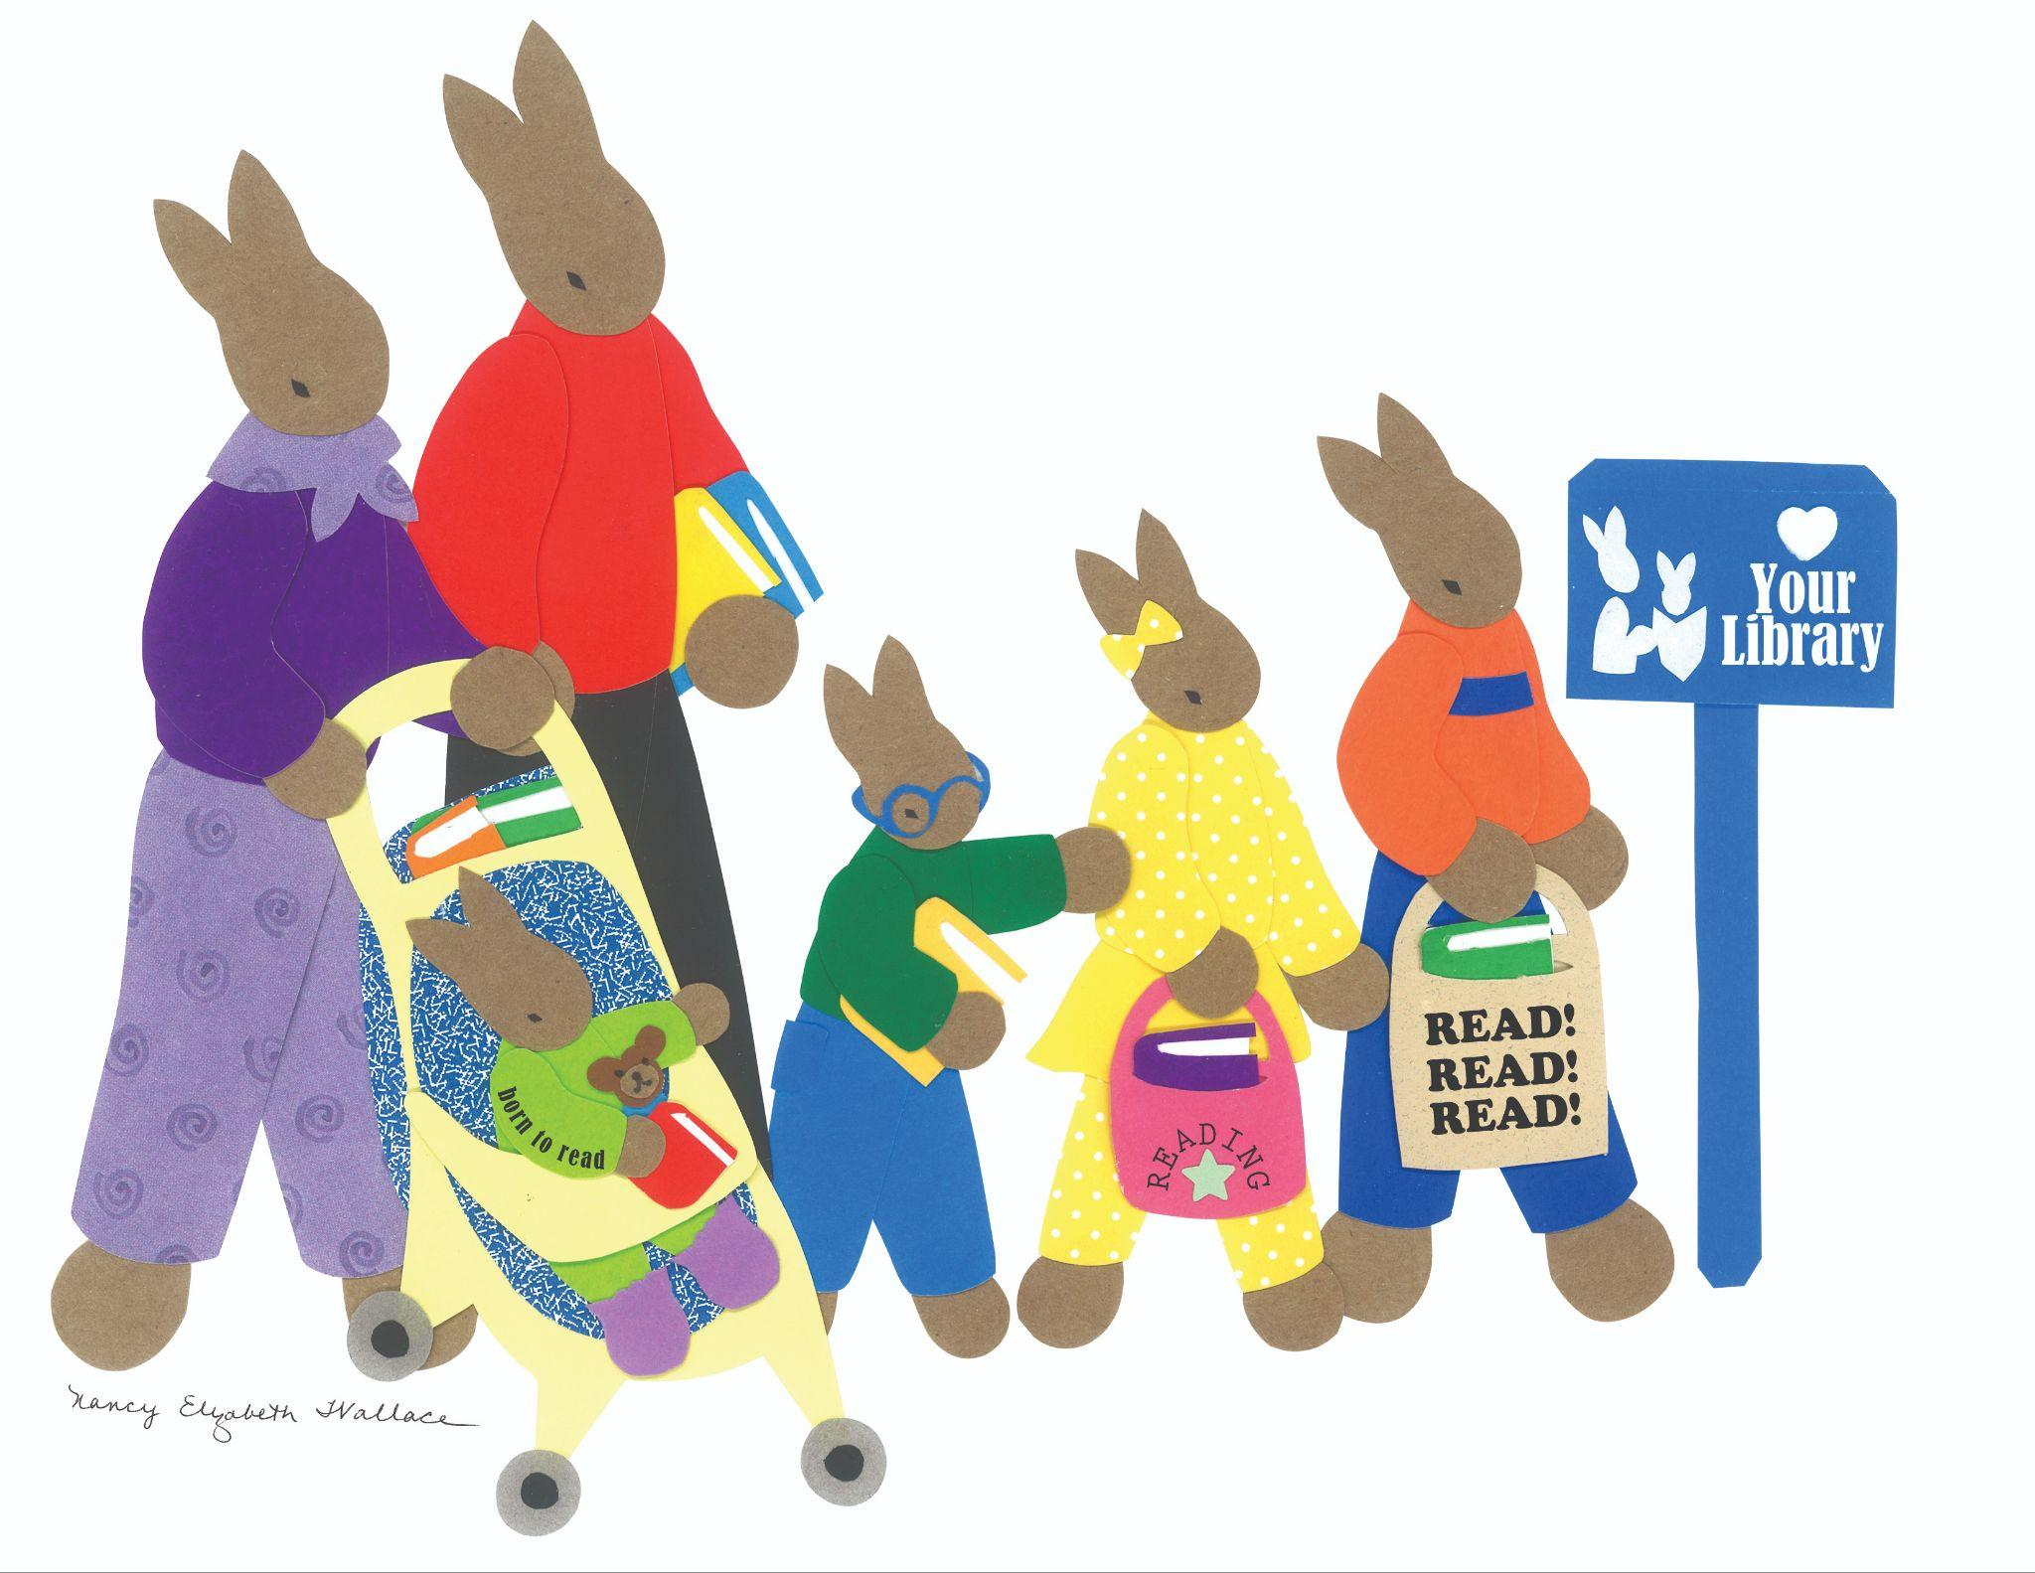 | FOR IMMEDIATE RELEASE  CONTACT:  Jennifer Earp-Johnson  828-264-8784 x 3  jearp-johnson@arlibrary.org

Watauga County Public Library Celebrates Take Your Child to the Library Day
with Free Family Events

When was the last time you took your child to the library? Or visited the library yourself? On Saturday, February 3, 2024, Watauga County Public Library, along with public libraries across the country, will celebrate the 13th annual Take Your Child to the Library Day with free events and activities for children and families.

Take Your Child to the Library Day celebrates the importance of the library in the lives of children and families. Children who are proficient in ​reading by the end of grade 3 are significantly more likely to graduate high school, ​opening doors to a bright future. Libraries help families build solid foundations of literacy and love of learning by providing access to books, early literacy story times, technology access, homework help, online resources, and fun, safe spaces to explore and grow.

For this year’s Take Your Child to the Library Day celebration, Watauga County Public Library is hosting the following special programs:

- 10 AM: Coffee and pastries before Story Time

- 11 AM – 12 PM: A special extended Family Story Time featuring books all about libraries! Special guest reader, Appalachian Regional Library Director Jacob Starks, will also join us for a story.

- 2 PM: Try It Club for ages 8-18. Try It Club will feature a “Zine Workshop” for participants to create and design a booklet or mini magazine. Registration is required; please email jearp-johnson@arlibrary.org to register.

- 3 PM: Teen Craft Workshop for ages 12-18. The craft workshop will feature book earrings. Registration is required and spots are limited to 10. Please email jearp-johnson@arlibrary.org to register and include your favorite book in the email.

- ALL DAY: Open Art Book-Making Station for all ages. Create your own book with various art supplies and a bit of imagination!

For more information about Take Your Child to the Library Day at Watauga County Public Library, email jearp-johnson@arlibrary.org or call Youth Services at 828-264-8784 x 3.

