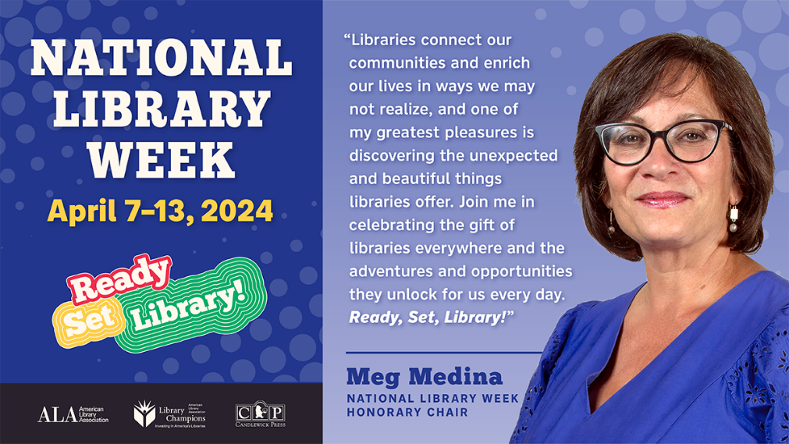

National Library Week 2024
For Immediate Release:
Contact: Monica Caruso, County Librarian, 828-264-8784 X 4, mcaruso@arlibary.org
Celebrate National Library Week April 7-13, 2024
(Boone, NC) – Watauga County Public Library encourages all community members to visit the library during National Library Week, April 7-13, to explore all they have to offer. Children’s storytime guest readers are:
- Friends’ members Karen Hodges and Geri Purpur on Tuesday, April 9 at 3:30 pm
- Olivia Burke, Lead Park Ranger for Blue Ridge Parkway Highlands District, on Wednesday, April 10 at 11 am
- Eric Plaag and Edie Tugman, Town Council Members on Thursday, April 11 at 11 am
- Friends’ member, Bettie Bond on Saturday, April 13 at 11 am
On Monday, April 8, beginning at 1:53 pm, we’ll have activities for kids, light snacks and a livestream of the eclipse in the meeting room. Maximum coverage will be around 3:11 pm. Thanks to the Friends for their support.
For adults, we have Chair Tai Chi on Monday, April 8 at 10 am; the High Country Writers will host Joseph Bathanti, local author and former NC Poet Laureate as their guest speaker on Thursday, April 11 at 10 am and Oliva Burke returns to talk about the history of the Blue Ridge Parkway at 5:30 pm.
At the Western Watauga Branch, in partnership with the Project on Aging, there will also be a Solar Eclipse Event at 1:30 pm on Monday, April 8. On Thursday April 11th, they will have a special morning storytime at 9:30 am with “The Story Lady” Sharon Clarke. Thanks to the Western Watauga Friends for their support.
Most people know about the books available at the library, from picture books and large print to audiobooks and e-books. But there's so much more available to take you to the finish line.
Libraries are welcoming spaces that bring communities together for entertainment, education, and connection through book clubs, story times, crafting classes, author talks, and more. Watauga County Public Library offers a wide array of programs, classes and resources for all ages to ensure lifelong learning, thanks to our Friends groups , the Library’s Endowment, and many other volunteers.
A few recent examples of services and programs are listed below:
- A Seed Library located adjacent to the Circulation Desk (thanks to volunteers)
- Annual shred truck
- Repair Hub
- Story times, Lego club, crochet, and other arts and crafts for children and young adults
- Tai Chi and Yoga
- Annual Free Volunteer Income Tax Assistance thanks to Appalachian State University’s Accounting Department and the Friends
- Computer tutorials by appointment
- A Book lease program that allows us to offer high demand titles
Libraries play a critical role in the economic vitality of communities by providing internet and technology access and support for job seekers, small businesses, and entrepreneurs in the community with services such as NC Live resources, the NC Cardinal consortium, referrals, tutorials, meeting space, and print and online resources.
If you haven't checked out Watauga County Public Library lately, you're missing the race. Follow our Facebook page, Instagram and the hashtag #National Library Week to join the online celebration.
First sponsored in 1958, National Library Week is a national observance sponsored by the American Library Association and libraries of all types across the country each April.
For more information, visit the library’s website at https://www.arlibrary.org/watauga
The Watauga County Public Library is located at 140 Queen Street, Boone.
Western Watauga Branch is located at 1085 Old US Highway 421, Sugar Grove.

