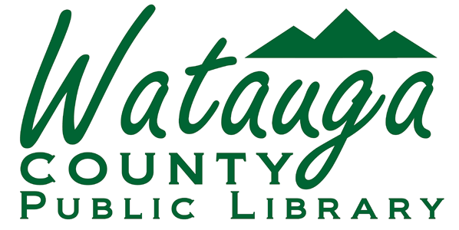

For Immediate Release
Contact: Watauga County Public Library, mcaruso@arlibrary.org
828-264-8784, X 4

LIBRARY AWARDED FEDERAL GRANT

Boone, NC
September 28, 2023

The Watauga County Public Library has been awarded a $ $34,832.00 grant with a $11,611.00 match to be used for a new outreach vehicle to serve homebound, residents at elder care facilities and for visits to events in our community, with emphasis on getting out to rural parts of the county. The vehicle and supporting technology and equipment was supported by grant funds from the Institute of Museum and Library Services under the provisions of the federal Library Services and Technology Act as administered by the State Library of North Carolina, a division of the Department of Natural and Cultural Resources (IMLS grant number LS-252476-OLS-22).

These federal funds are investments that help libraries deliver relevant and up-to-date services for their communities. At the Watauga County Public Library, the LSTA grant will be used to purchase a new outreach vehicle, laptops, a hotspot and other equipment to support the creation of library cards and for checkouts, a pop-up tent, collapsible book shelf, book giveaways, a table and chairs, and banner. All of these accessories will support library outreach this year and for years to come. Library Director Monica Caruso said, “the vehicle will be on the move in Watauga County and we hope to reach a large number of folks in some of our more rural areas by working with the schools, parks, the farmer’s market, and more. The more people know about their Library’s services, the more they can reach their goals and improve the quality of their lives.”

Watauga County Public Library received one of the 37 competitive grants for fiscal year 2022-2023 awarded to North Carolina libraries from this year’s federal allotment. The LSTA grant program administered by the State Library of North Carolina funds library projects across the state that advance excellence and promote equity by strengthening capacity, expanding access, and community engagement in North Carolina’s libraries.

The Institute of Museum and Library Services is the primary source of federal support for the nation’s 122,000 libraries and 17,500 museums. The Institute's mission is to create strong libraries and museums that connect people to information and ideas. Through the LSTA Grants to States program IMLS provides funds to State Library agencies using a population-based formula. State libraries may use the appropriation to support statewide initiatives and services; they may also distribute the funds through competitive subgrants to public and academic libraries. To learn more about the Institute, please visit www.imls.gov.

For more information about North Carolina’s LSTA program visit the State Library of North Carolina’s LSTA web page at https://statelibrary.ncdcr.gov/services-libraries/grants-libraries/lsta-grant-information or contact the State Library’s Federal Programs Consultant at 919-814-6796.

---

