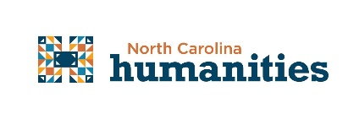

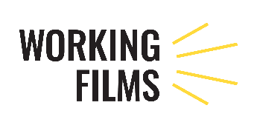

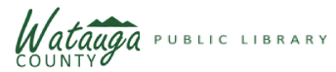

**CONTACT:**

Monica Caruso

[mcaruso@arlibrary.org](mailto:mcaruso@arlibrary.org)

828-264-8784, X 4

Melissa Giblin, NC Humanities

mgiblin@nchumanities.org

(704) 687-1520

***Revisioning Recovery Film Screening in Boone, NC***

*April 14, 2021, Boone, NC*

On April 22 at 6:30 pm, in partnership with the Watauga County Public Library, Working Films and Appalachian State University’s Sustainable Department, a film screening and discussion event sponsored by North Carolina Humanities and titled “*Revisioning Recovery: Uncovering the Roots of Disaster”* will take place.

The program features a collection of five short films that tell environmental disaster recovery stories and examine historical inequities that worsen when disasters hit. This free event will also include an interactive post-screening discussion.

Communities across North Carolina, and the United States, have faced increasing threats from climate disasters including hurricanes, wildfires, floods, and tornadoes which leave them hoping to recover before the next climate event occurs. Equitable disaster preparedness and recovery are important, especially in communities where preparation and recovery efforts have historically experienced inequities. *Revisioning Recovery* examines these inequities and explores how the issues of preparedness and recovery can become more equitable and inclusive.

These screening events will take place in eight counties across North Carolina in 2021:

Alamance, Alleghany, Macon, Nash, New Hanover, Onslow, Wake, and Watauga.

“These films show how inequities exist within the framework of disaster recovery and spread awareness which allows us to learn from mistakes that have occurred in other areas. Viewers will also learn about local environmental organizations and what they do to help our communities. Each participant will receive a resource listing via email after attending”, says Monica Caruso, County Librarian.

North Carolina Humanities and Working Films have partnered on this presentation of

*Revisioning Recovery* as part of North Carolina Humanities’ “Watershed Moments” initiative and Working Films’ *Revisioning Recovery* campaign. “Watershed Moments” programs include a Statewide Read of *The Water Knife* by Paolo Bacigalupi and *Dry* by Neal and Jarrod Schusterman as well as the statewide tour of the Smithsonian exhibit *Water/Ways*.

Learn more about NC Humanities at www.nchumanities.org. Learn more about Working Films at www.workingfilms.org .

**April 22, 2021, 6:30 pm – 8:30 pm**

RSVP at: [bit.ly/rrapril22](https://bit.ly/rrapril22?fbclid=IwAR0MdNiNAhjJdc7YUpUgX6IgPR51mxtXf_EtQBh4Z7C_TJ9OER2OYbnOxJo)

###