“The Limited Jurisdiction of the Supreme Court”
by
Stephen L. Corrigan
All copyrights reserved
When the Declaration of Independence was signed by the people residing in the thirteen American colonies, those colonies became a compound republic, a confederation of thirteen free and sovereign small republics.
Each small republic was a State body politic consisting of the residents of that State. Each State had a militia with the primary purpose to defend their State. Each State had all the rights of a republic. As a sovereign body politic, the people of each State, according to the Declaration of Independence, had the right to create a written constitution consisting of job descriptions that reflected the will of the people in their State. They then had the right and authority to enforce those job descriptions in order to protect their lives and their God given rights of life, liberty, and the pursuit of happiness. This was the form of government that existed in every state and now guaranteed to exist in every State of the Union under Article IV, Section 4 of the U.S. Constitution. According to the Declaration, any government created would be temporary and not a part of the republic. Governments would depend upon the will and support of the people and being temporary could not own any property belonging to the people of the United States.
When the Declaration was signed, each state body politic was obligated to use God’s standard for Truth. They pledged to protect one another as a republic and live by God’s standard for Truth as free men. They believed God created all men as equals and as adults wrote His laws in their minds. He then gave to each the individual capacity to interpret His laws without the aid of another human being. With this individual capacity, man had the right to form a conscience and to discriminate his actions and the actions of his neighbor. However, man’s freewill was restricted to a certain extent. He could not steal, kill, or bear a false witness against his neighbor or cause damage to his neighbor’s property.
Our founders believed that God also gave each adult a sovereign capacity. They had the right to have an active part in the body politic. Each had the right to have a part in the selection of leaders. These leaders were controlled by the use of job descriptions. This tool placed limits on leaders limiting them what they were allowed to do. This protected the two capacities of every citizen. The following illustration represents the context of what happened politically on July 4th, 1776.

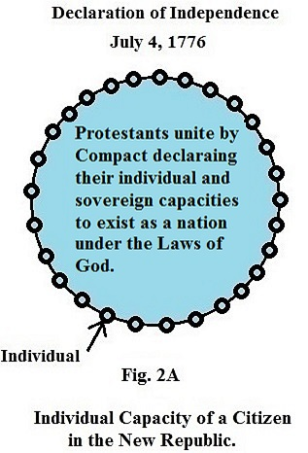

In Fig. 2A, all the men are equal with two God given capacities. The blue represents a safe place where every adult has the right to form a conscience and live by his interpretation of God’s Laws as long as he does not harm his neighbor or destroy his neighbor’s property.
The colonies also declared each state was now a sovereign State. They identified God’s laws as defining their Liberty. These laws would be the laws they would enforce when disobeyed. They pledged to defend each other with their lives, their fortunes, and their sacred honor for the right to live as free men.
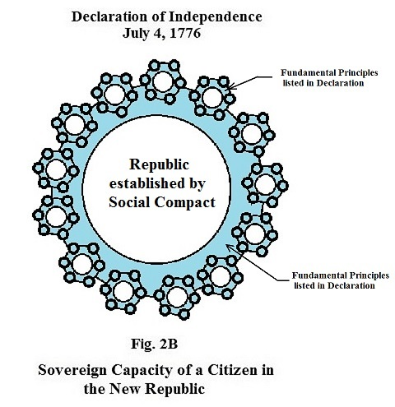

In Fig. 2B, we have an illustration of the sovereign capacity our founders believed they had coming from God as long as they used His standard for Truth. They believed each colony was now a free and sovereign State body politic, where each State body politic had the right to create a government by the use of a written constitution.
Unlike other forms of government where the people have no say in how they are governed, our founders created a new tool in their constitutions. This new tool for the people was the use of job descriptions to tell the elected their limited authority to govern. The elected had to swear to abide by their job description. If they did not, the people who elected them had the right at any time to fire that person and elect another.
Because the Republic was Free Protestant and founded upon the liberty principle of self government, no government created could pass a law concerning the conscience. Being able to form a conscience and restricted only by God’s Laws of Liberty allowed every individual to make decisions and act upon them without the fear of being penalized by a government. Thomas Jefferson said:
"The error seems not sufficiently eradicated that the operations of the mind as well as the acts of the body are subject to the coercion of the laws. But our rulers can have no authority over such natural rights, only as we have submitted to them. The rights of conscience we never submitted, we could not submit. We are answerable for them to our God. The legitimate powers of government extend to such acts as are injurious to others." (Thomas Jefferson quoted from "Jefferson Himself" edited by Bernard Mayo, p.81, University Press of Virginia).
If all constitutions in America do not allow the resulting governments to pass laws concerning the right of conscience of all individuals, then how could that limit be illustrated on paper? Because God designed us to think in pictures not words, I have drawn this law mechanical to help the mind better understand the limits of all government in America concerning the conscience.
The next illustration, Fig. 4A represents both the individual capacity and the sovereign capacity of the people. The individual capacity is represented by the areas in blue where the individual is free to form a conscience and limited only by God’s Laws for Liberty. He then has the right to use his conscience and discriminate his actions and the actions of his neighbors. He then has the right to make decisions to support or reject what he sees and hears. This thinking process is called “common sense”.
The sovereign capacity of the individual is illustrated by the colored area in the center of each State. It represents a written constitution by the people, a sovereign body politic. It represents their consent and not the consent of their representatives. Each State has a different constitution representing job descriptions describing the areas the people of that state will obey and support. Although each is different, there is one thing common in all. There are no job descriptions where the people give their consent to their governments to pass laws concerning their rights of conscience.

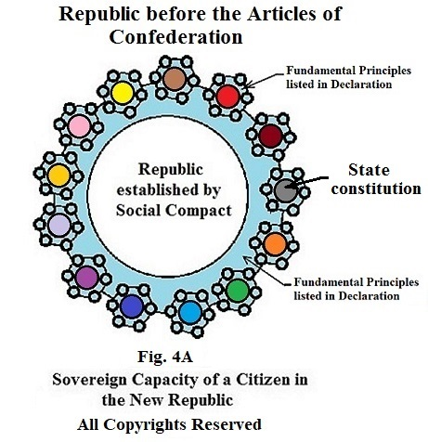

In 1787, the U.S. Constitution was passed by the State body politic and not there state governments. It was a federal constitution giving the federal government the right to govern the States, but not the people in the States.
This is the preamble in our federal U.S. Constitution:
“WE THE PEOPLE of the United States, in Order to form a more perfect Union, establish Justice, insure domestic Tranquility, provide for the common defence, promote the general Welfare, and secure the Blessings of Liberty to ourselves and our Posterity, do ordain and establish this Constitution for the United States of America.”
Fig. 5 is a mechanical illustration of the context of the U.S. Constitution. It represents the limits placed on it by “We the People of the United States.”

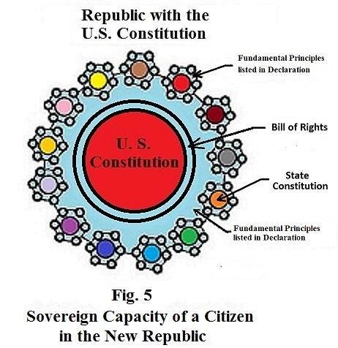

When it states “We the people of the United States” it means the people of the thirteen sovereign state body politics. Since the Civil War, there has been a movement in the government to erase the three previous illustrations from our history. The Supreme Court no longer recognizes the Declaration as the founding of this republic. It recognizes the U.S. constitution as the founding document. There are no laws which identify a standard for truth. There is no mention of the rights of conscience of individuals or their right to discriminate their actions or the actions of others. There is no mention of God or a standard concerning what is right or wrong conduct. The people have been conditioned to think the federal constitution is a national constitution. How many conservative groups have “We the People” in the name of their group or organization.
If there were areas in the U.S. Constitutions that resulted in a controversy when the government told the people how to treat their neighbor and how to use their property, it would finally be presented in the Supreme Court. Let’s see if the State body politics (We the people of the United States) gave their Supreme Court the right or authority to hear those cases when defining the limits of their jurisdiction.
The following is found in Article III, SECTION 2 of the U.S. Constitution. It states the following:
1 The judicial Power shall extend to
- all Cases, in Law and Equity, arising under this Constitution, the Laws of the United States, and Treaties made, or which shall be made, under their Authority;
- all Cases affecting Ambassadors, other public Ministers and Consuls;
- all Cases of admiralty and maritime Jurisdiction;
- Controversies to which the United States shall be a Party;
- Controversies between two or more States;
a. between a State and Citizens of another State; 10
b. between Citizens of different States,
c. between Citizens of the same State claiming Lands under Grants of different States, and between a State, or the Citizens thereof, and foreign States, Citizens, or Subjects.
2 all Cases affecting Ambassadors, other public Ministers and Consuls, and those in which a State shall be Party, the Supreme Court shall have original Jurisdiction.
In all the other Cases before mentioned, the Supreme Court shall have appellate Jurisdiction, both as to Law and Fact, with such Exceptions, and under such Regulations as the Congress shall make.
3 The Trial of all Crimes, except in Cases of Impeachment, shall be by Jury; and such Trial shall be held in the State where the said Crimes shall have been committed; but when not committed within any State, the Trial shall be at such Place or Places as the Congress may by Law have directed.
The U.S. Constitution is a federal constitution and not a national constitution.
You will notice the Supreme Court and its inferior courts do not have any authority to handle any cases inside a state between two or more people. The Supreme Court is a federal court and is limited to controversies between States. They have no authority to hear criminal appeals. Inferior courts cannot be created and given greater power that was not given to the Supreme Court.
The U.S. Constitution was written as a federal constitution and not a national constitution. It was written to secure or protect the Blessings of liberty from God. The Supreme Court has no authority to deny or void the restrictions placed on mankind by God. Nowhere in the Constitution does it give the federal government the right to specify conduct for individuals telling them how to treat their neighbor or how to use their property.
The federal government cannot interfere with politics within any State. They have to recognize the sovereignty of a State which is a small republic. A republican form of government means each state body politic has the right to form a government and operate as a republic without interference from the federal government.
From the very beginning States, being a republic, have the responsibility of deciding who can become a citizen of their State and who has the right to vote.
Concerning elections, Article 1, SECTION 4 states: 1The Times, Places and Manner of holding Elections for Senators and Representatives, shall be prescribed in each State by the Legislature thereof.
Concerning naturalization, each State has control of that process. They decide who becomes a member of their State. After the Declaration was signed, each state had a process for naturalization. Every State had a naturalization process for someone to become a citizen of their state. The body politic required one had to pledge allegiance to the body politic of that State to protect them and to support and stand for the fundamental principles in the Declaration. The congress in each state was allowed by the body politic to add some conditions.
In order to have a naturalization process be more uniform among the sovereign states, the people wrote the following in Article I, Section 8. Clause 4. It stated that Congress shall have the power “To establish an uniform Rule of Naturalization, .…throughout the United States;” It did not give Congress the power to naturalize none citizens to make the process the same in every State.
All the job descriptions in the U.S. Constitution were designed to be applied to govern the States and not the people in the States.
As long as a majority of the people in America believes that “We the People” wrote a national Constitution, you will have the elected in the federal government telling you how you are to treat your neighbor and how you are to use your property. The only real freedom you will have is voting for the master you wish to obey.
No federal judge has the right to interfere with the politics within a State. Article IV, Section 4, states:
“The United States shall guarantee to every State in this Union a Republican Form of Government, and shall protect each of them against Invasion;”
They have no right to mess with the right of conscience of individuals. The 9th amendment states: “The enumeration in the Constitution, of certain rights, shall not be construed to deny or disparage others retained by the people.”
I have shown you in this article how the people of each body politic in the new republic became a politic by compact and how they established the Laws of God as there standard for Truth. I have shown you how the people as a body politic keeps control of the government they create by the use of a new tool called a job description. Each elected leader must swear to fulfill that job description. His sworn consent gives the people the right to fire and replace him if he does not fulfill his promise to the people.
I have shown you the context of the U.S. Constitution as created by our founders. The Supreme Court has become a place where they write laws from the bench which give rights to those groups who openly appose God and His Laws for conduct saying we cannot discriminate their conduct.
Alexander Hamilton, in letter #33 of the Federalists papers, warns the American people how the federal government could interfere with the rights of the people in a sovereign State. The following is that warning:
“If individuals enter into a state of society the laws of that society must be the supreme regulator of their conduct. If a number of political societies enter into a larger political society, the laws which the latter may enact, pursuant to the powers entrusted to it by its constitution, must necessarily be supreme over those societies, and the individuals of whom they are composed. It would otherwise be a mere treaty, dependent on the good faith of the parties, and not a government; which is only another word for POLITICAL POWER AND SUPREMACY. But it will not follow from this doctrine that acts of the larger society which are not pursuant to its constitutional powers but which are invasions of the residuary authorities of the smaller societies will become the supreme law of the land. These will be merely acts of usurpation and will deserve to be treated as such. Hence we perceive that the clause which declares the supremacy of the laws of the Union, like the one we have just before considered, only declares a truth, which flows immediately and necessarily from the institution of a Federal Government. It will not, I presume, have escaped observation that it expressly confines this supremacy to laws made pursuant to the Constitution; which I mention merely as an instance of caution in the Convention; since that limitation would have been to be understood though it had not been expressed.”

Hamilton wasn’t the only one to tell the people about the proper context of the new U.S. Constitution. The following is a portion of an opinion delivered by Chief Justice Marshall in the case Marbury v. Madison. It should be read by the elected leaders in every State to remind them that they work for the people; that they are public servants of the people who elected them.

Chief Justice Marshall states:
"That the people have an original right to establish, for their future government, such principles as, in their opinion, shall most conduce to their own happiness, is the basis, on which the whole American fabric has been erected. The exercise of this original right is a very great exertion; nor can it, nor ought it to be frequently repeated. The principles, therefore, so established, are deemed fundamental. And as the authority, from which they proceed, is supreme, and can seldom act, they are designed to be permanent. "
"This original and supreme will organizes the government, and assigns, to different departments, their respective powers. It may either stop here; or establish certain limits not to be transcended by those departments. "
"The government of the United States is of the latter description. The powers of the legislature are defined, and limited; and that those limits may not be mistaken, or forgotten, the constitution is written. To what purpose are powers limited, and to what purpose is that limitation committed to writing, if these limits may, at any time, be passed by those intended to be restrained? The distinction, between a government with limited and unlimited powers, is abolished, if those limits do not confine the persons on whom they are imposed, and if acts prohibited and acts allowed, are of equal obligation. It is a proposition too plain to be contested, that the constitution controls any legislative act repugnant to it; or, that the legislature may alter the constitution by an ordinary act. "
"Between these alternatives there is no middle ground. The constitution is either a superior, paramount law, unchangeable by ordinary means, or it is on a level with ordinary legislative acts, and like other acts, is alterable when the legislature shall please to alter it. "
"If the former part of the alternative be true, then a legislative act contrary to the constitution is not law: if the latter part be true, then written constitutions are absurd attempts, on the part of the people, to limit a power, in its own nature illimitable. "
"Certainly all those who have framed written constitutions contemplate them as forming the fundamental and paramount law of the nation, and consequently the theory of every such government must be, that an act of the legislature, repugnant to the constitution, is void."
"...It is emphatically the province and duty of the judicial department to say what the law is. Those who apply the rule to particular cases, must of necessity expound and interpret that rule. If two laws conflict with each other, the courts must decide on the operation of each."
Chief Justice Marshall

We think in pictures not words. I have illustrated mechanically every principle listed in the Declaration of Independence and the limits of both state and federal government in our compound republic using constitutions. The book is entitled “The Birth of the Republican Form of Government” by Stephen L. Corrigan. You can order it on Amazon or at any bookstore or go to my website https://youtu.be/EMTtscLOJeA

Stephen Corrigan contact 513-505-4616
Submitted by Frank D Lovell 978-850-2299 americanpatriotnow@yahoo.com

