“ The Limited Jurisdiction of the Federal Government”
by
Stephen L Corrigan
On July 4, 1776, the American colonies under the Common law of England, declared their independence from England and that Common Law. When the representatives of the people, as thirteen separate sovereign body politics, signed the Declaration, they became a compound republic with each adult having two capacities, individual and sovereign. The following two illustrations illustrate those two capacities.
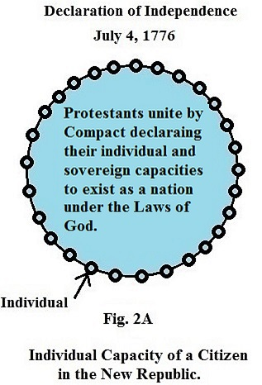
In Fig. 2A, the blue represents a republic of Free Protestants where each adult has the right to form a conscience and live according to that conscience without any government restricting that right.
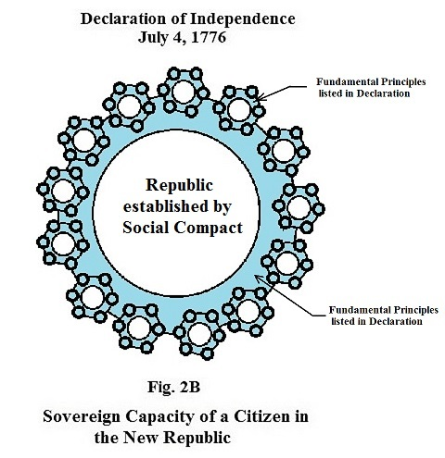
Fig. 2B represents the sovereign capacity of the people of each state, as a compound republic, to create written job descriptions for their elected leaders. The new Republic was formed without having a government in a single State. Because of each citizen’s pledge to become a member of his state, each adult had the responsibility to governed himself according to the Laws of liberty written by God on his mind. His free will, however, was restricted to a certain extent. He could not steal, kill, or bear a false witness against his neighbor or destroy his property. God also gave to each adult the capacity to understand those laws without the aid of another human being.
Thomas Jefferson stated the following defining the limits of any government in every State of the new Republic.

Extract from Thomas Jefferson’s Notes on the State of Virginia
“The error seems not sufficiently eradicated, that the operations of the mind, as well as the acts of the body, are subjects to the coercion of the laws. But our rulers can have authority over such natural rights only as we have submitted to them. The rights of conscience we never submitted, we could not submit. We are answerable for them to our God. The legitimate powers of government extend to such acts only as are injurious to others. But it does me no injury for my neighbor to say there are twenty gods, or no god. It neither picks my pocket nor breaks my leg.”
No government in any state was allowed by a body politic to make a law affecting any individual’s right of conscience. I have illustrated how every adult’s right of conscience is protected and how all levels of government in every state are limited.
The following illustration Fig. 4A illustrates what each State looked like with a written constitution. None of these state constitutions allowed the governments that were created, to pass any laws dealing with the rights of conscience. It represents the Republic before the Articles of Confederation was signed. Every adult’s right of conscience is protected no matter what State he is in. To make sure the elected knew what the right of conscience meant, the first law schools, Harvard, Princeton, and Yale, were Protestant seminaries.

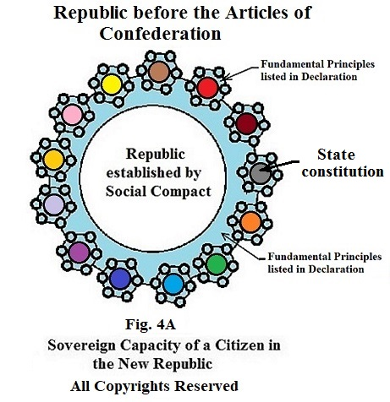

The first attempt to create a federal government failed. This was the Articles of Confederation.
In Article I, of the Articles of the Confederation, the united sovereign States agreed that the name of the Republic would be “The United States of America”.
In Article II, they reaffirm the right of each State to be a small sovereign republic. They reinforce this principle by stating all authority not delegated to the federal government in these Articles of Confederation would remain with the sovereign States.
When the people of the colonies signed the Declaration, they entered a social compact stating they had two capacities. These two capacities consisted of having an individual capacity to form a conscience based upon their interpretation of God’s Laws and a sovereign capacity to be a part of a body politic to write a written constitution to protect their first capacity.
When they signed the Articles of Confederation, it was a federal compact where the constituents were the people, in their sovereign capacity as State body politics. Any constitution created by them would govern the sovereign State body politics, the constituents, and not the adult residents in the States.
So in Article III, they define their loyalty to each other as State body politics and their common purpose or goal, thus identifying their confederation as a league of friendship. The following is the text of those three articles.

“I. The Stile of this Confederacy shall be "The United States of America".

II. Each state retains its sovereignty, freedom, and independence, and every power, jurisdiction, and right, which is not by this Confederation expressly delegated to the United States, in Congress assembled.

III. The said States hereby severally enter into a firm league of friendship with each other, for their common defense, the security of their liberties, and their mutual and general welfare, binding themselves to assist each other, against all force offered to, or attacks made upon them, or any of them, on account of religion, sovereignty, trade, or any other pretense whatever. “

Let me pause for a moment and explain what just happened. In a Free Protestant body politic, each individual respects the other as an equal. They bond themselves together by a social compact as a body politic. The first body politic was formed by the Mayflower Compact. Today, members of all body politics create a written constitution, consisting of job descriptions which will be filled by members of the body politic when elected. The elected are considered to be public servants of the body politic. Because all governments consist of the members of the body politic, the members do not become a separate entity. It is a group of temporary positions with job descriptions.

Because the States identified their compact as being federal, all three articles refer to the body politics, the constituents, and not to the individuals in the States. The States and not the people in the States are the constituents of any feature government created.

Everything was going great until Article VIII. Article VIII gave the federal government the right to know the assets of individuals inside the sovereign States. States soon realized they had no way of seeing that Article II was respected by the federal government.
Some of the States, after the signing, realized that if Article VIII was enforced, the States would no longer be sovereign because the federal government would have the right to specify conduct to the people inside a State.
Alexander Hamilton said: “He who controls the purse, control the person.” Hamilton, in letter #33 of the Federalist Papers, also warned about the dangers of a tyrannical government. Here is a portion of that letter.

“If individuals enter into a state of society, the laws of that society must be the supreme regulator of their conduct. If a number of political societies enter into a larger political society, the laws which the latter may enact, pursuant to the powers entrusted to it by its constitution, must necessarily be supreme over those societies, and the individuals of whom they are composed. It would otherwise be a mere treaty, dependent on the good faith of the parties, and not a government, which is only another word for POLITICAL POWER AND SUPREMACY. But it will not follow from this doctrine that acts of the large society which are not pursuant to its constitutional powers, but which are invasions of the residuary authorities of the smaller societies, will become the supreme law of the land. These will be merely acts of usurpation, and will deserve to be treated as such.” “Hence we perceive that the clause which declares the supremacy of the laws of the Union, like the one we have just before considered, only declares a truth, which flows immediately and necessarily from the institution of a federal government. It will not, I presume, have escaped observation, that it expressly confines this supremacy to laws made pursuant to the Constitution; which I mention merely as an instance of caution in the convention; since that limitation would have been to be understood, though it had not been expressed.”
When the federal government could not collect the taxes from the people and saw the people were rebelling, an amendment was created. Under this amendment the federal taxes in each State had to be collected by the States and not the federal government. The amendment did not pass. The following is what the republic looked like under the Articles of Confederation.

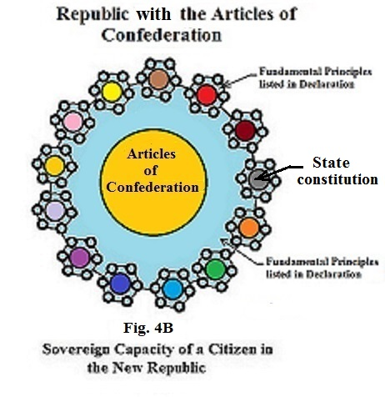
When the U.S. Constitution was written, the exact text that was in the amendment that failed to amend the Articles of Confederation, was the exact text that was placed in the U. S. Constitutions. When Congress reaffirmed the Northwest Ordinance, after the signing of the U. S. Constitution, they declared that form of taxation was a fundament principle of the original compact.
You will now be able to understand the meaning or context of Thomas Jefferson when he was trying to convey the following to the Danbury Baptist Association. This was an association of Free Protestants who were worried that this new federal constitution might override or cancel the protection of the individual’s rights of conscience in the republican form of government existing in each of the States. Here is the essence of that Jefferson’s letter; to the Danbury Baptist Association:
“Believing with you that religion is a matter which lies solely between Man & his God, that he owes account to none other for his faith or his worship, that the legitimate powers of government reach actions only, & not opinions, I contemplate with sovereign reverence that act of the whole American people which declared that their legislature should “make no law respecting an establishment of religion, or prohibiting the free exercise thereof,” thus building a wall of separation between Church & State. adhering to this expression of the supreme will of the nation in behalf of the rights of conscience, I shall see with sincere satisfaction the progress of those sentiments which tend to restore to man all his natural rights, convinced he has no natural right in opposition to his social duties.”
Each adult had the social duty, as a citizen of his State, to treat his brothers as equals and restrict his actions according to God’s Laws defining this liberty.
Now we come to the illustration that describes the context of the U.S. Constitution. Fig.5 represents the context of the U.S. Constitution.
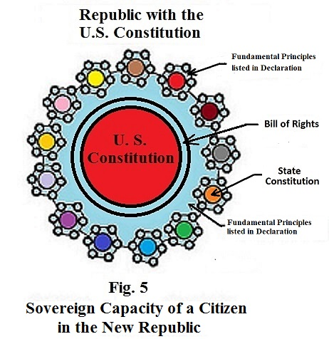

The red represents the U.S. Constitution. The preamble to the Constitution begins identifying the entities that have the authority to write the Constitution, “We the People of the United States”. Without writing another word, we know that the Constitution is federal and not national because it is all the people of each State in their sovereign capacities, who have given their consent to the text of this Constitution. As we go on further, we find that this Constitution was written to protect the goals of the League of friendship as stated in the Articles of the Confederation.
ARTICLE I, SECTION 1 of the Constitution declares: “All legislative Powers herein granted shall be vested in a Congress of the United States, which shall consist of a Senate and House of Representatives.
SECTION 8 declares the limited power that has been given to Congress to govern the States and not the people in the States. The only individuals that the States give Congress the power to regulate is the people in the federal government. ARTICLE 1, SECTION 8, CLAUSE 14, states Congress has the power “To make rules for the government and Regulations of the land and naval Forces.”
If you back up and look at clause 4 of SECTION 8, you will see the federal government does not have the power to be in charge of the Naturalization process. Clause 4 states the following concerning naturalization. Congress shall have power “To establish an uniform Rule of Natuallization, and uniform laws on the subject of bankruptcies throughout the United States.”
Uniform means “the same” throughout the States. Each State should still be in control of who becomes a citizen of their State. I don’t think the federal government can construe in this job description that they have the right to be involved with the Naturalization of an individual or the bankruptcy of an individual without crossing the line established by it being a federal Constitution. The ninth amendment clearly states:
“The enumeration in the Constitution, of certain rights, shall not be construed to deny or disparage others retained by the people.”
Finally, in ARTICLE III, SECTION 3, THE People of the States describe the jurisdiction of the Supreme Court. It list nine areas that the Court can hear. In none of areas, does it give the Court the right to hear cases concerning an individual with legal problems in his State. The Court does not have the authority to hear felony cases or appeals from individuals from a State. Each State is a small Republic with the sovereignty ability to govern the people in their State.
In all courts of law, the right of conscience of an individual must be respected. No one in the justice system has the right to violate a citizen’s right of conscience. There is no better proof than when a person takes the standard to give a testimony as a witness. The court does not have the authority to require the individual to tell the truth. The court must ask if they will swear to tell the truth. It is not until he gives his consent to telling the truth can he be held accountable. It is not a tradition when sworn in. It is a law referred to as the principle of consent and required. If the court cannot require an individual to tell the truth, they cannot require an individual to appear in court to testify. There is only one reason the court can use a subpoena to require someone to testify. The request cannot be initiated by the court. It must be requested by the accused in a criminal case. The 6th amendment states:
“In all criminal prosecutions, the accused shall enjoy the right to a speedy and public trial, by an impartial jury of the State and district wherein the crime shall have been committed, which district shall have been previously ascertained by law, and to be informed of the nature and cause of the accusation; to be confronted with the witnesses against him; to have compulsory process for obtaining witnesses in his favortes that in all criminal cases .
No one in the legislative branch of the federal government nor anyone in the federal court system has the right to issue a search warrant or a subpoena to anyone inside a state. No one in the federal government can issue a mandate or create a law for a citizen of a State. The federal government does not have the authority to regulate the conduct of an individual or a business inside a sovereign State.
At the time of the writing of the U.S. Constitution, the only legal documents that where mainly used were Blackstone’s Commentary on Law and the King James Version of the Bible. Blackstone’s Commentary was based upon the Bible and written to justify the way the people were governed by Parliament.
Our founders were Free Protestant. Because the Parliament in England was patterned after the Roman Catholic Church, Congress hired a friend of Jefferson to right a commentary on parts of Blackstone’s Commentary. The following is a portion from Tucker’s Commentary on Blackstone’s Commentary on Law describing the context of all constitutions in America. Tucker’s commentary is seen as footnotes 10 and 11 on what Blackstone claims to be true. The following is a portion taken from Blackstone’s Commentaries with Notes from St. George Tucker/
SECTION THE SECOND.
OF THE NATURE OF LAWS IN GENERAL.
"How the several forms of government we now see in the world at first actually began, is matter of great uncertainty, and has occasioned infinite disputes.”

“It is not my business or intention to enter into any of them. However they began, or by what right soever they subsist, there is and must be in all of them a supreme, irresistible, absolute, uncontrolled authority, in which the jura summi imperii or the rights of sovereignty, reside. And this authority is placed in those hands, wherein (according to the opinion of the founders of such respective states, either expressly given, or collected from their tacit approbation) the qualities requisite for supremacy, wisdom, goodness, and power, are the most likely to be found."
"The political writers of antiquity will not allow more than three regular forms of government; the first, when the sovereign power is lodged in an aggregate assembly consisting of all the free members of a community, which is called a democracy; the second, when it is lodged in a council, composed of select members, and then it is stiled an aristocracy; the last, when it is entrusted in the hands of a single person, and then it takes the name of a monarchy. All other species of government, they say, are either corruptions of, or reducible to, these three."
“By the sovereign power, as was before observed, is meant the making of laws; for wherever that power resides, all others must conform to, and be directed by it, whatever appearance the outward form and administration of the government may put on. For it is at any time in the option of the legislature to alter that form and administration by a new edict or rule, and to put the execution of the laws into whatever hands it pleases; by constituting one, or a few, or many executive magistrates: and all the other powers of the state must obey the legislative power in the discharge of their several functions, or else the constitution is at an end.[10]"

Tucker's Commentary on Blackstone's Commentary:
"[10] 5. In a former note, (Appendix, note A,) we endeavoured to shew that this maxim does not apply to the governments of the American Stales; by whose respective Constitutions, as also by the Constitution of the Federal Government, the legislative power is restrained within certain limits, both in the Federal and State Governments, which neither the Congress, nor the State Legislatures can transgress, without an absolute breach of the Constitutions from whence the Legislative Authority is derived. For, both the Federal, and State Constitutions derive their authority and existence from the immediate act, and consent of the people, "in whom" as our bill of rights expresses it, "all power is vested, and consequently, is derived from them." These acts of the people having, then, the stamp of primitive authority, must be paramount to the act of the Legislative body, which derives its authority, and even its existence from that origin."
"[11] And since the powers of the Legislature are thus limited, it follows that the Jura summi imperii, or that supreme, irresistible, absolute, uncontrolled authority, of which the commentator makes mention in a preceding paragraph, doth not reside in the legislature, nor in any other of the branches of the Government, nor in the whole of them united. For if it did reside in them, or either of them, then would there be no limits, such as may be found in all the American Constitutions, to the powers of Government. The existence of such limits proves the existence of an higher power elsewhere; that is, in the PEOPLE; in whom, and in whom, only, the rights of sovereignty remain: the people, therefore, only, and not the Legislature, have it at any time in their option to alter the form and administration of Government, by a new edict or rule, and to put the execution of their authority into whatever hands they please: and all the powers of the State, the Legislature as well as the rest, must obey them in the execution of their several functions, or the Constitution will, indeed, be at an end. For the Constitution is a law to the Government, 'which derives its just powers therefrom, as from the consent of the governed, for whose benefit that power is entrusted, and by whom, whenever it is abused, or exceeded, it may be revoked, and a new government instituted.' See the American Declaration of Independence, July 1776."

Tucker also wrote the following about the nature of the U.S. Constitution.

Tucker's Blackstone

Volume 1 — Appendix
Note D

[Section 2 — Nature of U.S. Constitution; manner of its adoption (cont.)]
5. “It is a written contract; considered as a federal compact, or alliance between the states, there is nothing new or singular in this circumstance, as all national compacts since the invention of letters have probably been reduced to that form: but considered in the light of an original, social, compact, it may be worthy of remark, that a very great lawyer, who wrote but a few years before the American revolution, seems to doubt whether the original contract of society had in any one instance been formally expressed at the first institution of a state ²⁰; The American revolution seems to have given birth to this new political phenomenon: in every state a written constitution was framed, and adopted by the people, both in their individual and sovereign capacity, and character. By this means, the just distinction between the sovereignty, and the government, was rendered familiar to every intelligent mind; the former was found to reside in the people, and to be unalienable from them; the latter in their servants and agents: by this means, also, government was reduced to its elements; its object was defined, it's principles ascertained; its powers limited, and fixed; its structure organized; and the functions of every part of the machine so clearly designated, as to prevent any interference, so long as the limits of each were observed.”

Application of the above fundamental principles is illustrated by the People of the State of New York when they wrote their 1st State constitution, creating a republican form of government in their State.
A subpoena is a tool use by the court to require a person to appear against his will. It is a tool in the Common Law of England used by Parliament. It, along with search warrants without sworn statements of a crime, are repugnant to the consent principle in a republican form of government. It was used in the colonies under the Common L.aw. Here is what the People said immediately after they became a member of the Republic. It is found in Article XXXV of their 1st State constitution describing the protection of the individual capacity.
Article XXXV. And this convention doth further, in the name and by the authority of the good people of this State, ordain, determine, and declare that such parts of the common law of England, and of the statute law of England and Great Britain, and of the acts of the legislature of the colony of New York, as together did form the law of the said colony on the 19th day of April, in the year of our Lord one thousand seven hundred and seventy-five, shall be and continue the law of this State, subject to such alterations and provisions as the legislature of this State shall, from time to time, make concerning the same. That such of the said acts, as are temporary, shall expire at the times limited for their duration, respectively. That all such parts of the said common law, and all such of the said statutes and acts aforesaid, or parts thereof, as may be construed to establish or maintain any particular denomination of Christians or their ministers, or concern the allegiance heretofore yielded to, and the supremacy, sovereignty, government, or prerogatives claimed or exercised by, the King of Great Britain and his predecessors, over the colony of New York and its inhabitants, or are repugnant to this constitution, be, and they hereby are, abrogated and rejected. And this convention doth further ordain, that the resolves or resolutions of the congresses of the colony of New York, and of the convention of the State of New York, now in force, and not repugnant to the government established by this constitution, shall be considered as making part of the laws of this State; subject, nevertheless, to such alterations and provisions as the legislature of this State may, from time to time, make concerning the same.

Because the people of New York included the Declaration of Independence in their Constitution, all parts of the Common Law of England that are repugnant to their State Constitution and the Declaration of Independence are now unconstitutional and are to be rejected.
If you want to see a complete set mechanical illustrations of the principles referred to in this paper and see mechanical illustrations of each stage of development of this nation, get my book entitled “The Birth of the Republican Form of Government” by Stephen L. Corrigan. I have a website where you may order it. It is in all bookstores. https://youtu.be/EMTtscLOJeA

