Christmas/Easter, the Religious Exemption from Human Law
by
Stephen L Corrigan
All copyrights reserved

Government leaders exceeding their assigned duties hate Christmas and Easter. They know under a republican form of government, they could be fired by the people who elected them at any time. Free Protestant Americans celebrating Christmas and Easter is the biggest threat they face to keep their power. They fear these Free Protestant Americans will find out we are a nation because of Christ. They fear these Americans will take a second look to see this nation was founded in 1776 and not 1788. We are a nation because God has established a new way to communicate His Laws to man under the New Testament. They fear these Americans will discover the Declaration establishes the people, not the government as the sole authority to make a law binding upon them.

These tyrannical leaders know God, in the Declaration, gives all Americans of all faiths the individual capacity and authority to govern themselves in all areas of life and worship Him according to their interpretations of His Laws for Liberty. They also know God has given the people the sovereign capacity and authority to undo any existing government at any time and restore a form of government that protects their two capacities. They know the form of democracy that existed in Rome is not the form of government that was created by our founders and guaranteed to exist in each of the United States.

In the republican form of government that our founders created, the individual rights of conscience of all faiths are protected. This is because God, through Jesus Christ, created a new method of communicating His Laws to mankind. He then gave to each adult the individual capacity to understand the purpose of those Laws without the aid of another human being.

This new way of communication and a new royal Commandment given by the Lord Jesus Christ gives adults of all faiths a religious exemption from human law, thus giving them the right to follow their conscience without penalties.

Our Republic and governments are not based upon any form of government or hierarchy that existed in Rome. In fact, the Senate or hierarchy in the Roman government attempted to cancel the first Christmas, the birth of Jesus Christ. The Senate, fearing they might lose their power to control the people of Judea, promoted a Galilean governor called Herod to the position of King of Judah. They gave him an army to search out and kill any person who was a threat to the hierarchy in the Roman government. After King Herod got the news that a king of the Jews had been born in Bethlehem of Judea, he sent out his army to kill all boys in Bethlehem and vicinity two years of age or younger from the time he first heard of Christ’s birth. The following paragraphs will explain why he gave those orders.

In the Old Testament, in the Book of Jeremiah, Jeremiah is speaking for God and declares why God does not like certain experts in the law. These experts, called scribes or lawyers wrote the official interpretations of God’s Law. Over the years these lawyers added some six hundred and thirty five amendments to God’s Ten Commandments. God makes this statement in Jeremiah 8:8-9.

8 “‘How can you say, “We are wise, for we have the law of the Lord,” when actually the lying pen of the scribes has handled it falsely?
9 “ The wise will be put to shame; they will be dismayed and trapped. Since they have rejected the word of the Lord, what kind of wisdom do they have?

In Jeremiah 31:31-34, God makes a promise to His people to correct this problem. He states He will make a new covenant which eliminate the experts of His Law from ever interfering with Him communicating His Law to His people again. In Jeremiah 31; 31-34, God states the following;

31 “The days are coming,” declares the Lord, “when I will make a new covenant
with the people of Israel and with the people of Judah.”
32 “It will not be like the covenant I made with their ancestors when I took them by the hand to lead them out of Egypt, because they broke my covenant, though I was a husband to them,” declares the Lord.
33 “This is the covenant I will make with the people of Israel after that time,” declares the Lord.“I will put my law in their minds and write it on their hearts.
I will be their God, and they will be my people.
34 “ No longer will they teach their neighbor, or say to one another, ‘Know the Lord,’ because they will all know me, from the least of them to the greatest,” declares the Lord. “For I will forgive their wickedness and will remember their sins no more.”

This promise by the Supreme Law Giver is the biggest threat to every political hierarchy in America. Since the Mayflower Compact in 1620, Free Protestants have been promoting self government. They believed this new communication of His laws was found in the Gospel of the New Testament or Covenant. The text in our Declaration proves our founders believed their liberty was the same and came directly from God without the aid of another man. Their pledge to live by His Laws created a religious wall of protection for all adult citizens preventing human law from restricting their rights of consciences.

When the people of the Free Protestant colonies, declared their independence as an association of free and sovereign States, they as Protestants were interpreting God’s Laws, His Commandments, as giving each citizen the right to defend their Life, Liberty, and property in their Pursuit of happiness.

This interpretation was not the result of an interpretation handed down from the Pope in the Roman Catholic Church, the king of England, or from one of their lawyers experienced in Canon or Common law. It was based upon the founders’ belief that all men are created equal. Our founders were Protestants because of a statement made by a Roman Catholic priest by the name of Martin Luther. Luther believed a Christian was required to make a promise to God to make Him Lord of their life and then honor or be faithful to that promise by following His Laws. Thus, he made the following statement regarding a Christian’s faith.

"I say, then, neither pope, nor bishop, nor any man whatever has the right of making one syllable binding on a Christian man, unless it be done with his own consent. Whatever is done otherwise is done in the spirit of tyranny...I cry aloud on behalf of liberty and conscience, and I proclaim with confidence that no kind of law can with any justice be imposed on Christians, except so far as they themselves will; for we are free from all." (4th edition, Man’s Religions by John B. Noss, p. 483, The Macmillan Company)

Our founders believed when God gave man life, He equipped man with senses to recognize danger as a level of fear. When man sensed a certain level of fear, He then gave man the ability to react and defend his life, liberty, and property.

These Protestants believed when He gave man freewill, He limited his freewill to a certain extent with Laws restricting his freedom. This restricted freedom was referred to in both the Old and New Testaments as liberty. Under the laws of liberty, man cannot steal, kill, or bear a false witness against his neighbor or harm his neighbor’s property. In other words, his actions cannot cause harm to his neighbor, his family, or his property. Thomas Jefferson made the following statement.

“But our rulers can have authority over such natural rights only as we have submitted to them. The rights of conscience we never submitted, we could not submit. We are answerable for them to our God. The legitimate powers of government extend to such acts only as are injurious to others.”
Thomas Jefferson’s “Notes on the State of Virginia,”

As a Free Protestant nation of men, all elected leaders in government are servants and not masters of the people. All people of faith, however, are free to have a hierarchy in their religious establishment. We as a Free Protestant nation celebrate the birth of Jesus Christ at Christmas as the beginning of the end of all political hierarchies that restrict our right to control our lives and live as free individuals. We believe God’s Word became flesh and dwelt among men. His life is the perfect example of man living by His royal law. Citizenship in every State originally required every individual to commit to respect every person as an equal and to love his neighbors as he loves himself. This nation was founded upon the principle of self government. We believe God gave each person the right to be under His Law for liberty, releasing him from man’s laws for conduct.

In the movie “It’s a Wonderful Life”, Frank Capra shows how one ordinary working man, living by God’s perfect Law, affects a community. He portrays George Bailey as one who risked his life for his brother, helped to correct mistakes made by others, and gave up his life savings to keep a local savings and loan of the people in his community alive. Throughout the movie, no religion is ever mentioned. Capra then shows what would happen to a community if a man like George had never been born to practice God’s perfect Law.

We as Americans believe it is our duty to worship God. Yet, we as a nation have forgotten to see Jesus as the light. God gave man the opportunity, through Jesus Christ as light, to see Him as our model for living. We are obligated as Americans to live in that light in order to show the world of God’s love in action.

We celebrate Easter as the end of the Old Covenant and the beginning of a New Covenant where God no longer depends upon man to teach other men how to know Him. In history, we find the hierarchies in Judaism and the Roman government coming together to cancel the effect of the life of Christ. They unite as one to try and stop God’s promise effecting future generations. They kill the King of the Jews. Little did they know that His death ended the Old Covenant and created a New Covenant which is now a threat to every elected politican.

This nation is founded upon the Liberty found in the Gospel of the New Covenant or Testament. We as Protestants under the new covenant, believe God kept His promise and now writes His Laws on the hearts and minds of all mankind respecting no one or the religions they may establish. He then gives to each the individual capacity to know or interpret His Laws concerning right and wrong conduct without relying upon the interpretations of another human being. Each time God writes His laws on an adult, He is performing a miracle that cannot be explained by man. He is expressing His love toward each adult and giving to each the opportunity to live free from the laws of man.

Our founders believed God gave each citizen the individual capacity to form a conscience according to his interpretations of God’s Laws. The right to use this capacity and make decisions concerning one’s life according to one’s conscience is called common sense. It is the foundation of liberty for every American citizen and is protected as a citizen’s right in every State by their State’s constitution.

In law, there are two types of law, exterior and interior. Exterior law is made by one or more humans who have the authority to make law in a society. Interior law is created when an individual promises or pledges a certain conduct in the future. If he or she does not honor that pledge or promise in the future, they are liable and risk being held accountable in a court of law.

When our founders pledged to conduct their lives according to God’s Laws for liberty and defend each other with their lives and fortunes, they created an interior religious and political law creating a religious republic in America, with each of its members obligated to follow God’s Laws of Liberty.

Because God designed us to think in pictures and not words, I have drawn two mechanical illustrations that represent the two capacities of all adult citizens in our Republic that were established when the Declaration was signed.

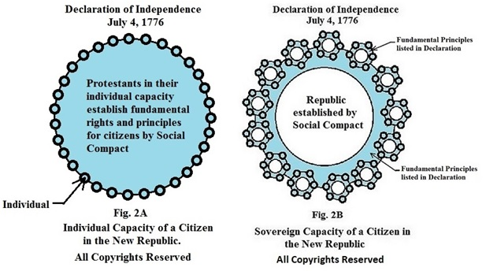

The blue area in Fig. 2A represents the individual capacity of all the adult men who signed the Declaration. Upon signing, each respects his brothers as an equal. Each has the God given capacity to know and understand God’s Law without the help of another human being. Each has the right to defend his rights and live as a free man. Because these men pledged their lives, fortunes, and sacred honor to one another to live by God’s Laws, they created a Republic by interior law, obligating each member to follow God’s Law for liberty. Because the Republic is based upon interior law, there are no physical requirements for citizenship other than to be an adult. This interior law guarantees to all adult citizens regardless of race, color, sex, or creed, they will have the same protected rights as the original men who signed the Declaration. The blue area represents the protected rights of consciences of all citizens to discriminate their actions and the actions of their neighbors when making decisions. Because each controls his own life, all political mandates are unconstitutional.

Fig. 2B represents the sovereign capacity of the people of each State as members of the new Republic. The people of each State exist as a sovereign body politic with the people having the sovereign capacity to create and enforce a written constitution to protect the blue area of each citizen within their State.

The people of each State as a sovereign body politic have the sole authority to write a written State constitution stating the individual capacity of its citizens to govern their lives according to their interpretations of God’s laws. All man-made law, depicting conduct, is a two step process in America. It requires all State legislators to get the consent of the people of their State before a law, passed by their legislature, is binding upon them as citizens. In their sovereign capacity, the people of a State also have the sole authority to control who becomes a citizen of their State and who is eligible to vote in their State elections.

Their pledge to become a citizen creates a religious exemption concerning human law. All men of different religions, making the same pledge, can worship God according to their conscience and make decisions to support or not support the conduct of their neighbors using their conscience. Because their religious exemption protects their rights of conscience, each can use their common sense to determine how to treat their neighbor. This religious exemption also creates a free market where each can use his property to run a business according to his conscience. Under a republican form of government, they have the right to do these things without fear of being harmed or penalized by their government.

Under a republican form of government, no one is obligated to support the decisions made by his neighbor but he is obligated to support and defend his neighbor’s life and their right to make decisions concerning how they treat their neighbors and how they use their property.

The two illustrations represent the two capacities of the people and their right to create and enforce written constitutions in their State. All governments are temporary servants of the body politics and are not a part of the Union.

The purpose of a written State constitution is to be the weapon of the people in their sovereign capacity to limit their government and protect the rights of conscience of all the citizens of their State at all times. In this sovereign capacity, it is the right of the people to write job descriptions within their constitution for their elected leaders. If and when an elected leader refuses to follow their job description, it is the right of the people, at all times, to suspend that person and withhold his salary until a vote is taken to fire that person and replace him with another who will follow the job description of the people.

It is the purpose of the U.S. Constitution to protect and govern the people as a sovereign body politic or State in areas assigned by the States. It is not designed to create or protect rights of individuals in a State. The federal government must respect the sovereignty of the States and protect all State Constitutions which identify the two capacities of the citizens of that State.

The U.S. Constitution does not give the federal government the authority to restrict or void individual rights or assets of citizens of a State for any reason. State politics have never created an agency with authority to control the assets of a State in order to protect the environment. States will never give Congress power to void the rights of the people. (See the 9th amendment.)

The people of the States have given the heads of both their State and federal governments the right to issue mandates to reestablish order in case of an emergency. These mandates, however, cannot restrict the areas of the conscience that are protected by State Constitutions. The people as a state body politic have never given their State or federal representatives the power or authority to issue mandates restricting or voiding any of the rights of consciences of any group whether religious or secular. If they ever give their consent, then the religious exemption concerning human law will cease to exist and the people will have given up their right to be governed by God’s Laws. This religious exemption from human law concerning the conscience is only recognized in the United States of America.

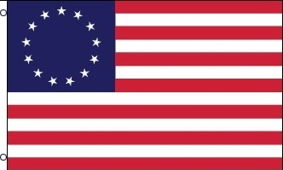

The original flag, representing the Union, was a battle flag. The thirteen strips represented the original principles of the people in each State of the Republic, as declared in their Declaration. The red stripes also represented their commitment to each other to die for those principles. Each star represents a State. Although States varied in size, the stars representing the States were equal in size and placed in a blue background representing a new consolation in the Universe. Today our flag has many more stars in the consolation but the thirteen strips remain as the symbol of the original principles and commitment of the men who signed the Declaration, the document that created this nation.

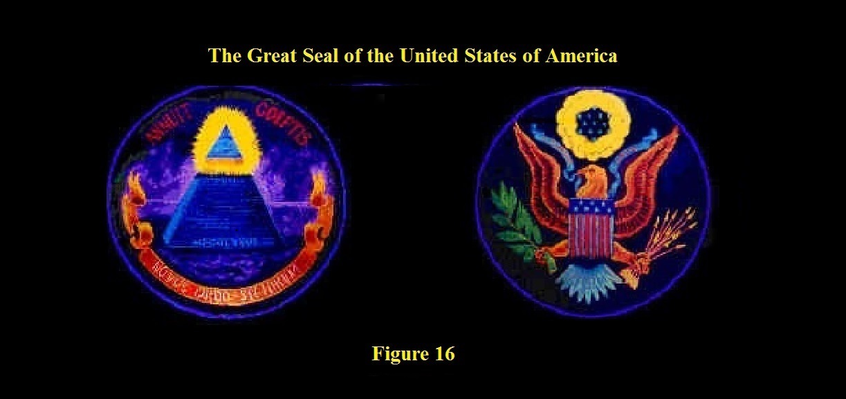

Our Great Seal consist of two Crests. The Crest on the left describes the foundation of the Confederation of States as stated in the Declaration. The square at the base represents the Providence of God. Thirteen layers of blocks represent the States as a pyramid or Republic, committed to live by the Laws of God. The Roman numerals at the foundation of the pyramid represent 1776.

The Crest on the right describes the context of the form of government created by the U.S. Constitution. The Stars at the top represent the authority of the people of the United States as an association to create and enforce their federal government. Law made by an authority is not a law if the one making the law cannot enforce it. That law becomes nothing more than good advice. Thus the ribbon in the beak of the Eagle represents the sole authority of the people of the United States to enforce their U.S. Constitution. The people in the States have the same right to enforce their job descriptions, in their sovereign capacity, as the people, in their individual capacity, have to enforce their State constitutions. The ribbon, held by the Union, controls the federal government.

This control is accomplished by creating a written constitution limiting the number of agencies and assigning job descriptions with limited authority to the elected leaders in those agencies. The Constitution is a collection of job descriptions to be used as a tool by the people of each State collectively, in their sovereign capacity, to control and limit their federal government.

As we celebrate Christmas each year, sing songs about the birth of Jesus Christ, and quote scripture about the government being upon His shoulders, maybe some will see there is something drastically wrong. Maybe they will see the form of government we have now controls every aspect of our lives. It tells us when and where we can go. It does not respect our rights of conscience. Hopefully, they will see there wouldn’t be an American flag, Great Seal, or a place where men of all faiths could worship God without the stand one man made fifteen hundred years ago to protest the hierarchy in a church.

Americans are not against the religious hierarchy of any religion especially the hierarchy in the Roman Catholic Church. We are, however, opposed to elected or appointed leaders who use a Roman form of Democracy and a Roman Catholic document, to restrict the powers and authority of the American people to govern their lives according to God’s Laws of Liberty found in the Declaration.

Since 1877, the members of the Supreme Court, experts of the law like the ones God hated in the Old Testament, have been operating under an authority similar to that of the British Parliament. Under this kind of authority, there can be no concept of self government and no free markets. Using their pens to establish a political hierarchy, these Supreme experts in American law gave future presidents of the United States, the powers of a King and Congress, the powers in the British Parliament. Oh yes, the present government believes in the rule of law as long as they make the laws. The first Amendments states:

“Congress shall make no law respecting an establishment of religion, or prohibiting the free exercise thereof; or abridging the freedom of speech, or of the press; or the right of the people peaceably to assemble, and to petition the Government for a redress of grievances.”

Because of a federal case in 1877, the governments at both the federal and State level, no longer have to respect any law by the people that restricts their power and authority. In the case Munn vs. Illinois, Munn, a business owner, said the State of Illinois did not have any right or authority to govern his business. The supreme experts in American Law differed with him and stated the following conclusion. The Supreme Court declared:
“When the people of the United Colonies separated from Great Britain, they changed the form, but not the substance, of their government. They retained for the purposes of government all the powers of the British Parliament, and through their State constitutions, or other forms of social compact, undertook to give practical effect to such as they deemed necessary for the common good and the security of life and property. All the powers which they retained they committed to their respective States, unless in express terms or by implication reserved to themselves. Subsequently, when it was found necessary to establish a national government for national purposes, a part of the powers of the States and of the people of the States was granted to the United States and the people of the United States. This grant operated as a further limitation upon the powers of the States, so that now the governments of the States possess all the powers of the Parliament of England,”

The people, a social body politic residing in a State, no longer had control of their lives or their State government. But the experts in the law were not finished. Now that the people of a State were under the Common Law of England, they quote a case in Common Law predating the Declaration to explain the essence of government. The Supreme Court says the powers of government
"are nothing more or less than the powers of government inherent in every sovereignty, . . . that is to say, . . . the power to govern men and things." Under these powers the government regulates the conduct of its citizens one towards another, and the manner in which each shall use his own property, when such regulation becomes necessary for the public good. In their exercise it has been customary in England from time immemorial, and in this country from its first colonization, to regulate ferries, common carriers, hackmen, bakers, millers, wharfingers, innkeepers, &c., and in so doing to fix a maximum of charge to be made for services rendered, accommodations furnished, and articles sold.”

Did you notice they quoted the rule of law for American colonies still under the Common Law of England before they as States declared their independence. Most of the Common Law was band in the States when they became a State after pledging their lives and fortune to each other to live by the Laws of God. The people of New York declared in their first Constitution that any law in the Common Law of England that was repugnant to the principles in their State constitution would be considered unconstitutional. Just to be clear, the people of New York quoted the entire text of the Declaration in their Constitution. Agreeing with the same complaints and principles declared in the Declaration, they pledged their lives and fortunes to support the same.

Finally these Supreme experts in law said the principle for governments to govern the people has always been there in history. They use a Roman Catholic document to make their point. They said:

“it is old as a principle of civilized government. It is found in Magna Charta, and, in substance if not in form.”

The Supreme Court has no problem with not respecting any part of the first Amendment. The Protestant principle in Christianity which is fundamental to our liberty is under attack today in America. The question is which system of laws will you obey? Both systems have penalties and serious consequences. The system of laws for man, made by experienced lawyers, contains over 60,000 pages of interpretations divided into 54 titles. It’s called “The U.S. Code”

Jesus, on the other hand, gave those who would follow Him one Law or Commandment; “Love your neighbor as you love yourself.” He added that when one follows this Commandment, he will not steal, kill, bear a false witness, or commit adultery. He also gave man the capacity to understand this Commandment without the aid of another human being.

Both systems of government have penalties that create fear if one violates a law. Because God’s Word became flesh and dwelt among us, God through Jesus Christ gave us the following advice when faced with the decision of who to follow. He said in Mathew 10:28 KJV:

“And fear not them which kill the body, but are not able to kill the soul: but rather fear him which is able to destroy both soul and body in hell.”
Unlike man’s system which tries to change man’s conduct by threatening bodily harm creating fear, God’s system requires man to voluntarily change his conscience toward how he treats his brothers. If he chooses to go with God’s system, he is required to love his brothers without respecting one person or group more than another. Thus he and his brothers have no fear of each other. By voluntarily pledging to follow God’s Commandment of love, man no longer obeys because of fear, but because he loves his brothers and is faithful to honor his pledge. He knows his neighbors have pledged to have his back in hard times.

As you celebrate Christmas and Easter this year and see your government legalizing every act that God has told you is wrong and you see your neighbors being laid off because they will not submit to follow the tyrannical mandates of those in our government, what will you do or how will you react?

Christ gave us hope for the future by showing each of us how to live in peace by loving one another as we love ourselves. His Law is the true light to show us how to live. As American citizens, we are under the same obligation as our founders, to follow His Law of Love.

“Truly He taught us to love one another, His Law is love and His Gospel is peace. Chains shall He break, for the slave is our brother and in His name all oppression shall cease.” These familiar lyrics can come true if we follow His Law of liberty.

God’s Word gives us hope if we will do what He says. In 2 Chronicles 7:14, God promises this to His people:
^{14 “}If my people, which are called by my name, shall humble themselves, and pray, and seek my face, and turn from their wicked ways; then will I hear from heaven, and will forgive their sin, and will heal their land.” KJV

Our founders gave us the legal right to practice Christ’s new Commandment to oppose tyranny all the time without violence. Our founders gave each of us the right to band together and say no to all laws restricting our rights of conscience.

We don’t need a weapon to say no and we don’t need to burn down or destroy property to say no. No is the weapon!

If you are an American citizen, all you have to do is to stand with the rest of us who belong to the league of friendship that was founded by our brothers back in 1776. It is time we stand together as religious men of all faiths and say a resounding “no!” to all laws that restrict our rights of conscience. Tyrants can only control our bodies but they have no power to control our minds.

Use the gift God gave to man to fight tyranny. Commitment to His system of government will set you free of man’s laws. Don’t let Christ’s teachings be in vain. If you want to see mechanical illustrations of the principles referred to in this paper and see mechanical illustrations of each stage of development of this nation, get my book entitled “The Birth of the Republican Form of Government” by Stephen L. Corrigan. I have a website where you may order it. It is in all bookstores. https://youtu.be/EMTtscLOJeA

