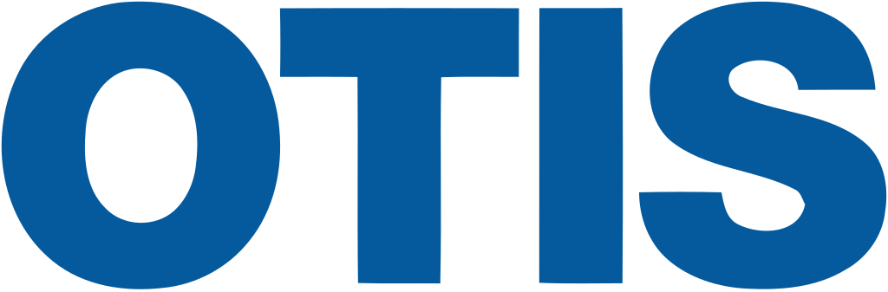

Fast Facts about OTIS:
- Largest manufacturer of elevators worldwide
  - Moves approximately 2 billion people per day (in normal circumstances)
- Fortune 50 company
- CEO Judy Marks commits that by 2030, executives will be 50% women
- Great benefits!
  - Health: Medical/Rx, Employee Assistance Program, Dental, Vision, and Health Savings Account
  - Retirement Savings/Financial Planning
  - Time Off: Vacation, Personal Time Off, Sick, Birth/Adoption Leave, Military Leave
- Tons of Resource Groups
  - OTIS For All, OTIS Pride, OTIS WIN, and many more!

Current Opportunities at OTIS:
- Full-time Trainee Programs
  - 4 to 6 months in depth development training in Sales and Project Management
  - Starts Jan/Feb and June/July
- Full-time Rising Leaders Program
  - Two year leadership development rotation program in digital technology, engineering, finance, and operations
  - Starts June 2021
- Paid Internships
  - 10-12 weeks
  - Starts May-June 2021
  - Opportunities across the U.S. in sales, project management, finance, engineering, digital technology, and operations
Application Process:
- For Internship:
  - Apply Complete On Demand Hirevue If selected, you will do a virtual interview with a hiring manager Decision
- For full-time Training Programs
  - Apply Complete On Demand Hirevue Interview with one of the managers you’ve applied to Panel Style Interview with other candidates/leaders

What they look for in a resume:
- Extracurricular activities, projects, leadership experiences, classes/courses you’ve taken, relevant experiences, transferable skills

Summer Internship Openings (apply by November 30th, 2020!!):
- Digital Technology Summer Internship
- Operations: Supply Chain Summer Internship
- Engineering Internship

Contact Linda at Linda.lam@otis.com if you have any questions about any of the internship/job openings and/or the application process.

For more career opportunities, click here.

