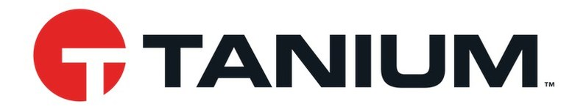

Fast Facts about Tanium:
- #4 “Best Workplaces in Technology” by FORTUNE
- 12 of the top 15 U.S. Banks and 4 of the U.S. Armed Forces use Tanium
- Tanium’s mission: to reduce complexity, improve efficiency and align IT teams for the world's largest companies and government organizations.

Tips/Facts on Applying to Tanium’s Internships/Full-time Positions:
- Have a one-page resume
  - Make sure your name, email, linkedin, and phone number are listed
  - List classes/projects/relevant work experience that are applicable to the job/internship you’re applying for
- Don’t worry if you don’t have a software experience!
  - Depending on the internship/job you’re applying for, they don’t look for technical/specific background
- Internship can be remote or hybrid depending on the COVID-19 Pandemic
- You’ll have a mentor for your internship
- If you’re applying for a technical internship/position, interview questions will be more specific and technical

Internships for upcoming summer (2021):

Summer 2021 Technical Account Management Intern

Technical Account Management Intern

Summer 2021 Sales Intern-Northeast

For more internships and/or full time positions, click here.
For questions regarding internships/full-time positions, contact Gabriella Nanson.

