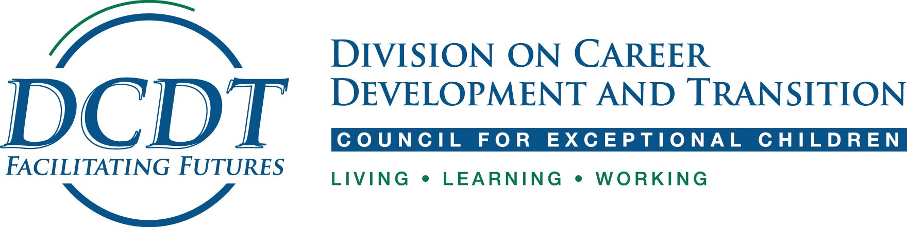

2019 Winter DCDT Meetings
JW Marriott, Indianapolis, IN
DCDT Executive Committee & Board Meetings (Overview)

Date | Time | Event | Location
Thursday  Jan 31st | 8:30 AM – 9:30 AM | CDTEI Editorial Board Meeting | Grand Ballroom 2
“ “ | 9:30 – 10:30 AM | Research Committee | “ “
“ “ | 10:30 – 11:30 AM | Membership Committee | “ “
“ “ | 11:30 – 12:30 | Conference Planning Committee
“ “ | 1:30 – 2:30 | Policy & Advocacy Committee
“ “ | 2:30 – 3:30 | Past Presidents’ Meeting
“ “ | 5 -6 PM | DCDT Business Meeting  RECEIVE A FREE GIFT | Grand Ballroom 3
“ “ | 6 - 8 PM | DCDT Member Welcome Reception  FREE FOOD and CASH BAR  ALL encouraged to attend! | Grand Ballroom 4
Friday  Feb 1 | 8 – 9 AM | Human Rights & Diversity | Grand Ballroom 2
 | 10 – 11 AM | National Certification in Transition | Grand Ballroom 2
 | 11 – 12 AM | Student Committee | Grand Ballroom 2

