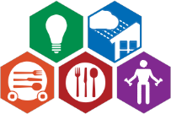

Helping Seniors and Low-Income Families in Alameda County

**510-881-0300 | www.SpectrumCS.org**

P.O. Box 4317, Hayward, CA 94540

Low Income Household Water Assistance Program (LIHWAP)

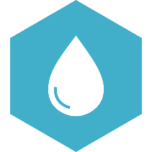**Get help paying your overdue water bill**

LIHWAP is a temporary, federally-funded, COVID-relief program to help low-income households with a one-time payment on their past due water or sewage bill. Assistance is in the form of a direct payment to the participating water or wastewater service. The program ends after August 15, 2023.

Program overview:

* LIHWAP can assist with only overdue water or sewage, not both, unless they appear on the same bill
* Applicants’ water or wastewater provider must be enrolled in the LIHWAP program
* Applicants can apply simultaneously to LIHWAP and the Low Income Home Energy Assistance Program (LIHEAP)
* Priority is given to those facing discontinuation of services
* Last day to apply is August 15, 2023

To qualify, you must:

* 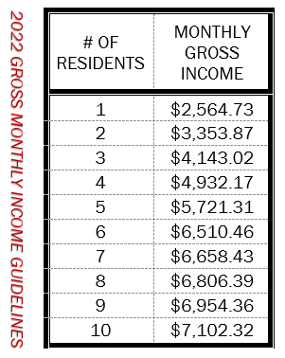…live in Alameda County
* …fall under these household monthly gross income guidelines
* …be past due on your bill
* …be able to show government-issued ID

To apply:

* Call 510-881-0300 to request an application
  + Specify if you are requesting LIHWAP assistance alone, or LIHEAP and LIHWAP combined
  + Specify the name of your water or wastewater agency
* Or email us at LIHEAP@SpectrumCS.org

