1.
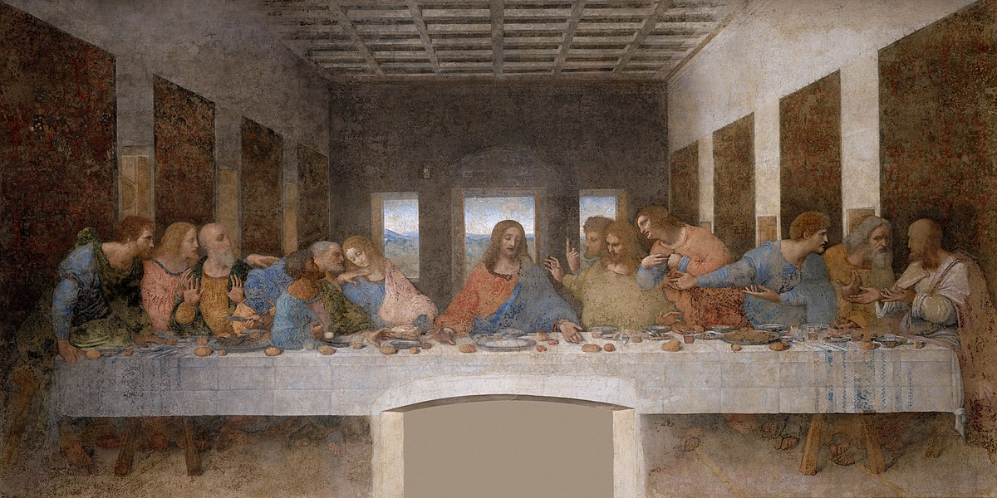

2. 3.
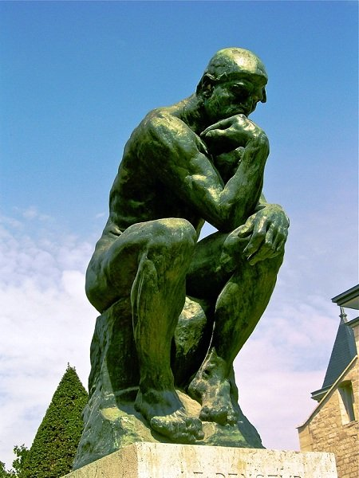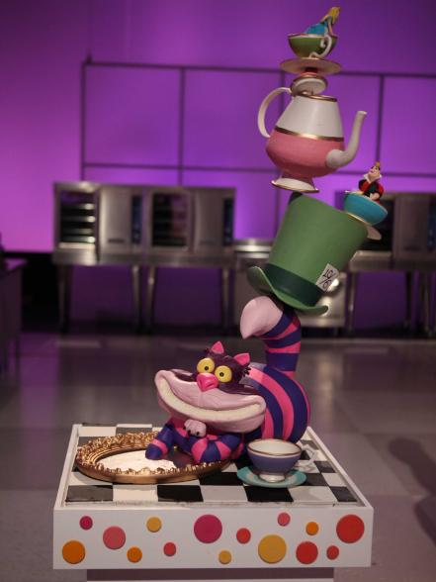
4.
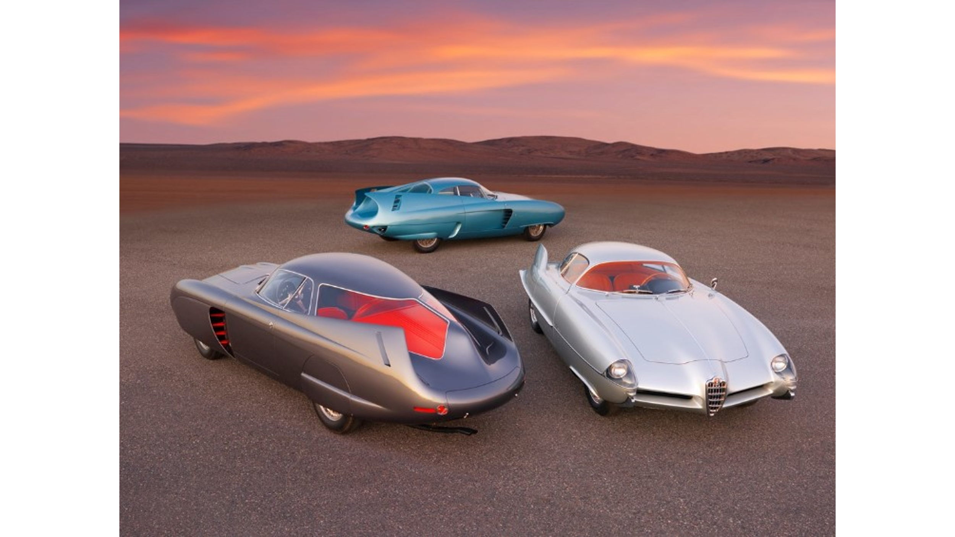

5.
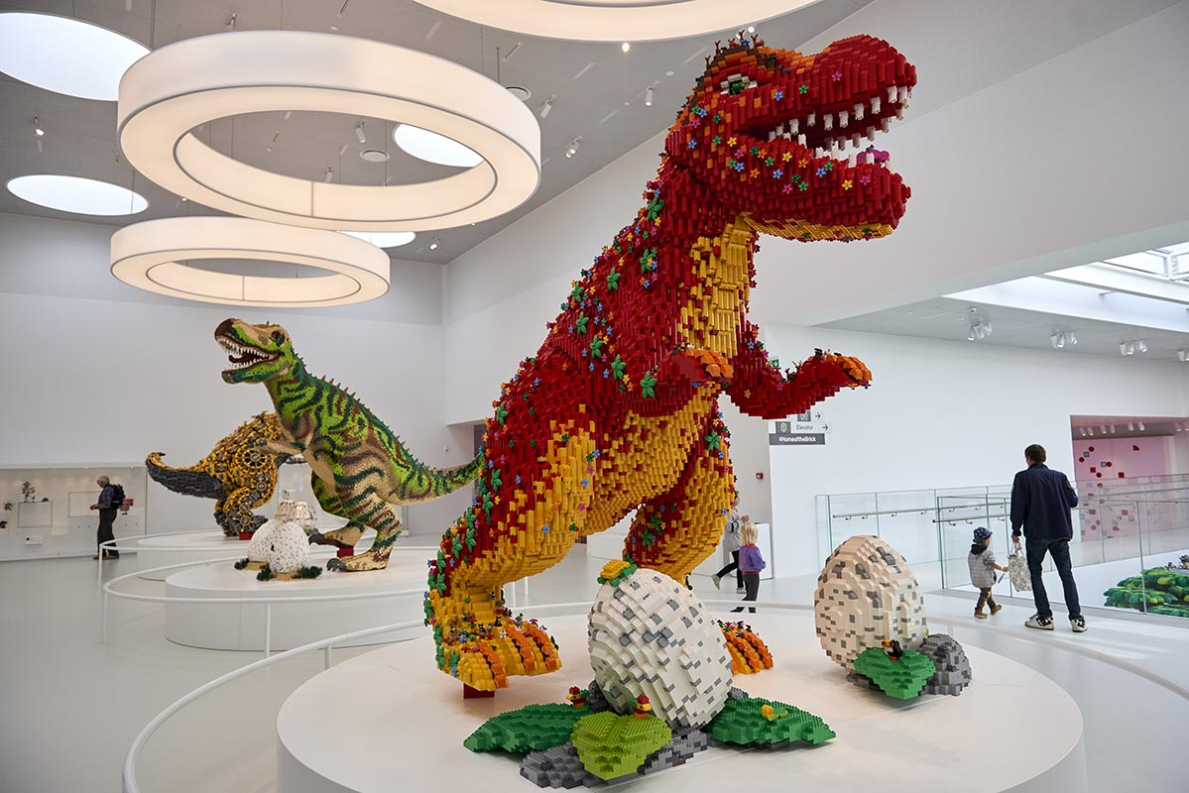

6.
God is a creator, not a duplicator!

7.
- What are 3 things that I love to do that bring joy and fulfillment in my life?
- Who do I love to work with most, and the ages or types of people?
- If you had no roadblocks, what God sized dreams/goals would you have for your life?

