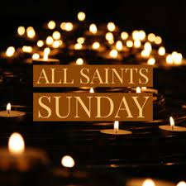

Sunday, November 6, 2022

November 1, 2021 – October 31, 2022

Clyde Knowles Barbara Allen’s cousin
Steve Hoffman* Calvary member
Sherry Jones* Calvary member
Ray “Noonie” Wright* Calvary member
Joel McDermott Sr. Barbara Allen’s niece’ husband
Myrtle Pringle Vallerie’s mother
Ron Leon Ray’s friend
Verona Seymour Barbara Allen’s cousin
Mary Mireku Margaret’s niece
Eric S. Badu Margaret’s nephew
Debbie Snapp Bonnie Jewett’s sister
Maxwell Okyere Boateng Gladys’ brother
Rita Deines Ann Honious’ mother
Joan E. Allen Barbara Allen’s friend

*Current & past members

Closing Hymn: "Look Who Gathers at Christ's Table!"

Look who gathers at Christ's table! Hear the stories that they bring. Some are weeping; some are laughing; some have songs they want to sing.
Others ask why they're invited, burdened by the wrong they've done. Christ insists they all are welcome. There is room for everyone.

Clouds of light surround the table; ancient followers appear, saints confessing how they wrestled with their guilt, their doubt and fear.
Peter tells of his denying Christ was ever in his sight; Paul relates his fruitless efforts to obliterate the light.

Their sad stories are repeated in a thousand different ways, but they share one thing in common: they all end in thanks and praise
For the host who has invited north and south and east and west to converge around this table, where all life is fed and blest.

Bring your joy and bring your sadness, and prepare to be surprised by the host whose hands are wounded, who will open wide your eyes
When he blesses bread and breaks it--truth and manna from above!--and then passes wine that wakens in your heart the taste of love.

