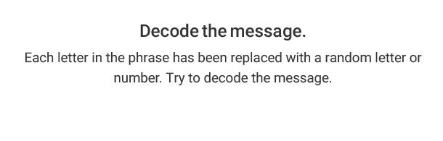
Each number represents a letter of the alphabet. Substitute the correct letter for the numbers to reveal the words.

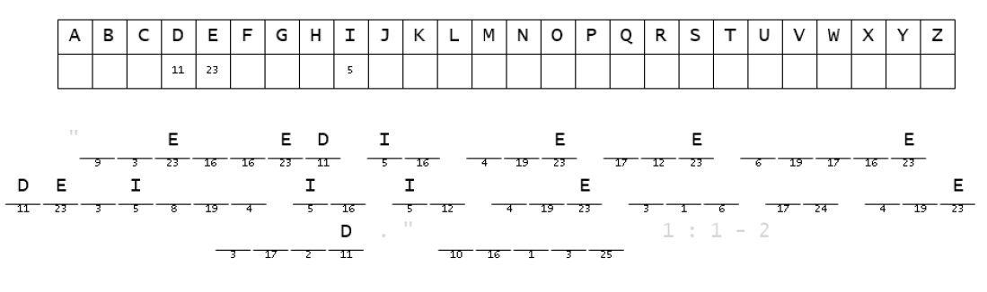

Copyright © Sermons4Kids, Inc.
May be reproduced for Ministry Use

Children’s Worship Bulletin

Delight in God’s Word

Psalm 1:1

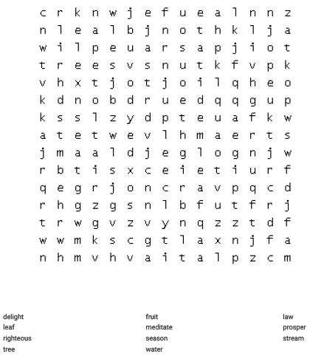

Your Church Name Here
Anytown, USA

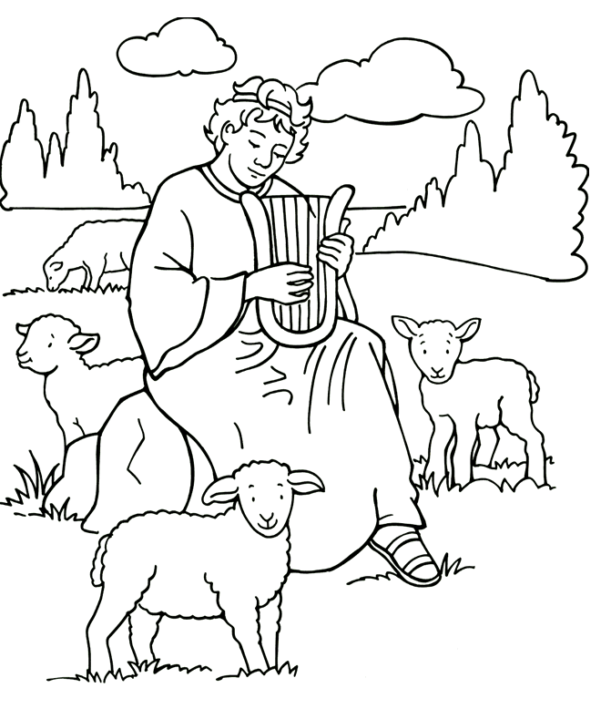
“Blessed is the one who does not walk in step with the wicked or stand in the way that sinners take or sit in the company of mockers, but whose delight is in the law of the Lord, and who meditates on His law day and night.” Psalm 1:1-2

Copyright © Standard Publishing
Used by Permission

