**MCI to deliver 25 new coaches to Massachusetts’ Peter Pan, both celebrating historic 90-year milestones**

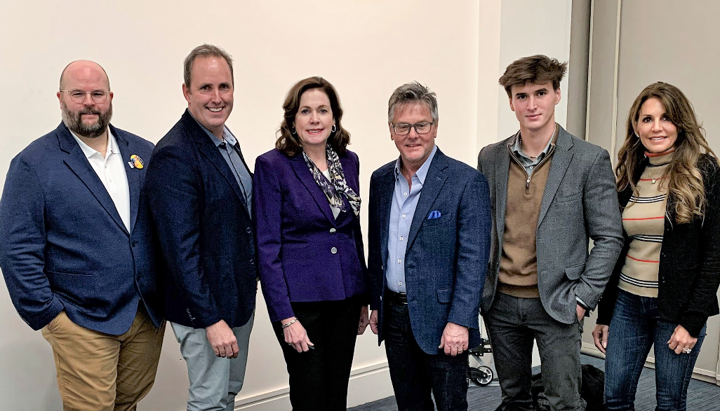

**Des Plaines, Illinois, USA – April 17, 2023: (TSX: NFI, OTC: NFYEF, TSX: NFI.DB)** Motor Coach Industries (“MCI”), a subsidiary of NFI Group Inc. (“NFI”), a leading independent bus and coach manufacturer and a leader in electric mass mobility solutions, today announced delivery plans for 25 new clean-diesel J4500 coaches to Peter Pan Bus Lines (“Peter Pan”). MCI delivered the first ten motor coaches to the iconic bus operator in January 2023, spurring the order for 15 additional vehicles signed for at the American Bus Association’s Marketplace and BusWorld North America held in Detroit, MI, from February 4-7, 2023.

Based in Springfield, MA, Peter Pan is one of the largest privately-owned bus companies in the United States, operating a fleet of more than 200 coaches and delivering over 1,000 daily departures to more than 100 destinations across the Northeast and Mid-Atlantic States.

This announcement coincides with a significant milestone for both companies: celebration of their 90th anniversary. Peter Pan and MCI were both founded in 1933 and have supported one another for half a century.

"We are true-blue MCI," said Peter A. Picknelly, CEO and third-generation owner of Peter Pan, one of the industry's most prominent family-owned motor coach companies. "We started with the MC-8 in 1974, and since the 1980s, our fleet has been exclusively MCI."

Peter Pan, a scheduled service and charter company, was among the first operators to buy the popular DL model (MCI D4505) when it was introduced in 1993. When MCI launched the all-new J4500 in 2001, Peter Pan was the first operator to place a 12-coach order. Peter Pan has counted on MCI's reliability since placing an annual order for new vehicles, with the exception of the COVID-19 pandemic period in 2020 and 2021.

"MCI is a real workhorse," added Picknelly. "The J4500 is great for our line runs, and our charter customers enjoy its curb appeal and spacious interior. MCI has been a good partner. We are pleased with their service and access to parts."

The new motorcoaches are equipped with advanced safety features, modern amenities, and eco-friendly technology, demonstrating MCI's commitment to innovation and sustainability. Peter Pan‘s passengers will enjoy a comfortable and enjoyable travel experience on board the state-of-the-art motor coaches, featuring Peter Pan's signature interiors and 54-passenger seating configuration, providing a luxurious interior with best-in-class legroom.

"Our productive partnership with Peter Pan spans a half-century; over this time, MCI earned Peter Pan's trust and confidence in the reliability of our vehicles, backed up by excellent service and aftermarket support," said Brent Maitland, Vice President of MCI Private Sector Sales and Marketing. "Our J4500 coach has gone through several evolutions since its market launch, and feedback from Peter Pan has been instrumental to MCI’s continuous improvement. The Peter Pan team strives to upgrade its fleet with the newest and the best vehicles, but not at the expense of reliability.”

“As MCI nears 100 years in the industry, we will keep our J4500 at the forefront of our product portfolio while offering reliable support to help operators like Peter Pan continue to be industry leaders,” added Maitland.

In addition to Peter Pan’s recent [announcement](https://peterpanbus.com/nextgeneration/) of management promotions, Peter A. Picknelly and the late Tom Picknally have four of their children (the fourth generation) actively involved in operations. Each generation brings its unique talents to Peter Pan. Recent advancements include digital technology, with nearly 85% of all ticketing and charter sales now transacted online.

**About MCI**

MCI is North America’s public and private market motor coach leader. Products include the luxury [J Series](https://www.mcicoach.com/coach/j-series/features/) (an industry best-seller for over a decade), the workhorse [D Series](https://www.mcicoach.com/coach/d-series/features/), and the brand new zero-emission luxury and commuter coaches: the battery-electric [J4500 CHARGE™, D45 CRT CHARGE™ and D45 CRT LE CHARGE™](https://www.mcicoach.com/coach/electric-series/features/). MCI also provides maintenance, repair, 24-hour roadside assistance, parts, and technician training through the industry’s only Automotive Service Excellence (“ASE”) accredited and award-winning [MCI Academy](https://www.mciacademy.com/).

**About NFI**

Leveraging 450 years of combined experience, NFI is leading the electrification of mass mobility around the world. With zero-emission buses and coaches, infrastructure, and technology, NFI meets today’s urban demands for scalable smart mobility solutions. Together, NFI is enabling more livable cities through connected, clean, and sustainable transportation.

With 7,700 team members in nine countries, NFI is a leading global bus manufacturer of mass mobility solutions under the brands New Flyer® (heavy-duty transit buses), MCI® (motor coaches), Alexander Dennis Limited (single and double-deck buses), Plaxton (motor coaches), ARBOC® (low-floor cutaway and medium-duty buses), and NFI Parts™. NFI currently offers the widest range of sustainable drive systems available, including zero-emission electric (trolley, battery, and fuel cell), natural gas, electric hybrid, and clean diesel. In total, NFI supports its installed base of over 100,000 buses and coaches around the world. The Shares are traded on the Toronto Stock Exchange under the symbol NFI and NFI’s convertible unsecured debentures trade on the Toronto Stock Exchange under the symbol NFI.DB. News and information is available at [www.nfigroup.com](https://www.nfigroup.com/), [www.newflyer.com](https://www.newflyer.com/), [www.mcicoach.com](https://www.mcicoach.com/), [www.nfi.parts](https://nfi.parts/), [www.alexander-dennis.com](https://www.alexander-dennis.com/), [www.arbocsv.com](https://arbocsv.com/), and [www.carfaircomposites.com](https://carfaircomposites.com/).

**Forward-Looking Statement**

This press release may contain forward-looking statements relating to expected future events and financial and operating results of NFI Group that involve risks and uncertainties. Although the forward-looking statements contained in this press release are based upon what management believes to be reasonable assumptions, investors cannot be assured that actual results will be consistent with these forward-looking statements, and the differences may be material. Actual results may differ materially from management expectations as projected in such forward-looking statements for a variety of reasons, including market and general economic conditions and economic conditions of and funding availability for customers to purchase buses and to purchase parts or services; customers may not exercise options to purchase additional buses; the ability of customers to suspend or terminate contracts for convenience; production may be delayed or production rates may be decreased as a result of the pandemic or ongoing and future supply chain disruptions and shortages of parts and components, shipping and freight delays, and disruption to labor supply; and the other risks and uncertainties discussed in the materials filed with the Canadian securities regulatory authorities and available on SEDAR at [www.sedar.com](http://www.sedar.com/).

Due to the potential impact of these factors, the NFI Group disclaims any intention or obligation to update or revise any forward-looking statements, whether as a result of new information, future events or otherwise, unless required by applicable law.

For media inquiries, please contact:   
Amanda Wanke  
P: 515.474.1704  
[Amanda_Wanke@newflyer.com](mailto:Amanda_Wanke@newflyer.com)

For investor inquiries, please contact:

Stephen King  
P: 204.224.6382  
[Stephen.King@nfigroup.com](mailto:Stephen.King@nfigroup.com)