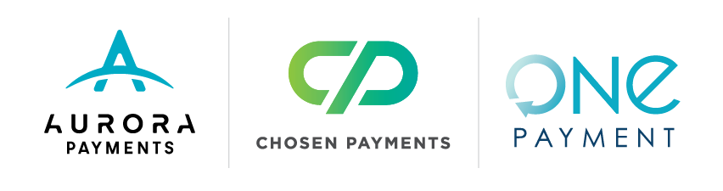

How to: Market with Emailed Transaction Receipts

Over the past few years, you’ve likely noticed merchants asking if you would like your receipt emailed to you when completing an in-person transaction. Merchants asking if you want your receipt emailed to you are embracing the power of technology.
Merchant Benefits
- Emailed receipts have the highest open rate of any type of email received.
- Presents an opportunity to further engage with your customer
- Opportunity for another transaction.
- Opportunity to create stronger and deeper relationships
- Drive more sales

The Subject Line
Make sure your customer knows what's in the email by clearly spelling out what's inside. Here are a few examples you can use:

- Your purchase for $59.99
- Your recent purchase of Jordan Cabernet Wine
- Your March 2023 purchase of Jordan Cabernet Wine s
- Do not include your company name in the subject line – it’s redundant to the send name

Include Details
- Method of payment such as Visa or Mastercard
- Last 4 or 5 digits of the card number
- Billing date
- Name on the card
- Purchaser's name if different than cardholder name

Include shipping information as the first part of your email. Include:

- Date of shipping
- Shipping method
- Estimated delivery date
- A package tracking link

Say Thanks
- Say “Thank You” with a heartfelt message in a large graphic
- Don't type the words in the body of your message as it likely won't be read
- Make it pop!

Here's the message that Abercrombie & Fitch uses when emailing receipts:

"We're honored that when it comes to style, you think of us. There's a lot of choices out there but you singled us out and that means a lot. We just want to express how much we appreciate your business. When you're looking for something truly special, we hope that we'll continue to be the place you think of first. Thank you! Abercrombie & Fitch".

Special Offers
- Emailed receipts offer an opportunity to gain another sale
- Jewelers - adding a special Mother's Day offer on your receipts from April 1st through May 14th
- Limo Services - include an offer to add a dozen roses for $69 for all limo reservations
- Include personalized recommendations based on past purchases into the emailed receipt
- Provide links to relevant blog posts or videos
- Turn receipts into a coupons by offering a percentage off the next purchase
- The sky is the limit on promotions

Just having your customer's email address means you can send them offers as often as you want, and it doesn't always have to be a sales receipt.

Double Down
- Provide coupons that can be shared with friends
- Create a sense of urgency by including a limited time offer
- One Day sale with coupons that expire at midnight the same day
- Invite existing customers to provide emails addresses for friends to be added to the VIP Club
- Offer the existing customer a referral bonus such as $10 off their next order for each referral
- VIP Club Welcome discount of 25% off a first purchase
- Turn your customers into sales reps for your business

Ask for a Review
Make it easy for customers to review your business
Reviews help boost your search engine results
Emailed receipts almost always elicit a positive review
Provide links to share feedback on your social media page or review sites such as Yelp

Who is Aurora?
Aurora Payments is a network of professionals providing Merchants with reliable payment solutions for any industry and any environment. We help businesses increase efficiency and growth. Our proprietary technology provides One Ecosystem - One Contract - One Partner - One Aurora. As a Full-Service Provider (FSP), we have the all the products, services, solutions, and support Merchants need - all-in-one place. We’re an organization driven by a passion for helping our Merchants succeed. Interested in learning how you can eliminate credit card processing fees? Send us an email at hello@risewithaurora.com or call us at 833-287-6722. You’ll be saving money in no time!

