MCI completes milestone delivery to Peoria Charter
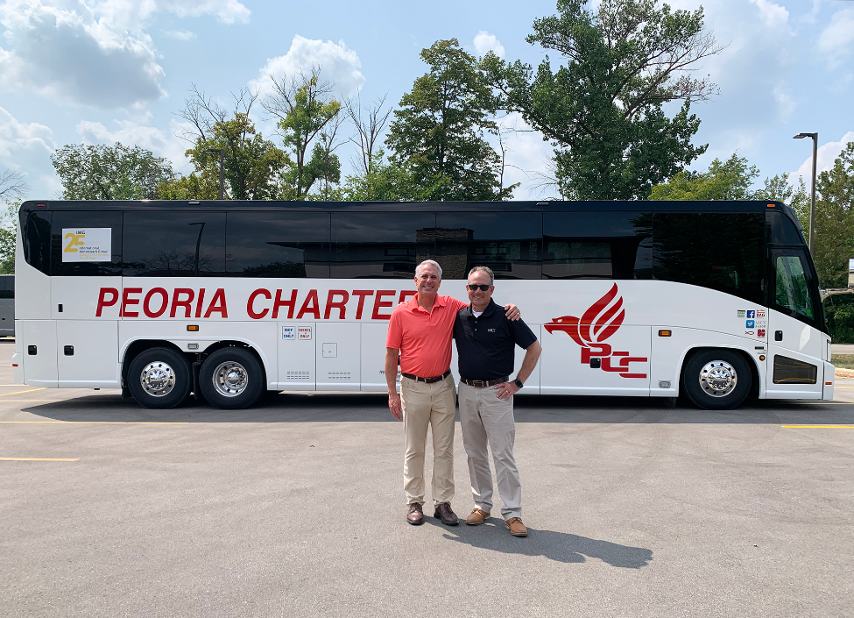
Des Plaines, Illinois, USA – September 14, 2023: (TSX: NFI, OTC: NFYEF, TSX: NFI.DB) Motor Coach Industries (“MCI”), a subsidiary of NFI Group Inc. (“NFI”) and North America’s motor coach leader backed by reliable in-field technical expertise, 24/7 roadside assistance, and parts support, today announced the delivery of two 2024 MCI J4500 coaches to Peoria Charter. This delivery marks a milestone of 60 MCI motor coach deliveries to Peoria Charter over the course of the two companies’ long-standing relationship.
“We have had more MCI models in our fleet than any other,” said Bill Winkler, the third generation of the Winkler family to lead Peoria Charter since its founding in 1941. “We are thankful to be able to purchase new coaches again. We are back running strong.”
As of June 2023, Peoria Charter, the largest privately owned charter bus company headquartered in Illinois, achieved a 96 percent gain in revenue while returning to pre-COVID-19, 2019 earnings, explained Winkler.
“MCI and Peoria Charter have a long-standing relationship that spans several decades,” said Brent Maitland, Vice President of Private Sector Sales and Marketing, MCI. “We are proud to have consistently been a part of their history and reputation for service and safety throughout the Midwest.”
“We are especially grateful for the opportunity to continue our partnership into the future. Bill and his team push us to be better, and we are proud to deliver this latest clean-diesel motorcoach, one of the safest and most efficient modes of transportation,” continued Maitland. “Peoria Charter’s decision to continue working with MCI today demonstrates their trust in our reliability driven products, service and support, and further strengthens our partnership to serve Peoria Charters for decades to come.”
Peoria Charter’s newest MCI J4500, displayed at the recent International Motorcoach Group (IMG) meeting in Green Bay, WI, features 56-passenger seating, a 180-degree color backup camera and a Cummins clean-diesel engine.
At the beginning of 2023, Peoria Charter was honored by industry peers at the United Motorcoach Association (UMA) EXPO 2023 with an environmental award sponsored by MCI. The award recognized the transportation provider for its fuel conservation policies, a proprietary software system that plans routes to minimize trip miles and biodiesel fuel usage that keeps its fleet running clean with near-zero emissions.
Serving private and public universities, sports teams, and daily routes 365 days a year – along with shuttles to Chicago’s O’Hare International Airport – Peoria Charter operates from three locations in Illinois, including a new office in Chicago, and transports 500,000 passengers each year.
About MCI

MCI is North America’s public and private market motor coach leader. Products include the luxury J Series (an industry best-seller for over a decade), the workhorse D Series, and the brand new zero-emission luxury and commuter coaches: the battery-electric J4500 CHARGE™, D45 CRT CHARGE™ and D45 CRT LE CHARGE™. MCI also provides maintenance, repair, 24-hour roadside assistance, parts, and technician training through the industry’s only Automotive Service Excellence (“ASE”) accredited and award-winning MCI Academy.

About NFI

Leveraging 450 years of combined experience, NFI is leading the electrification of mass mobility around the world. With zero-emission buses and coaches, infrastructure, and technology, NFI meets today’s urban demands for scalable smart mobility solutions. Together, NFI is enabling more livable cities through connected, clean, and sustainable transportation.

With 7,700 team members in ten countries, NFI is a leading global bus manufacturer of mass mobility solutions under the brands New Flyer® (heavy-duty transit buses), MCI® (motor coaches), Alexander Dennis Limited (single and double-deck buses), Plaxton (motor coaches), ARBOC® (low-floor cutaway and medium-duty buses), and NFI Parts™. NFI currently offers the widest range of sustainable drive systems available, including zero-emission electric (trolley, battery, and fuel cell), natural gas, electric hybrid, and clean diesel. In total, NFI supports its installed base of over 100,000 buses and coaches around the world. NFI’s common shares are traded on the Toronto Stock Exchange under the symbol NFI, its convertible unsecured debentures trade on the Toronto Stock Exchange under the symbol NFI.DB, and its subscription receipts trade on the TSX under the symbol NFI.R. News and information is available at www.nfigroup.com, www.newflyer.com, www.mcicoach.com, www.nfi.parts, www.alexander-dennis.com, www.arbocsv.com, and www.carfaircomposites.com.

Forward-Looking Statement

This press release may contain forward-looking statements relating to expected future events and financial and operating results of NFI Group that involve risks and uncertainties. Although the forward-looking statements contained in this press release are based upon what management believes to be reasonable assumptions, investors cannot be assured that actual results will be consistent with these forward-looking statements, and the differences may be material. Actual results may differ materially from management expectations as projected in such forward-looking statements for a variety of reasons, including market and general economic conditions and economic conditions of and funding availability for customers to purchase buses and to purchase parts or services; customers may not exercise options to purchase additional buses; the ability of customers to suspend or terminate contracts for convenience; production may be delayed or production rates may be decreased as a result of the pandemic or ongoing and future supply chain disruptions and shortages of parts and components, shipping and freight delays, and disruption to labor supply; and the other risks and uncertainties discussed in the materials filed with the Canadian securities regulatory authorities and available on SEDAR at www.sedarplus.ca.
Due to the potential impact of these factors, the NFI Group disclaims any intention or obligation to update or revise any forward-looking statements, whether as a result of new information, future events or otherwise, unless required by applicable law.
For investor or media inquiries, please contact:
Stephen King
P: 204.224.6382
Stephen.King@nfigroup.com

