Newport County
Martin Luther King Celebration Committee
presents
“WE SHALL NOT BE MOVED”
“Remember! Celebrate! Act! A Day
On Not A Day Off”
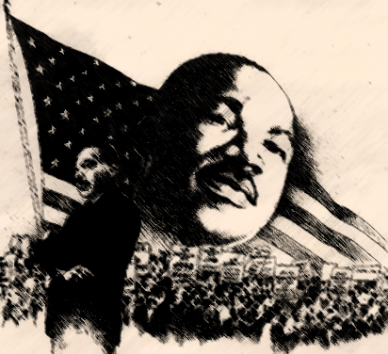

36th Annual
National Holiday
Celebration in Honor of
Dr. Martin Luther King, Jr.

January 18, 2021
12:00pm

Sponsored by the
Newport County Branch NAACP
National Association for the
Advancement of Colored People
In collaboration with
Newport Middle Passage Port Marker
R I Slave History Medallion
Sankofa Community Connection
Salve Regina University

ANNUAL BIRTHDAY PROGRAM
INTRODUCTION
Mrs. Victoria Johnson

WELCOME
James Winters, President
Newport County Branch NAACP

MUSICAL SELECTION
Kenneth Johnson
Keep You Eyes on the Prize

Non-Violence Pledge
Amiyah Johnson
Portsmouth Middle School

Student Essayist
Talia Cicilline
Thompson Middle School Student

Newport NAACP
Newport Middle Passage Port Marker
RI Slave History Medallions
Sankofa Community Connection

Speaker
Command Senior Chief Jerome Nurse
Naval Academy Prep School
“Choices”

MUSICAL SELECTION
Kenneth Johnson
A Change is Gonna Come

Benediction
Mrs. Victoria Johnson

Thank You Salve Regina University, for providing MLK events during the week giving guidance and mentoring for the President Commission on Equity and Inclusion.

Lift every voice and sing
Till earth and heaven ring,
Ring with the harmonies of Liberty:
Let our rejoicing rise
High as the listening skies,
Let it resound loud as the rolling sea.
Sing a song full of the faith that the dark past has
taught us,
Sing a song full of the hope that the present has
Brought us,
Facing the rising sun of our new day begun
Let us march on till victory is won.

Stony the road we trod,
Bitter the chastening rod,
Felt in the days when hope unborn had died;
Yet with a steady beat,
Have not our weary feet
Come to the place for which our fathers signed?
We have come over a way that with tears have
been watered,
We have come, treading our path through the
blood of the slaughtered,
Out from the gloomy past,
Till now we stand at last
Where the white gleam of our bright star is cast.

God of our weary years,
God of our silent tears,
Thou who has brought us thus far on the way;
Thou who has by Thy might
Led us into the light,
Keep us forever in the path we pray.
Lest our feet stray from the places, Our God,
where we met Thee;
Lest, our hearts drunk with the wine of the world,
we forget Thee;
Shadowed beneath Thy hand,
May we forever stand,
True to our GOD
True to our native land

Kirk Franklin

Words by JAMES WELDON JOHNSON
Music by ROSAMOND JOHNSON

