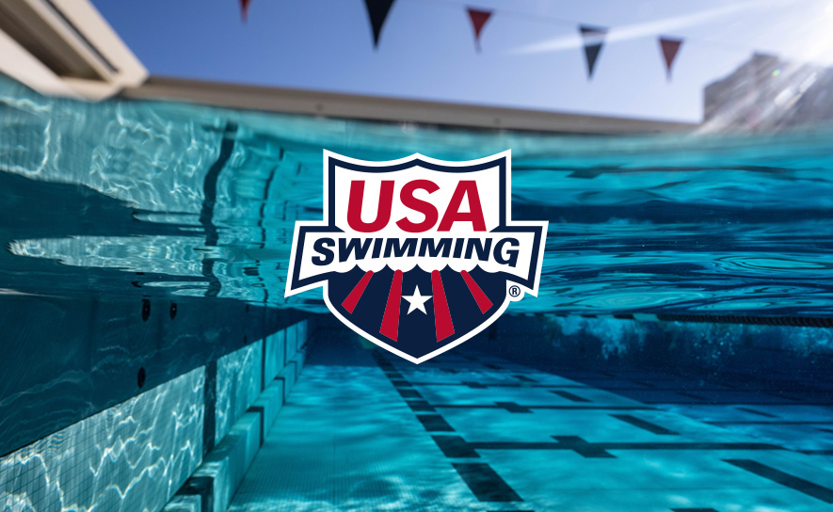
MIDDLE ATLANTIC SWIMMING NATIONAL FINISHERS
2026 TYR Futures Championships Top 8 Finishers in Knoxville:
Blue Hen Aquatics:
Malcolm Collins 100 meter breast 8th 1:04.36
50 meter breast 8th 28.94
Matvei Namkonov (23) 100 meter breast 2nd 1:01.59
100 meter free 2nd 50.27
50 meter breast 2nd 27.66
Brady Robidas 50 meter free 7th 23.75
Kade Snyder 100 meter back 1st 56.00
100 meter fly 5th 55.19
200 meter back 5th 2:06.38
Delaware Swim Team:
Payton Garnsey 100 meter breast 1st 1:10.51
200 meter breast 6th 2:39.85
200 meter IM 7th 2:23.51
50 meter breast 1st 32.15
Carson Kalish (19) 50 meter fly 5th 25.13
100 meter fly 8th 55.66
200 meter IM 7th 2:07.06
Anna Karanjia 50 meter fly 8th 28.32
Anna Mumford 1500 meter free 6th 17:29.50
Grady Redding 200 meter fly 4th 2:04.55
50 meter fly 3rd 24.95
100 meter fly 6th 55.29
Diamond State Aquatics:
Aidan Walsh 200 meter back 4th 2:05.22
Lancaster Aquatic Club:
Addie Elliot 50 meter back 5th 29.86
Trevor Olson 200 meter free 4th 1:52.66
Cami Schwartz 100 meter breast 8th 1:13.53
200 meter breast 7th 2:40.40
Penn Charter Aquatic Club:
Oskar Bauriedel 400 meter IM 2nd 4:29.92
200 meter back 3rd 2:04.90
Eila Spaman 50 meter free 7th 26.81
Upper Dublin Aquatic Club:
Jack Baumgardner 50 meter fly 8th 25.38
Joey Curcio 50 meter back 7th 26.45
200 meter back 7th 2:08.19
Brady Manser 100 meter free 5th 50.83
200 meter breast 4th 2:17.14
Kyle Spaman 100 meter breast 4th 1:02.32
50 meter breast 6th 28.63
Luke Sullivan 100 meter breast 7th 1:03.42
400 meter IM 3rd 4:30.13
200 meter IM 2nd 2:04.64
Alyssa Auwarter 50 breast 3rd 32.26
Sophia Sileo-Magliari 50 breast 2nd 32.17
100 breast 2nd 1:10.52
200 breast 2nd 2:34.45
2026 TYR Futures Championships Top 8 Finishers in Greensboro:
Lydia Strucko (Emmaus Aquatic Club) 100 meter back 7th 1:05.02
Briana Klock (Lower Moreland Aquatic Club) 50 meter fly 6th 28.05
Sam Gatesman (Jersey Wahoos) 400 meter free 8th 4:29.78
Christian Shenk (South Jersey Aquatic Club) 200 meter back 7th 2:07.62
Haven Fegely (EMAC) 50 breast 8th 34.02
Kelly Sommer (Methacton Aquatic Club) 50 breast 8th 29.81
2026 Speedo Junior National Championships Top 20 Finishers
Gage Mealy (JW) 17th 1500 meter free 15:56.15
Sophia Sileo-Magliari (UDAC) 11th 100 meter breast 1:11.19
15th 50 meter breast 32.73
Ava Buhrman (CVAC) 18th 100 meter breast 1:11.61
9th 400 meter IM 4:49.10
10th 100 meter back 1:02.72
4th 200 meter IM 2:17.09
Kyle Spaman (UDAC) 14th 100 meter breast 1:03.85
16th 50 meter breast 29.15
Addy Gebhart (SJAC) 20th 100 meter free 57.05
12th 50 meter free 26.16
Lillie Dirito (York YMCA) 9th 200 meter back 2:14.08
7th 100 meter fly 1:00.85
9th 100 meter back 1:02.23
Amelia Gipson (GAAC) 17th 200 meter back 2:15.94
18th 400 meter free 4:19.79
Brody Reber (LAC) 11th 100 meter back 56.55
Gavin Tran (unattached) 14th 200 meter breast 2:17.98
2026 Toyota National Championships Top 20 Finishers
Audrey Derivaux 200 meter fly 17th 2:07.86
200 meter back 18th 2:09.24
400 meter IM 17th 4:41.09
100 meter fly 17th 58.17
100 meter back 19th 1:00.94
200 IM meter 17th 2:11.89
Evan Summers 50 meter breast 20th 28.22
100 meter breast 20th 1:01.99
Henry McFadden 100 meter free 8th 48.69

