THE JARGON LIST
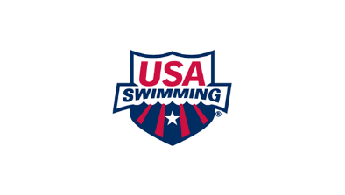
USA Swimming – The National Governing Body for competitive swimming in the United States that formulates the rules and implements the policies and procedures for the sport.

Middle Atlantic Swimming, Inc. (MASI) – The Local Swim Committee (LSC) overseeing competitive swimming in Eastern PA, Southern NJ and all of DE, which falls under the auspices of USA Swimming. MASI performs many functions including registering swimmers, coaches and clubs with USA Swimming, organizing and sanctioning meets and training and certifying meet officials.
Age-Group – A category that groups swimmers by age so they can compete against swimmers of similar ages. Typical age-groups are 8&Under, 10&Under, 12&Under, 14&Under.
Invitational Meet (“Invitational”) – A meet hosted for participating clubs or swimmers; eligibility and entry requirements are listed in the meet announcement.
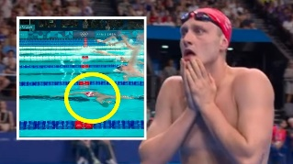
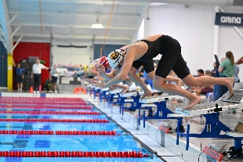
Championship Meets – MASI holds multiple championship meets at the end of each season. The Short Course Championship Series takes place in March and consists of 4 meets: 10 & Under Championships, Junior Championship, Senior Championship, and Silver Championships. The Long Course Championship Series takes place in July and includes the following: Senior Championship, Junior Championship, and Silver Championships. To be eligible to compete in the championship meets, swimmers must achieve qualifying times during the time period provided in the Meet Announcement.
Disqualification (“DQ”) – A swimmer may be disqualified when an official observes a violation of the rules (for example, a violation of the technical rules governing individual strokes and relays) and the call is accepted by the referee.
False Start - When a swimmer initiates the start before the starting signal and this action is observed by the Starter and independently observed and confirmed by the Referee. A confirmed False Start may result in the swimmer’s disqualification from the race.
Heats – Individual races within a swimming event. When an event has more swimmers than can race at one time, the swimmers are divided into heats (often based on the swimmers’ best times for the event) that race separately.
Individual Medley (IM) – An individual race where the swimmer completes the four strokes in a specific order: butterfly, backstroke, breaststroke and freestyle. Each stroke is swum for an equal portion of the total race. For example, in the 100-yard individual medley, the swimmer swims 25 yards – 1 lap/length – of each stroke.
Preliminary Session and Finals Session (“Prelims and Finals”) – Two sessions within a meet. Swimmers race Prelims to qualify for Finals; the number of swimmers advancing to Finals and the Finals format are stated in the Meet Announcement.
Timed Finals – Timed Finals meets are competitions where event heats are swum consecutively, usually slowest to fastest, and final places are determined by the times alone. So, if a swimmer in heat 1 of 10 swims the fastest time in the 10&Under Boys 50 breaststroke and a swimmer in heat 9 and 10 swim the next fastest times, those swimmers will have earned 1st, 2nd and 3rd, respectively, overall for the event.

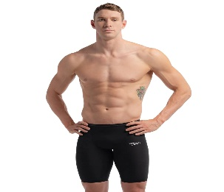
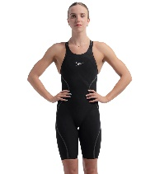
Tech/Technical Suit – A high-performance competition swimsuit using specialized fabric and construction designed to reduce drag and provide compression. USA Swimming rules provide guidance on when technical suits may be worn in competition and which athletes are permitted to wear them.

Scratch – To withdraw from an event after having entered and registered to swim. Meets may have scratch deadlines and specific scratch rules, which vary meet to meet.

