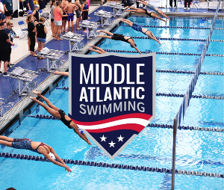
MIDDLE ATLANTIC SWIMMING 2026 LONG COURSE CHAMPIONSHIP MEETS
Standout Individual Performances – Senior Championships
Suburban Seahawk’s Joyce Lui won the Women’s 200 meter free A final in 2:04.31. Madison Sucheki, also from Suburban Seahawks, dominated the Women’s 400 IM A final touching the wall almost 10 seconds ahead of the field in 4:52.16. Cumberland Valley Aquatic Club’s Ava Buhrman earned 2 firsts in both backstroke events, with a 1:02.88 in the 100 and 2:16.46 in the 200 – almost 7 seconds faster than her 2nd place prelims swim. Brody Reber, from Lancaster Aquatic Club showed similar dominance in the men’s 400 IM, winning the A final in 4:36.38.
The men’s splash and dash also did not disappoint. The top 4 finishers in the men’s 50 meter free A final touched the wall within .02 seconds!
Ben Kutufaris (unattached) – 23.46
Derek Feldman (Central Bucks Swim Team) – 23.47
Jake Kennedy (unattached) – 23.48
M.J. Hoban (Diamond State Aquatics) – 23.48
The men’s 50 meter butterfly A final was another nailbiter. All 8 finalists finished under 26 seconds.
Standout Individual Performances – Junior Championships
Congratulations to Daniyar Bektembay from Orca Swim Club who earned an incredible 6 individual gold medal finishes in the 100 and 200 meter backstroke, 200 and 400 meter freestyle, 200 and 400 IM. He rounded out the meet with a silver medal in the 200 meter breaststroke and bronze in the 100 breaststroke.
Standout Individual Performances – Silver Championships
Congratulations to Boden Stauffer of Dallas Mountaineer Aquatic Club and Autumn Heigl who earned the high point awards at the Carlisle, PA meet site. Boden won with 7 Golds (200 meter free, 50 meter back, 100 meter back, 50 meter breast, 100 meter fly, 200 meter IM and 400 meter IM) and 1 Silver (100 meter fly). Autumn won 3 Golds (100 and 200 free, 50 breast), 4 Silvers (50 free, 200 breast, 200 and 400 IM) and 1 Bronze (100 breast).

