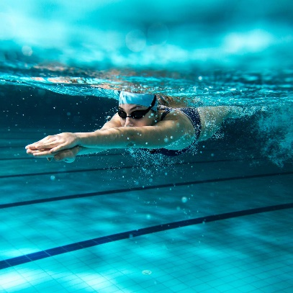
The Execution and Rationale
McBryan typically uses this workout early in a dedicated speed session, after a progressive warm-up and a few short efforts that prepare athletes to swim fast. On the resisted effort, the load must fit the swimmer. Start light and increase in small increments while watching catch, rhythm, and body position. If the swimmer stalls or substantially changes the stroke to move the resistance, reduce the load. The effort ends after ~8 seconds, rather than requiring the athlete to grind toward a distance marker. A parachute or resistance cord can replace the tower.
The no-push 25 asks swimmers to create their initial speed through swimming propulsion. They start stationary at the surface, fully extended in an 11 bodyline position with their feet clear of the wall and no preparatory kicking. The dragsox remain on the forearms, leaving the hands exposed for entry, and placing more feel on the athlete’s forearms. McBryan uses the sox to amplify swimmers’ awareness of pressure against the forearms early in the stroke and translate that into a clean powerful pull.
On the fins-only 25, swimmers remove the sox. The normal push and breakout return, and the task is to carry that awareness into fast swimming at a high tempo.
The unassisted 50 brings everything back to racing and is used to translate speed with equipment to racing without.
During recovery, each athlete gets one actionable adjustment for the next round. The easy 100 should be just that – easy. Then, passive rest for the remaining time. If the round takes more than 2 minutes or leaves swimmers insufficiently recovered, extend time to 4 minutes.
McBryan suggests the following if forearm dragsox are unavailable:
- Closed fists with fins: Keep the fists gently closed and wrists aligned. Reducing the hand’s available surface encourages swimmers to notice the forearm’s contribution to propulsion.
- Overpaddle grip with fins: Hold the top edge of the paddle so its body extends back across the palm and wrist toward the forearm. Use a manageable paddle and maintain a comfortable wrist position.

These alternatives share a technical purpose, but create different sensations and resistance. Prioritize the catch, pull, and coordination in the swimmer’s stroke.

Michael McBryan swam under Stu Kukla at Central Bucks Swim Team and continued under Frank Lichtner at La Salle College High School. After a standout high-school career, Michael joined the University of North Carolina Tar Heels where he served as team captain in his senior year. Michael competed in the 2016 Olympics Trials, qualified for and competed in the 2018 NCAA Championships, and was a two-time record holder in 200 yard breaststroke.
Michael started coaching in 2016 with Club Kickstart at UNC and thereafter coached at Nation’s Capital Aquatic Program as a Head Age Group Coach. Also at this time, Michael worked at SwimLabs, a technical review school for high performing swimmers, where he developed high-level technical skills and a passion for improving athlete’s efficiency in the water. In 2020, Michael became the head coach of Central Bucks Swim Team (CBST) and also assisted with Central Bucks South High School.
Michael's coaching philosophy focuses on quality over quantity, fosters a positive environment, and builds athletes' confidence through practice and goal attainment. Michael McBryan can be reached at mmcbryan83@gmail.com.

