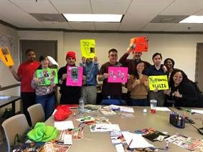

January Wellness Series

Zenit Journals’ mission is to make wellness accessible for everyone. Alina Liao, Founder of Zenit Journals, brought the Wellness Series to SEEC this January. The Wellness Series was the first rendition of SEEC’s Speaker Series—a new program welcoming volunteers to share their passions and expertise with the people we support.

During the four-part series, Alina lead the group in exercises, hands-on activities, and discussions to promote wellness habits that lead to real change. Stress Management, Goal Setting, and Self-Reflection were some of the topics Alina covered. We hope to offer the people we support sessions covering a wide range of topics in future Speaker Series. If you are interested in sharing your knowledge, passion, or skill in an upcoming Speaker Series, contact volunteer@seeconline.org for more information on how you can get involved!

