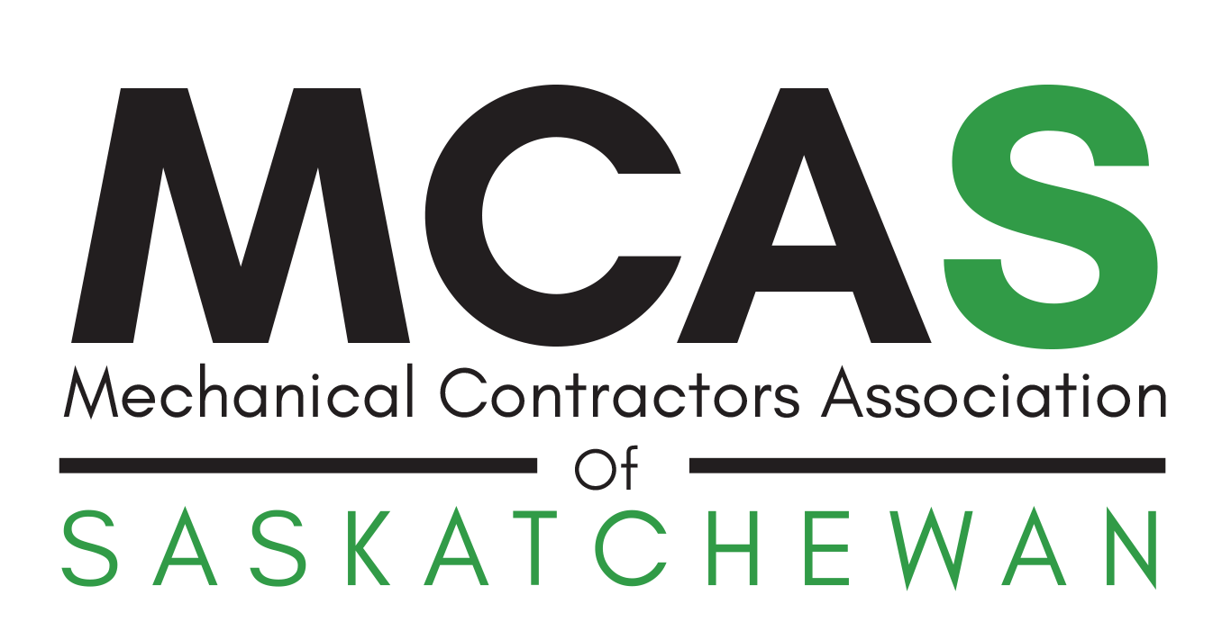 |  | ac theory
This 2-day course will cover the following:
· Refrigerants
· Basic refrigeration cycle
· Air movement and fans
· Duct sizing and installation
· Psychrometrics
· Economizers and mixing air
· Installations

AC THEORY & LABS  March 3 – 6, 2020  8:30am – 4:30pm daily  SaskEnergy / MCAS Training Centre  1301 Quebec Avenue  Saskatoon, SK S7K 1W7  Member Fee $1,500 + gst  Non-Member Fee $1,800 + gst  CONTACT  Nicole Kelly  Member Services Coordinator  Mechanical Contractors Association  Unit # 2 – 2412 Faithfull Avenue  Saskatoon, SK S7K 4A6  T. 306-664-2154  E. nicole@mca-sask.com |  | labs
The lab session includes hands on training for residential air conditioning systems. The participants will work on a variety of different air conditioning systems and will learn how to safely use gauge sets, recovery machines and vacuum pumps. The main topics include:
· Measurements of system parameters including superheat and sub-cooling
· Refrigerant charging and recovery
· Nitrogen purging and evacuation
The lab session is only one day. Please choose either March 5th or 6th. Participants must have AC Level 1 or AC Theory before enrolling in the lab session.

 |  | the presenter
 |  | Greg Scrivener has worked in the refrigeration and air conditioning industry for more than 15 years. He has experience in almost all aspects of the design, construction, operation and maintenance of commercial and industrial refrigeration systems. Greg is currently providing the industry with specialized refrigeration consulting services that focus on energy and capital spending management and advanced troubleshooting. He is also facilitating the training of many HVAC/R topics for owners, contractors, industry groups and governments. Greg graduated from the University of Saskatchewan with a B.Sc. in Mechanical Engineering and is a Journeyperson Refrigeration Mechanic. He currently sits on a number of ASHRAE Technical Committees and is very involved in the development of refrigeration system safety standards as an active member of the ASHRAE Standard 15 committee.
 |  | registration form
Company:
Contact:
Address:
City:
Postal Code:
Telephone:
Email:
Attendee 1 Name:
Lab Date (Mar 5 or 6):
Email Address:
Attendee 2 Name:
Lab Date (Mar 5 or 6):
Email Address:
Attendee 3 Name:
Lab Date (Mar 5 or 6):
Email Address:
____ x $1,500 member fee
____ x $1,800 non-member fee
5% GST
TOTAL
Method of Payment: |  |  |  |  | Cheque |  |  | Invoice
 |  |  |  |  | VISA |  |  | MasterCard
Card Number:
Expiry Date:
Cardholder Name:
Signature:

AC THEORY & LABS
March 3 – 6, 2020
8:30am – 4:30pm daily

SaskEnergy / MCAS Training Centre
1301 Quebec Avenue
Saskatoon, SK S7K 1W7

Member Fee $1,500 + gst
Non-Member Fee $1,800 + gst

send completed form to:
Nicole Kelly
Member Services Coordinator
Mechanical Contractors Association
Unit # 2 – 2412 Faithfull Avenue
Saskatoon, SK S7K 4A6
T. 306-664-2154
E. nicole@mca-sask.com

