CHRISTMAS DAY MITZVAH – 2025
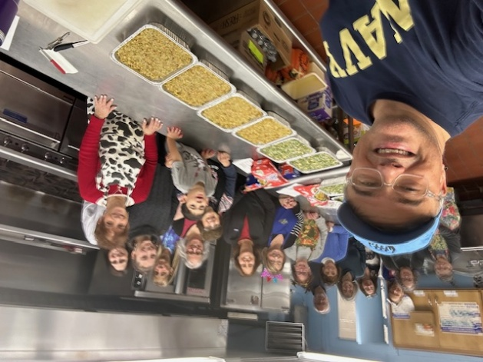
ALL ARE WELCOME to help your Sisterhood family on Christmas morning, for our long-standing tradition of cooking and preparing full turkey dinners for those less fortunate than us!
There will be a limited crew safely cooking full Christmas Dinners, Jewish maven style...lots of food, lots of fun and lots of chatter! Not a cook? No problem as there are other ways you can help!
Because every delicious turkey dinner deserves a fabulous dessert, you can also help by dropping off yummy desserts on Christmas day morning. Make or buy a dessert, bring it to TBA either on Christmas Eve by 1:00 pm or Christmas Day morning between 9:00-11:00 AM, and enjoy a schmooze with the TBA Sisterhood chefs!
Now more than ever it’s important to make this Christmas holiday bright and cheery for those who are alone. Going away for the holidays? No problem, we can use help shopping for the ingredients prior to Christmas. Can't make a dessert? No problem there – store bought is perfectly fine!

This is a great opportunity to teach your children about giving to others!
Ways you can help:
Prior to Christmas Day:
- Shop for the groceries and deliver to TBA by 12/19/25
- Help prepare turkeys to put in oven (Christmas Eve day, time TBD)
Christmas Day:
- Prepare & cook the meals (limited shifts range from 9:00 am-noon)
- Help arrange dessert platters & boxes for delivery
- Contactless delivery of meals between 12:00-2:00 (minimum 2 people per car)
- Drop off home-baked or store-bought desserts to TBA by 11:00 AM.
If you’d like to assist with any of these jobs, please go to
http://www.PerfectPotluck.com Coordinator Last Name: Schwartz Password: xmas
This project is the essence of Sisterhood! Thank you in advance for your support of this wonderful mitzvah!
Wendy Schwartz, Chair

