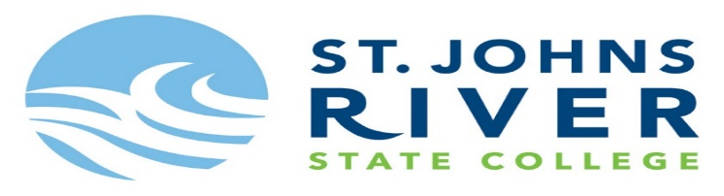
Interested in taking Dual Enrollment classes for the 2020-2021 School year…..
- Creekside High School partners with St. Johns River State College for students to take DE classes either on Creekside’s campus or on SJRSC campus (online or physically at the college campus)
- Students can participate in DE for 3 academic school years or 60 college credit hours – whichever comes first
- Students must meet all eligibility prior to being able to participate in DE classes
- DE classes replace the high school level class but offers students both a college credit and high school equivalent credit for each DE class
- AS a dual enrollment student, you will begin to earn college credit and also begin your college GPA
- As a dual enrollment student, you are considered a college student and all classes/grades are governed by the college (meaning grades are not on HAC). This means you must abide to the colleges grading policy, attendance policy testing policy and college timelines.
Dual Enrollment Eligibility:
- 3.0 or higher unweighted GPA
- Creekside Approval
- Qualifying test score on the PERT, SAT or ACT exam
  - PERT: Reading – 106, English: 103 and Math: 123
  - ACT: Reading: 19, English 17 and Math: 21
  - SAT: Reading: 24, Writing: 25 and Math: 25
I want to participate in Dual Enrollment classes – NEXT STEPS for new DE students:
- Complete the online Dual Enrollment application at: https://web.sjrstate.edu/pls/prod/bwskalog.P_DispLoginNon?wapp=D1
- Print Consent form upon completion on the online application
- Sign up for a test to earn qualifying test scores (students are encouraged to take the PERT Exam – attached is information to register for the PERT exam)
- Bring consent form and official test scores to your registration appointment in January/February 2020
Creekside Dual Enrollment course offerings (subject to change):
Junior level classes:
- ENC 1101 and ENC 2210
- BSC 1105 and BSC 1020
Senior level classes:
- ENC 1102 and AML 2020
- MAC 1105 and STA 2023
- POS 1112 and POS 1041
- BSC 1105 and BSC 1020
Students interested in taking classes at St. Johns River State College (online or at the college campus):
Underclassmen for Fall and Spring semesters:
- Students can attend the college campus part-time and take up to 10 credit overs during each semester – in this situation students would have a blended schedule between Creekside and the college
Seniors for Fall and Spring semesters:
- Students can attend the college campus part-time and take up to 10 credit overs during each semester – in this situation students would have a blended schedule between Creekside and the college
- Students can attend the college campus full-time and must take a minimum of 12 credit hours but a maximum of 16 credit hours – in this situation students would not attend Creekside at all but attend the college full-time
Summer classes for all eligible students:
- Students can attend the college campus part-time and take up to 8 credit overs over the summer sessions
Deadline to register for DE classes at Creekside for the 2020-2021 school year: March 31, 2020
Deadline to register for DE classes at the college campus for Summer 2020: To be determine but sometime in March 2020
Deadline to register for DE classes at the college campus for Fall 2020: To be determined but sometime in May 2020

