Sun | mon | tue | wed | thu | fri | sat
Key | Key |  |  | 01 | 02 | 03
HG = Harbor of Grace  LG = Loaves of Grace Food Pantry | CP = Choir Practice  BC = Bell Choir |  |  | 10A Crafters | 9A Garden Harvest  10A LG Food Packing | 10A LG Food Distribution
04 | 05 | 06 | 07 | 08 | 09 | 10
10A Worship | Labor Day  Office Closed | 10 Quilting at St. Mark  11A Baby Pantry  6:30P Bell Choir | 10:30A Choir Practice  6:30P Council | 10A Crafters  6:30P Instrument Practice | 9A Garden Harvest  10A LG Food Packing | 10A LG Food Distribution
11 | 12 | 13 | 14 | 15 | 16 | 17
10A Worship | 9A Quilting at HG | 10 Quilting at St. Mark  6:30P BC | 10:30A Choir Practice | 10A Crafters  6:30P Instrument Practice | 9A Garden Harvest  10A LG Food Packing | 10A LG Food Distribution
18 | 19 | 20 | 21 | 22 | 23 | 24
10A Worship | 9A Quilting at HG | 10 Quilting at St. Mark  11A Baby Pantry  6:30P BC | 10:30A Choir Practice | 10A Crafters  6:30P Instrument Practice | 9A Garden Harvest  10A LG Food Packing | 10A LG Food Distribution
25 | 26 | 27 | 28 | 29 | 30
10A Worship | 9A Quilting at HG | 10 Quilting at St. Mark  6:30P BC | 10:30A Choir Practice | 10A Crafters  6:30P Instrument Practice | 9A Garden Harvest  10A LG Food Packing
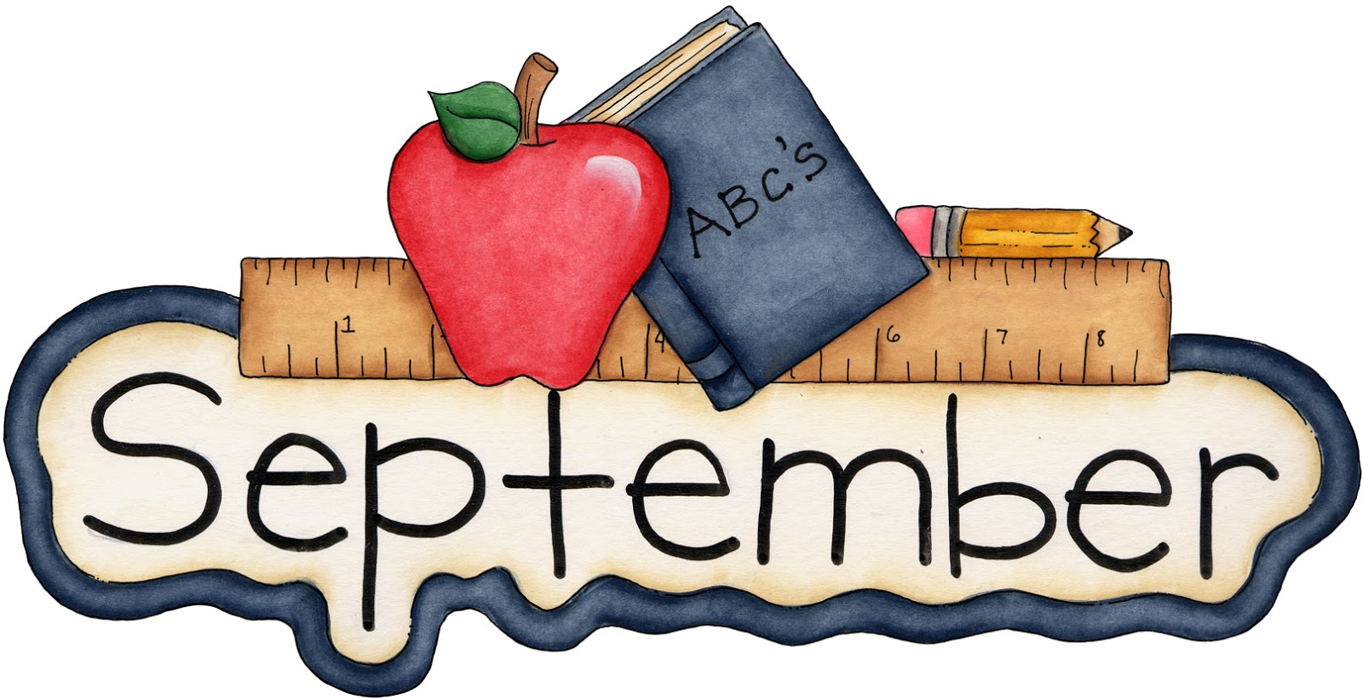 2022

