Are your students with disabilities prepared for further education, employment and independent living?
Independence Alliance is here for you!
We understand the challenges faced by special education administrators. Our services are designed to assist your work in enhancing your students’ lives and support their families.

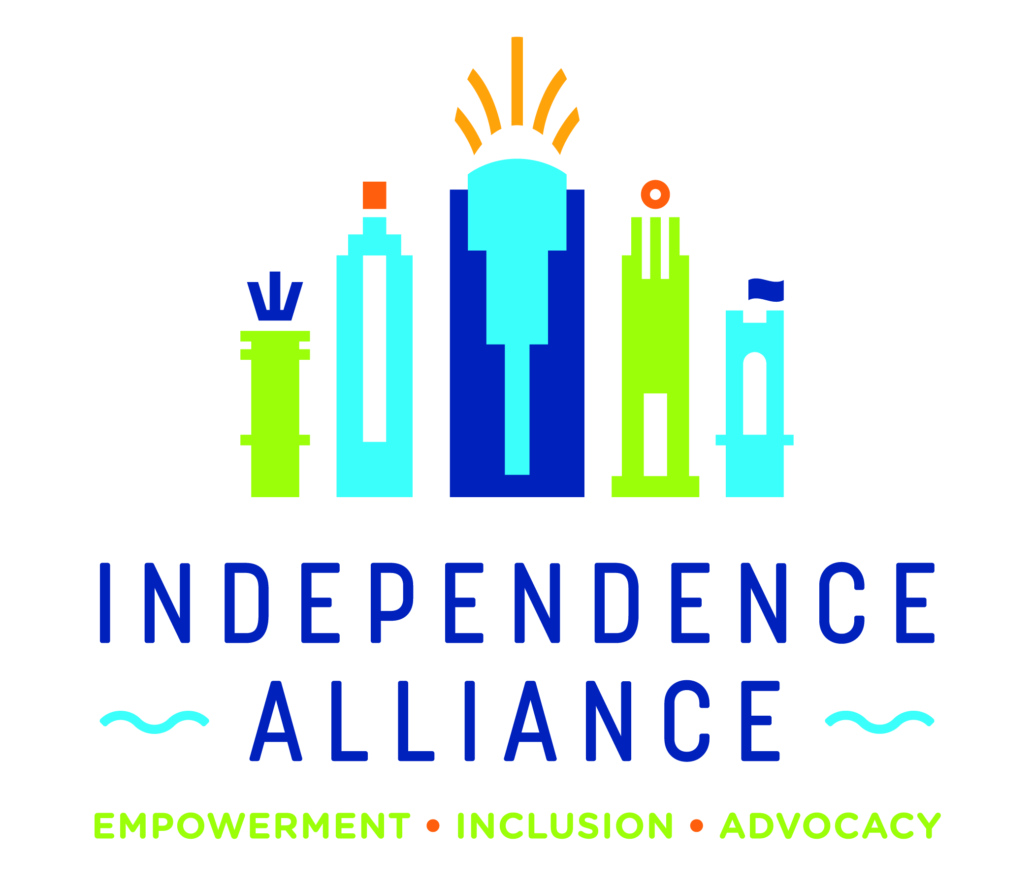
EMPOWERING FUTURES:
TRANSITION SERVICES FOR STUDENTS WITH DISABILITIES

CONTACT US TO GET STARTED!
Dawn Engel Youth Transition Services Specialist
Dawn@IndependenceAlliance.org
Phone: 513-338-5108
IndependenceAlliance.org
OUR TAILORED SESSIONS ARE AVAILABLE 1:1 OR IN GROUP FORMATS, BOTH IN-PERSON AND VIA ZOOM AND INCLUDE:

Introduction to Self-Advocacy
- Who Am I? Self-Awareness
- Your Rights and Responsibilities
- Leadership Skill Development
- SMART Goal Setting
- Speaking Up!
Workplace Readiness Training
- Learning Appropriate Work Behaviors & Ethics
- Completing Applications & Resume Development
- Interviewing Techniques
- Social Media Profiles & Other Communications
- Personal Hygiene & Money Management Skills



