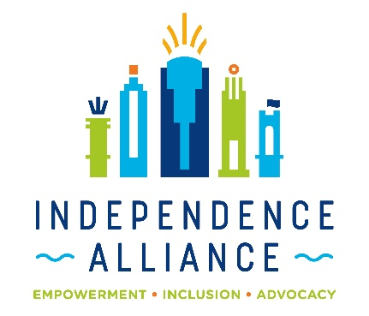
Empowerment through Vision Project Referral Form
Applicant Information:
Name ________________________________________
Address ______________________________________
County of Residence __________________________
Email ________________________
Phone _______________________
Tell us about your visual impairment:
________________________________________________________________________________________________________________________________________________

How will the items increase your independence:
________________________________________________________________________________________________________________________________________________________________________________________________
Describe the specific item(s) you need:
________________________________________________________________________________________________________________________________________________________________________________________________________________________________________________

Representative Contact (if applicable):
Name _______________________________________________
Email __________________ Phone _______________________

____ I understand this is a referral only and does not guarantee the items will be provided.
____ I understand this project is based on available funding.

Applicant Signature: __________________________________________________
Representative Signature (if applicable): __________________________________________________

Return form by email to: debbie@independencealliance.org
Or by mail to:
Independence Alliance
2368 Victory Parkway, Suite 501
Cincinnati, OH 45206

Contact: Debbie Moorehous at 513-338-5110

