Beginning Quilting Rail Fence
Pattern/book: Start Quilting by Alex Anderson
Instructor: Susan Harris
Dates: September 16 - 17, 9am – 4 pm
Sessions: 2
Skill level: beginner
In this class, students will be creating a wall hanging size quilt. Students are to bring their own sewing machine and supplies as listed below.
Session 1 - begins with rotary cutter safety, then students will proceed to cutting their fabrics according to the instructions for the pattern. They will be sewing the blocks, then sewing the blocks into rows, then sewing the rows together, and finally adding borders.
Session 2 - the students will continue to complete the tops of their wall hangings, then they will sandwich their tops by layering the top, batting, and backing to quilt and then attach the binding.
Price: $50
Class supplies | 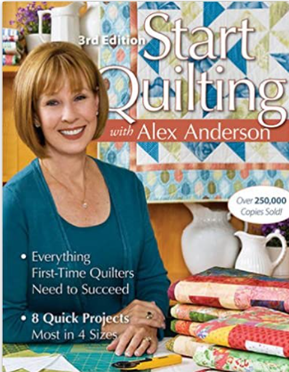
- Sewing machine (in good working order)
- 8 ½” x 24” nonslip ruler
- 6” square or larger nonslip ruler
- Flat flower pins with magnetic holder
- Rotary Cutter
- Thread
- Bobbins
- Sewing machine needles
- Small scissors for trimming threads
- Seam ripper
- Hand sewing needles
- Thimble
- Alex Anderson’s Start Quilting book

Fabric Requirements
- Focus Fabric: ¾ yard for outer border
- Fabric 1: ¼ yard of 3 each of different fabrics for blocks
- Fabric 2: ¼ yard of 3 each of different fabrics for blocks
- Fabric 3: ¼ yard each of 3 different fabrics for blocks
- Solid or Print: ¼ yard for inner border
- Binding: 3/8-yard
- Backing: 1 ¼ yards
- Batting

