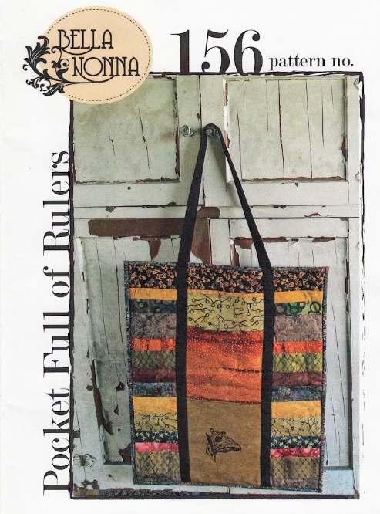 | Pocket Full of Rulers  Instructors: Laura Clark and Elizabeth Weidner  Level: Confident Beginner  Date: March 9 and March 16, 2023  Maximum students: 20  Cost: $50
Pocket Full of Rulers makes the perfect bag for classes and quilting on the go! Fit your 18” x 24” cutting mat and class rulers in this cute bag. Make it scrappy or pick out new fabrics to make a bag you’ll love!
Class Specific Supplies
Pattern: Pocket Full of Rulers | 4 yards cotton webbing
Fabrics to Complete Bag  - 3 fat quarters for pockets  - 1⅔ lining  - 30 strips (width range 1½-3½ x 22” | Stabilizers  - ¾ yard permanent press muslin  - 2 yards Deco Bond
Walking foot for your machine | 75/11, 80/12, and 90/14 needles
Decorative threads, Mono Poly

Standard Sewing Supply List
- Sewing machine (in good working order) | - 18 x 24 Cutting mat (or larger)
- Neutral thread and bobbins for sewing | - Standard 6.5 x 24-inch ruler (or larger)
- Fabric marker/pen/chalk | - Flat flower pins and magnetic pin cushion
- Ergonomic rotary cutter | - Scissors/snips
- Iron | - Seam ripper
- Portable ironing board/mat | - Measuring tape
- Optional: Extension cord, Best press/sizing, Thimble, spare rotary blades | - Safety pins

