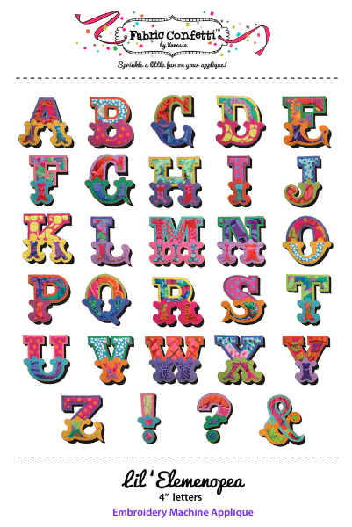 | EZ Applique ScanNCut Pillow  Instructors: Susan Harris  Level: Confident Beginner  Date: February 24, 2023, 10 am -2 pm  Maximum students: 15  Cost: $50
ScanNCut owners and applique aficionados, this class is for you. Quilt Lizzy Ayden’s EZ Applique ScanNCut Pillow class introduces students to the basics of using SVG files and machine applique without the need to trim around hooped shapes during embroidery. Bring your scraps to build your own “SEW” or “LOVE” pillow with us at Quilt Lizzy Ayden.
Class Specific Supplies
Pillow form: 12 x 16 or larger | Stabilizer
Fabrics for pillow cover  - 15” x 20” (or larger) background square  - 2 13” x 13” squares for split back panels  - Fabric scraps for “LOVE” or “SEW” message on pillow front | Wonder Under (or other iron on adhesive)
5”x7” or larger embroidery hoop | 75/11, 80/12 needles
Decorative threads for machine embroidery | Optional: ScanNCut machine

Standard Sewing Supply List
- Embroidery and Sewing (or combo) machines (in good working order) | - 18 x 24 Cutting mat (or larger)
- Neutral thread and bobbins for sewing | - Standard 6.5 x 24-inch ruler (or larger)
- Fabric marker/pen/chalk | - Flat flower pins and magnetic pin cushion
- Ergonomic rotary cutter | - Scissors/snips
- Iron | - Seam ripper
- Portable ironing board/mat | - Measuring tape
- Optional: Extension cord, Best press/sizing, spare rotary blades | - Safety pins

