Beginning Quilting Rail Fence
Pattern/book: Start Quilting by Alex Anderson
Instructors: Laura Clark and Elizabeth Weidner
Dates: June 17-18, 9am – 4 pm
Sessions: 2
Skill level: beginner
Maximum students:
In this class, students will be creating a wallhanging quilt. Students should bring their own sewing machine, or use one of ours. Session 1 begins with rotary cutter safety, then students will proceed to cutting their fabrics according to the instructions for the pattern. They will be sewing blocks and then sewing them into rows then sewing row to row and adding borders. Session 2, the students will continue to complete the tops of their wall hangings, then they will sandwich their tops by layering the top, batting, and backing to quilt and then attach the binding.
Price: $50
Class specific supplies | 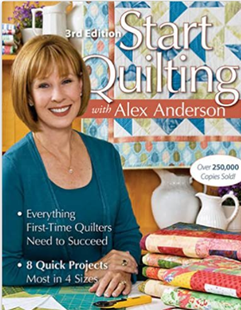
- Small nonslip ruler for trimming and squaring
- Alex Anderson’s Start Quilting book
Fabric Requirements
- Focus Fabric: ¾ yard of outer Border
- Pink: ¼ yard of 3 each of different fabrics for blocks*
- Green: ¼ yard of 3 each of different fabrics for blocks*
- Lavender: ¼ yard each of 3 different fabrics for blocks*
- Print: ¼ yard for inner border
- 3/8-yard binding
- 1 ¼ yards Backing fabric
- Batting
*Fat quarter friendly option: 2 FQ of each color or 6 FQ total
Standard Sewing Class Supply List
- Sewing machine (in good working order) | - Thread and bobbins
- 18 x 24 Cutting mat (or larger) | - Flat flower pins and magnetic pin cushion
- Standard 6.5 x 24-inch ruler (or larger) | - Fabric marker/pen/chalk
- Smaller ruler for trimming | - Scissors/snips
- Self-closing/Ergonomic rotary cutter | - Seam ripper
- Iron | - Measuring tape
- Portable ironing board/mat | - Machine and hand sewing needles
- Optional: Extension cord, Best press/sizing, Thimble, spare rotary blades

